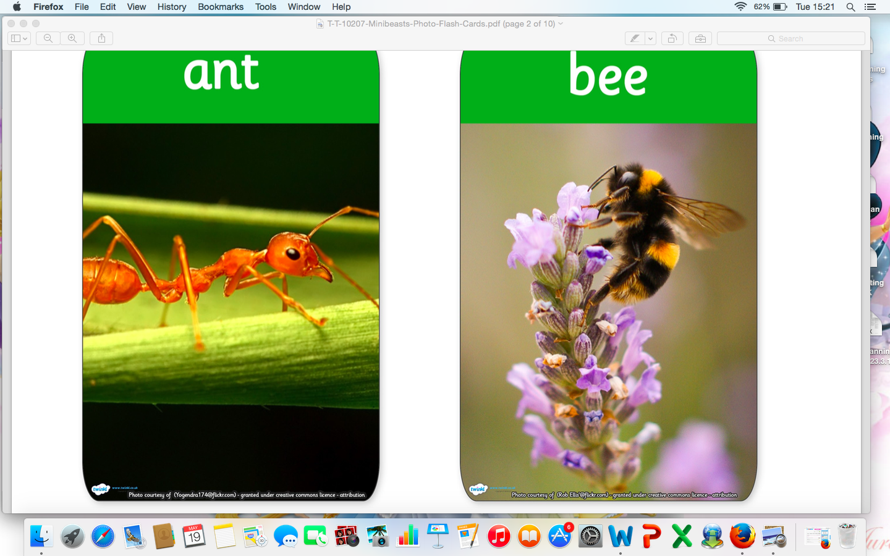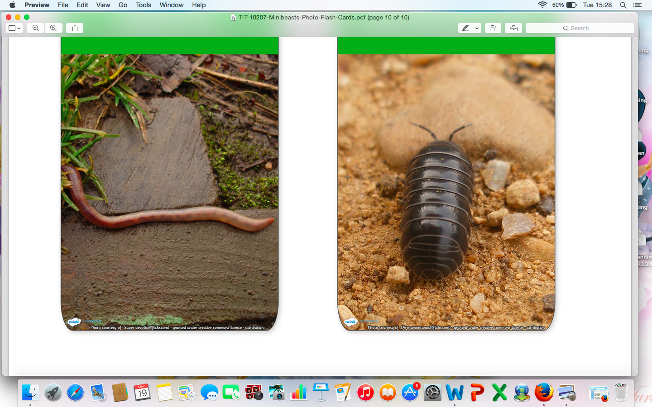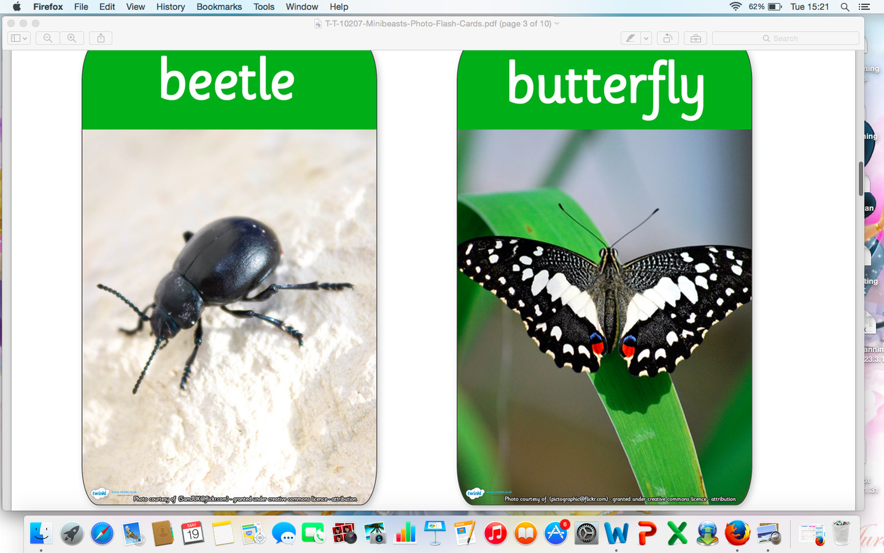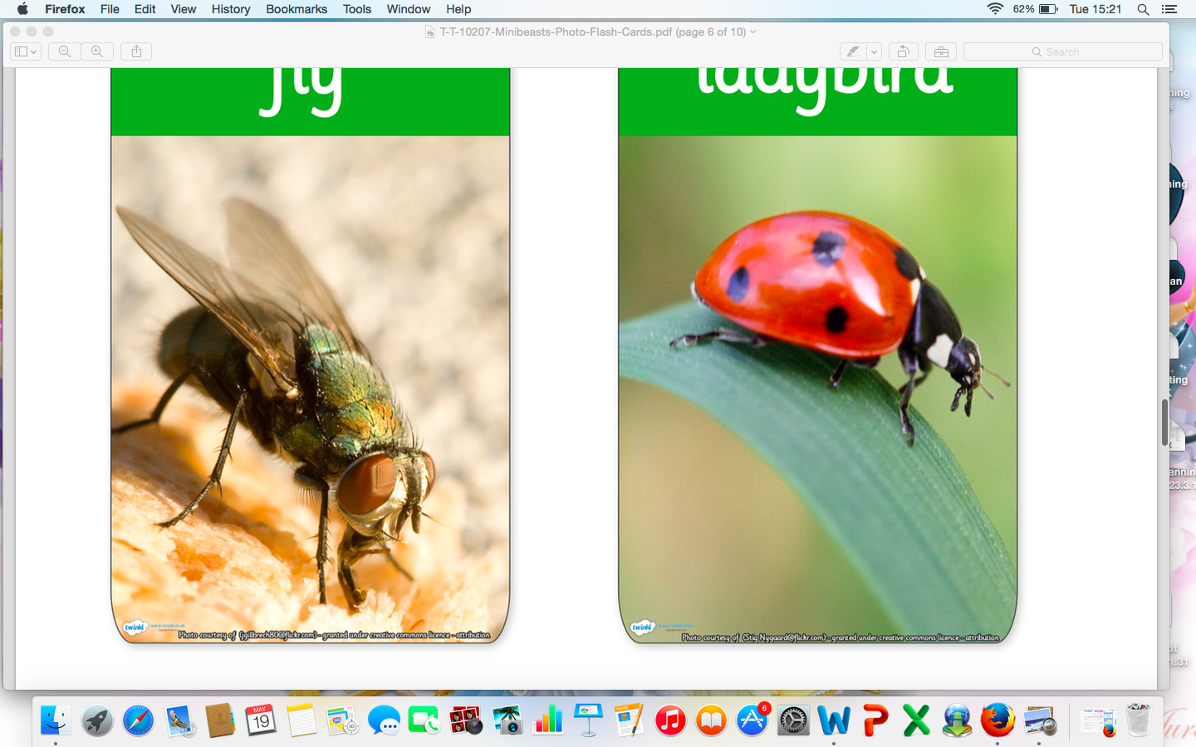

**Ladybird:**

- Doubling the spots on the wings.

- Symmetry.

- The bad tempered ladybird.

- Split pin ladybird.

- Bug Hunt.

**Things you can do at home:**

Go for a bug hunt in the garden. Read factual books about minibeasts. Write a fact about a minibeast to share in class. Talk about taking care of living things.

**Down Below-**

Worms and Snails, Spiders, Beetles, Grasshoppers.

**Worm/Snails:**

-Superworm- Julia Donaldson.

-Fingerprint snails.

-Egg Carton Snails.

- Fine motor skills cheerio worms.

-Measuring worms.

-Discuss habitats.

**Up Above-**

Butterfly/Caterpillar, Ladybird, Bee/Wasp.

Summer 1

Unit 10 Minibeasts

**Spiders:**

- Tube Spider Printing

- Concertina Spiders

-Spider Careful cutting

- Save bugs from the spider web

**Bee/Wasp:**

- Bumble Bee Pasta art.

-Bubble beehives.

- Cereal Beehive art.

- Discuss beehives and making honey.

- honey sandwiches.

**Beetles:**

-Beetles and mini beasts under the magnifying glass.

- Minibeast Bingo

- Minibeast fossil making.

**Literacy:**

* Describing Minibeasts and their features.
* Letter formation in spider trays.
* Minibeast initial sounds sorting.
* CVC words on minibeasts to aid writing.

**Grasshopper:**

-Jumping obstacle course.

- Measuring how high grasshopper can jump.

-Musical instruments.

- weighing minibeasts and bugs.

**Butterfly/Caterpillar:**

-The Hungry Caterpillar story.

-Finger paint caterpillar picture.

-Hungry caterpillar ordering the numbers to 20.

-Symmetry with butterflies.

-Butterfly lifecycle.

-Butterfly enclosure in class- growing butterflies.

-Days of the week.

-Healthy and unhealthy foods.

-There’s a tiny caterpillar on a leaf song.