Graham James Primary Academy

Anti-Bullying
Policy
Updated in line with ‘Keeping Children Safe in Education’ (KCSIE) September 2021 update.
Measures to prevent bullying, including cyberbullying, prejudice-based and discriminatory bullying.

Agreed by Governors: Autumn Term 2021
Next Review Date: End of Summer term 2022

Graham James Primary Academy
Anti-Bullying Policy

At Graham James Primary Academy we have a zero tolerance on bullying. Bullying is unacceptable. It happens in all schools and many normal young people are involved at some time. We are committed to creating a safe environment where young people can learn and play, can talk about their worries, confident that an adult will listen and offer help.
We will make it clear to children, staff, parents/ carers and governors that when bullying happens we will work as a community in accordance with the policy set out in this document to help both people who are harmed and the perpetrators. We will ensure the safety of the targeted child and do our best to support improved behaviour from the perpetrator.

Aims of the Policy
Graham James Primary Academy is committed to creating an atmosphere within our school that acknowledges that any form of bullying is unacceptable.
All staff members will be aware of this policy and of the procedures to prevent and/ or respond to observed or reported bullying.
Where adult to child bullying is suspected, observed or reported it must be managed as a concern about an adult’s behaviour within safeguarding procedures.
All staff, volunteers, children and parents/ carers should have an understanding of what bullying is
All children and parents/ careers should know what Graham James Primary Academy’s policy is on bullying and what they should do if bullying arises.

Bullying – Our definition
Bullying is deliberate, offensive, intimidating, malicious, abusive or insulting behaviour which makes the individual feel upset, threatened, humiliated or vulnerable. Bullying involves dominance of one child by another, or a group of others, is pre-meditated and usually forms a continued pattern of behaviour.
There are many different types of bullying. Bullying can be and includes:

Emotional | Being unfriendly, excluding and tormenting (e.g. hiding books, threatening gestures).
Physical | Pushing, kicking, hitting, punching or any use of violence, threatening or obscene gestures.
Sexual/Sexist | Unwanted physical contact or sexually abusive comments because of gender.
Verbal | Insults, sarcasm, spreading rumours, teasing and name-calling including comments made against particular groups for example because of disability, Special Educational Needs or on grounds of religion, cultural background, gender, sexual orientation or transgender status.
Cyber | All areas of internet, such as email & internet chat room misuse, social network sites, threats by text messaging & telephone calls, and misuse of photographic technology, e.g. cameras and videos. This includes sexting or threatening and/or blackmailing a person to share images of that person or purporting to be that person or connected with them in some way.
Prejudice Bullying - Children and young people can be bullied for a number of reasons; the colour of their skin, their sexual orientation, disability, gender, religion and many others factors. Some children and young people find it hard to understand the diversity of others and can only see it as a difference which can lead to prejudice bullying.

Religious | Unkind words or actions because of someone’s religion.
Racial | Racial - Using racial taunts, graffiti and gestures because of someone’s colour and/or origin.
SEN/D (also includes disabilities) | SEN/D - Unkindness because of physical or mental disabilities or having Special Educational Needs.
Homophobic | Treating someone unkindly because people think that they are or might be homosexual.
Transphobic - | Unkindness due to someone’s gender identity, their perceived gender identity or because they do not conform to culturally conventional gender roles.
Body image (including appearance) | The way you look and present yourself can be very important to children and if a child is noticeably over or under weight they may be at risk of bullying.
Family | Unkindness because a child is adopted or is a carer.

Bullying is therefore:
- Ongoing harmful behaviour over a period of time (e.g. not one off events) (STOP – Several Times On Purpose)
- Different from random acts of aggression (e.g. a one-off physical altercation)
- Not just physical violence (See table above for detailed categories) – but includes many different sorts of behaviour including intimidation, name calling, teasing and isolating etc.

Responsibilities:
Academy Staff – The adult as a role model
- The staff at Graham James Primary Academy will not misuse a position of power to dominate the children in our school. We will avoid:

- Sarcastic comments
- Derogatory nicknames
- Dominating and humiliating behaviour
- Shouting at children, unless it is the only means to communicate
At Graham James, all staff will listen to children when they are willing to talk about bullying and we will be sensitive to a child’s needs for privacy and respect. All staff will also adhere to and promote this policy.

Children – What we expect of the children
Children have responsibility for:
- Reporting any inappropriate behaviour/ bullying
- The physical safety of others
- Not taking or touching another child’s personal belongings without permission
- Including all children in play and learning activities
- Making sure their actions do not hurt another child/ adult (e.g. name calling/ teasing)
Children have the right to:
- Be physically safe
- Keep their own belongings without fear of losing them (the children are responsible for their own belongings)
- Be free of insult, derogatory terms and teasing
- Be able to associate with other young children for friendship and companionship
- Learn without worry or fear caused by others

Parents/ Carers – What we expect
- To arrange a meeting to discuss with their child’s teacher any concerns that their child may be experiencing bullying or be involved in some way
- To help establish an anti-bullying culture inside and outside of school
- To support our anti-bullying policy and procedure

Creating an anti-bullying climate (How we prevent bullying)
At Graham James Primary Academy our aim is to create a climate where bullying is not accepted by anyone within the academy community (zero tolerance). We promote positive behaviour in many different ways (Please refer to our Behaviour Policy) which helps to create an environment where children behave well, take responsibility for each other’s emotional and social well-being and include and support each other. This covers all aspects of school life and beyond the school gates.

Graham James Primary Academy aims to prevent bullying by:
- Involving pupils - All pupils understand the school’s approach and are clear about the part they can play to prevent bullying, including when they find themselves as bystanders (S.T.O.P principle – several times on purpose) – this is discussed throughout the year in assemblies and through the RSHE & PSHE curriculums.

- Regularly evaluating and updating our approach to take account of developments in technology, and adjusting our curriculums to meet the needs of the modern day child.

- Implement disciplinary sanctions - The consequences of bullying reflect the seriousness of the incident so that others see that bullying is unacceptable (please see ‘Behaviour Policy’ for further details)

- Curriculums - Through curriculums such as RSHE, PSHE & RE, we openly discuss differences between people that could motivate bullying, such as religion, ethnicity, disability, gender, sexuality or appearance related difference. Also children with different family situations, such as looked after children or those with caring responsibilities.

- Make it easy for pupils to report bullying so that they are assured that they will be listened to and incidents acted on. Pupils should feel that they can report bullying which may have occurred outside school including cyber-bullying. At Graham James Primary Academy, we have a ‘Share a concern’ box (one in KS1 & one in KS2) whereby children can post their concerns and it will be picked up by a member of the Senior Leadership Team and acted upon or the children are encouraged to speak directly to the teacher or a member of staff.

- Create an inclusive environment - Graham James Primary Academy create a safe environment where pupils can openly discuss bullying, without fear of further bullying or discrimination. Children are never made to feel that they are creating a problem.

- Celebrate success - Celebrating success is an important way of creating a positive school ethos around the issue. Every Friday a ‘Celebration Assembly’ is attended by all children. Here we celebrate all the positive achievements throughout the school week (Gold Awards/ STEP Awards & achievements outside of the academy)

- Engage parents - Through our regular newsletter and website, we promote parents to engage with the school if they have any concerns or worries about their child or another child. Our Bullying Policy also outlines what parents/carers need to do if they need to discuss any concerns. We also engage parents if an issue arises in school and discuss their child’s behaviour and consequences if inappropriate or bullying behaviours are proven to have occurred.

- Staff training – Staff are updated throughout the year with regards to safeguarding, within this are updates on bullying so all staff are aware of and can challenge any inappropriate behaviours witnessed or reported in line with the Bullying Policy.

At Graham James children are taught ‘S.T.O.P’ – Several times on purpose. Children understand that one incident does not constitute bullying. Children are also taught that they are not to tolerate any unkindness and must report it to an adult immediately.
In order for children to fully understand bullying – we have created a child friendly anit-bullying policy which staff and parents can use. (See appendix 1)

The procedure to follow
- Pupils who have been bullied (refer to earlier definition) or may have seen bullying should report this to a member of staff (This information will be passed to the class teacher). If a parent/ carer is reporting bullying, arrange to meet the class teacher and explain the situation in a non-confrontational way
- The concern will be logged in the class teachers behaviour log
- Where bullying is of a racist nature, we will record this using the Racial Incident Report Form and keep a log
- All reports will be taken seriously and an investigation will take place in order to determine whether the reported behaviour is a confirmed bullying case
- The behaviour policy will be followed if bullying is confirmed (See Behaviour policy for further information on sanctions/ procedure etc)
- A member of staff will meet with the victim and discuss the effects bullying has had on them. A group meeting may then be held (this will include the victim, perpetrator and any other child directly/ indirectly involved). The member of staff running the group will explain how the victim is feeling and the group will offer suggestions to find a solution. Those who were bystanders are given a chance to see that by doing nothing, they were condoning the bullying. By the end of the meeting, solutions and expectations will be discussed. A week or so later, the group will meet again to discuss the resolution process.
- The victim will be checked regularly to measure whether further support may be needed. All children know they can go to an adult with any concerns they may have.

Bullying outside of the academy premises
Graham James Primary Academy has a duty to address all forms of bullying. Therefore, if your child or you know of a child that is a victim of bullying (or is bullying other children), please bring this to the schools attention as soon as possible. This can be reported to the class teacher, or a senior member of staff. The procedure described on the previous page will then be followed.

Evaluation of the Anti-Bullying Policy
The Anti-Bullying policy will be reviewed every 2 years or as a result of:
- Pupil perception surveys of bullying in the academy
- Parents evening questionnaires
- Comments made by visitors and other people connected to the academy
- Local Authority / National guidance changes
This policy applies to all staff and to all children, whether temporarily or permanently on the academy roll.

The head teacher is responsible for introducing and implementing this policy. However, all staff, children and their parents/ carers have an active part to play in the development & maintenance of the policy and its success.

APPENDIX 1:
Graham James Primary Academy

Child friendly
Anti-Bullying Policy

Several Times On Purpose

What is bullying?

At Graham James Primary Academy, a bully is someone who hurts someone more than once, by using behaviour which is meant to hurt, frighten or upset another person.

Types of bullying:

PHYSICAL – Punching, kicking, spitting, slapping, pushing, hitting
EMOTIONAL – Hurting people’s feelings, leaving people out, being bossed about

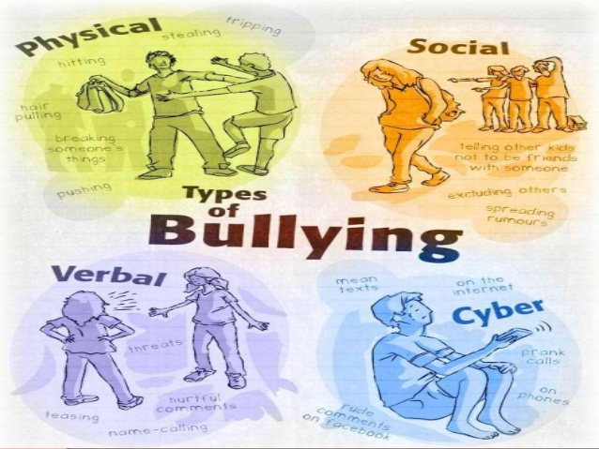

3rd Person – sending a friend to be nasty/ horrid messages
RACIST – Calling you racist names
CYBER – text messages, emails, social media, online games consoles (e.g. Xbox)

VERBAL – Being teased, name calling, hand signs/ gestures – this could be for the way you look, your beleifs or family situation – anything that is said that causes you upset.

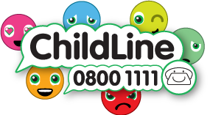

When is it bullying?

Several Times On Purpose

At Graham James Primary Academy, we say…
BULLYING IS NOT…

- When friends fall out.
- When children argue or have a disagreement.
- Accidents.

What to do if you are bullied:
DON’T:
- Do what they say
- Get angry or upset
- Hit them or fight them
- Think it’s your fault
- Keep it to yourself
- Take it personally
DO:
- Ask them to STOP (if you can)
- Ignore them
- Use eye contact and say ‘GO AWAY’
- Walk away
- Remember – it’s not your fault!
- TELL SOMEONE!!!!!

What do we do at Graham James to help?
- We always take bullying seriously

- We try and find a way to make it S.T.O.P so you can feel safe and happy at school

What our school does to respond to bullying:
- We listen to the child and offer support

- We work together with families to find solutions

- THERE ARE CONSEQUENCES FOR BULLYING BEHAVIOUR!

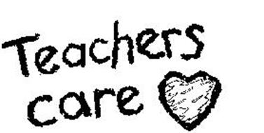

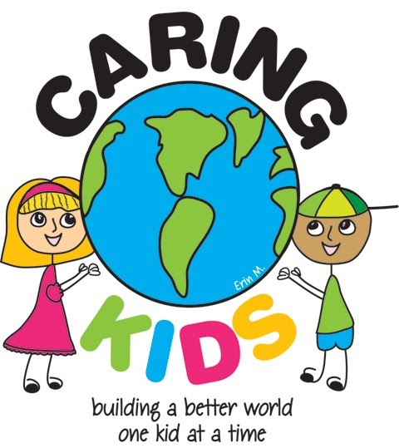
What should I do if I see someone being bullied?

- If it is safe, go up to the bully and tell them to STOP!
- Tell an adult
- Don’t act like nothing is happening – Take action!
- Be a good friend.

