
Spring Term Elmer, colour, shapes and patterns

Week 6 Little J’s Nursery PLANNING
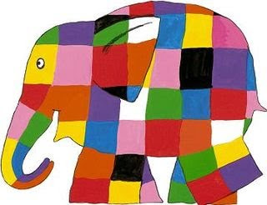
WEEK BEG MONDAY 08.02.2021
 | MONDAY | TUESDAY | WEDNESDAY | THURSDAY | FRIDAY
This is our second week of Elmer and colours, I’m sure that some of you are still working on the activities from last week however I have included lots more fun activities in this week’s plan.
Feel free to contact by either email or phone if you have any queries.

PSE | Develop their sense of responsibility and membership of a community.  Talk about their feelings using words like ‘happy’, ‘sad’ ,‘angry’ or ‘worried’.  Understand gradually how others might be feeling.  Activity: What makes you unique?  Draw a picture of your family and talk about similarities and differences. Do you all have the same colour hair or eyes? Who is the tallest or shortest? What is your favourite colour or song?  Share the story on YouTube  WE’RE DIFFERENT, WE’RE THE SAME Book Read Aloud - YouTube
Communication and  Language | Listen to simple stories and understand what is happening, with the help of the pictures.  Activity: Story ‘Elmer’s Parade’ Video link Read by Mrs Lane  Understand simple questions about ‘who’, ‘what’ and ‘where’ (but generally not ‘why’).  Activity: Look at the Ronald the Rhino poster (see attached) and use the questions attached to answer questions about what is seen in the picture.  Recognises and responds to many familiar sounds.  Activity: Actions to sounds e.g. when you hear the drum you need to jump, bells you clap your hands, shakers you stamp your feet. Watch the video link.
Physical Dev | Handwriting  Develop manipulation and control.  Activity: Handwriting-Hand control activity sheet –shapes enclosing circles drawing over the dotted lines, Left to right, top to bottom vertical and horizontal lines. etc.  Elmer to the Zebra mazes. (see attached link)  Fine motor skills, being imaginative: Making your own Elmer the elephant. Using an old, rinsed out milk carton, cut out an elephant shape (you might need a hand from an adult)  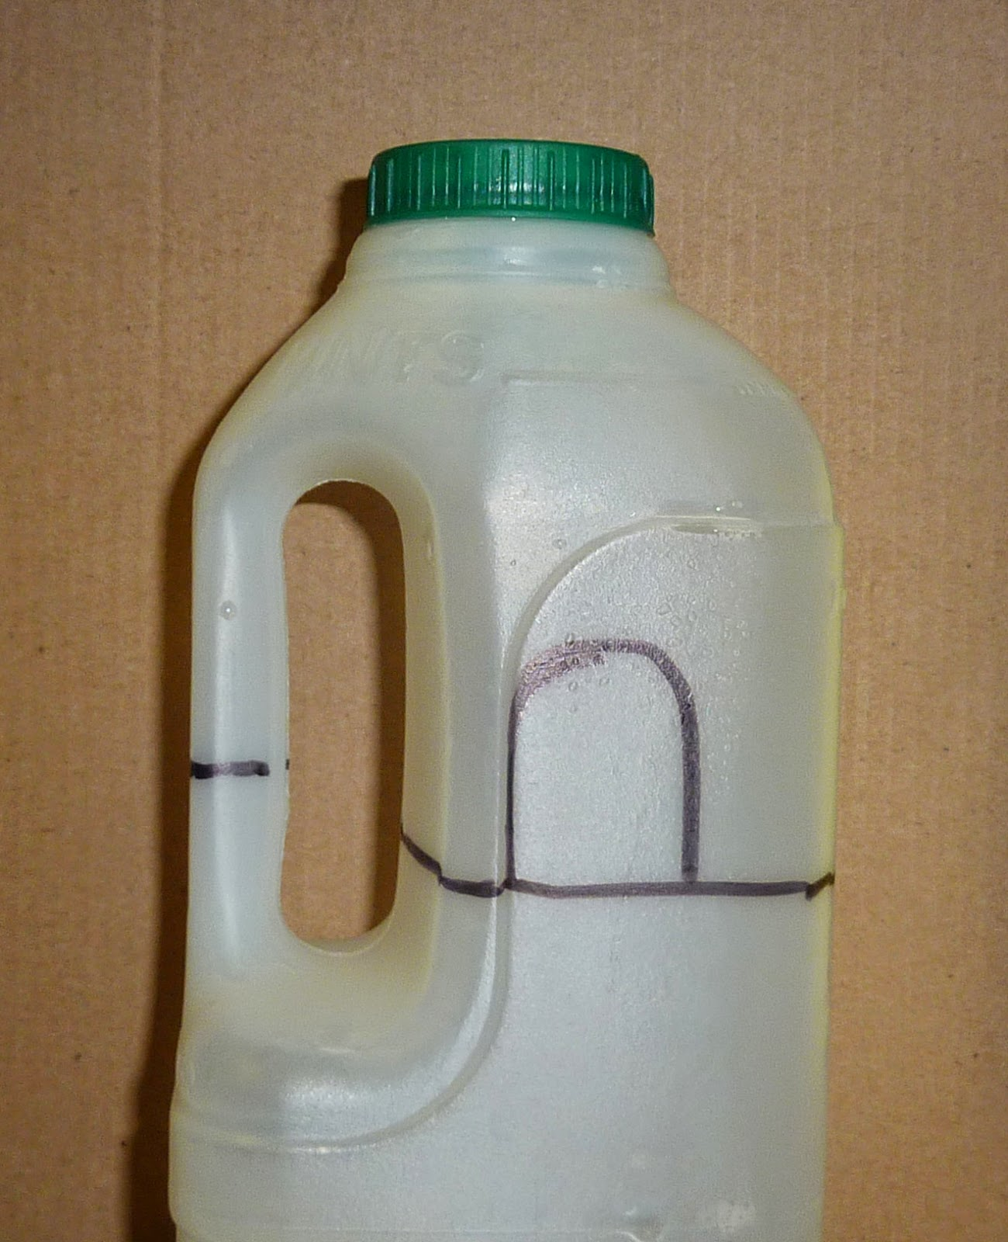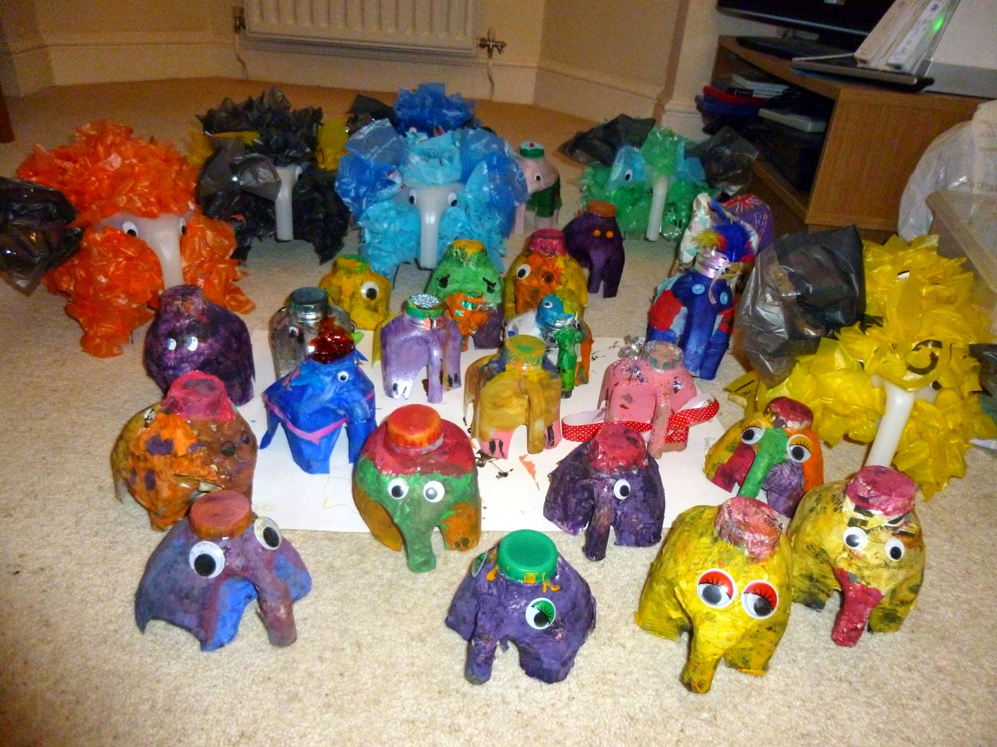  Use tissue paper or bright coloured paper, (you could recycle sweet wrappers, old wrapping paper, old comics you don’t want any more), to decorate your Elmer. Cut the paper into squares and glue it onto the milk carton elephant. You could make some more elephants and decorate them in a ‘real’ elephant colour. Use your elephant herd to retell the story of Elmer.  Continue to develop their movement, balancing, riding (scooters, trikes and bikes) and ball skills.  Activity: Throwing and catching games in the garden e.g. beanbags/ball in a bucket.  Can copy some letters from their name.  Use a comfortable grip with good control when holding pens and pencils.  Show a preference for a dominant hand.  Activity: Name writing – Use the Border paper attached
Literacy | Join in with songs and rhymes, copying sounds, rhythms, tunes and tempo.  Activity: Elmer songs  https://www.youtube.com/watch?v=sNCFFirFueQ  Notice some print, such as the first letter of their name, a bus or door number, or a familiar logo. Point out print in the environment and talk about what it means.  Activity: Suggestions: on a local walk, point out road signs, shop names and door numbers.  Develop their phonological awareness, so that they can: recognise words with the same initial sound, such as money and mother.  Activity: Last week you went on an initial sound hunt around your home finding objects that start with the sound ‘s’ This week can you find things that begin with ‘t’  How many things can you find? 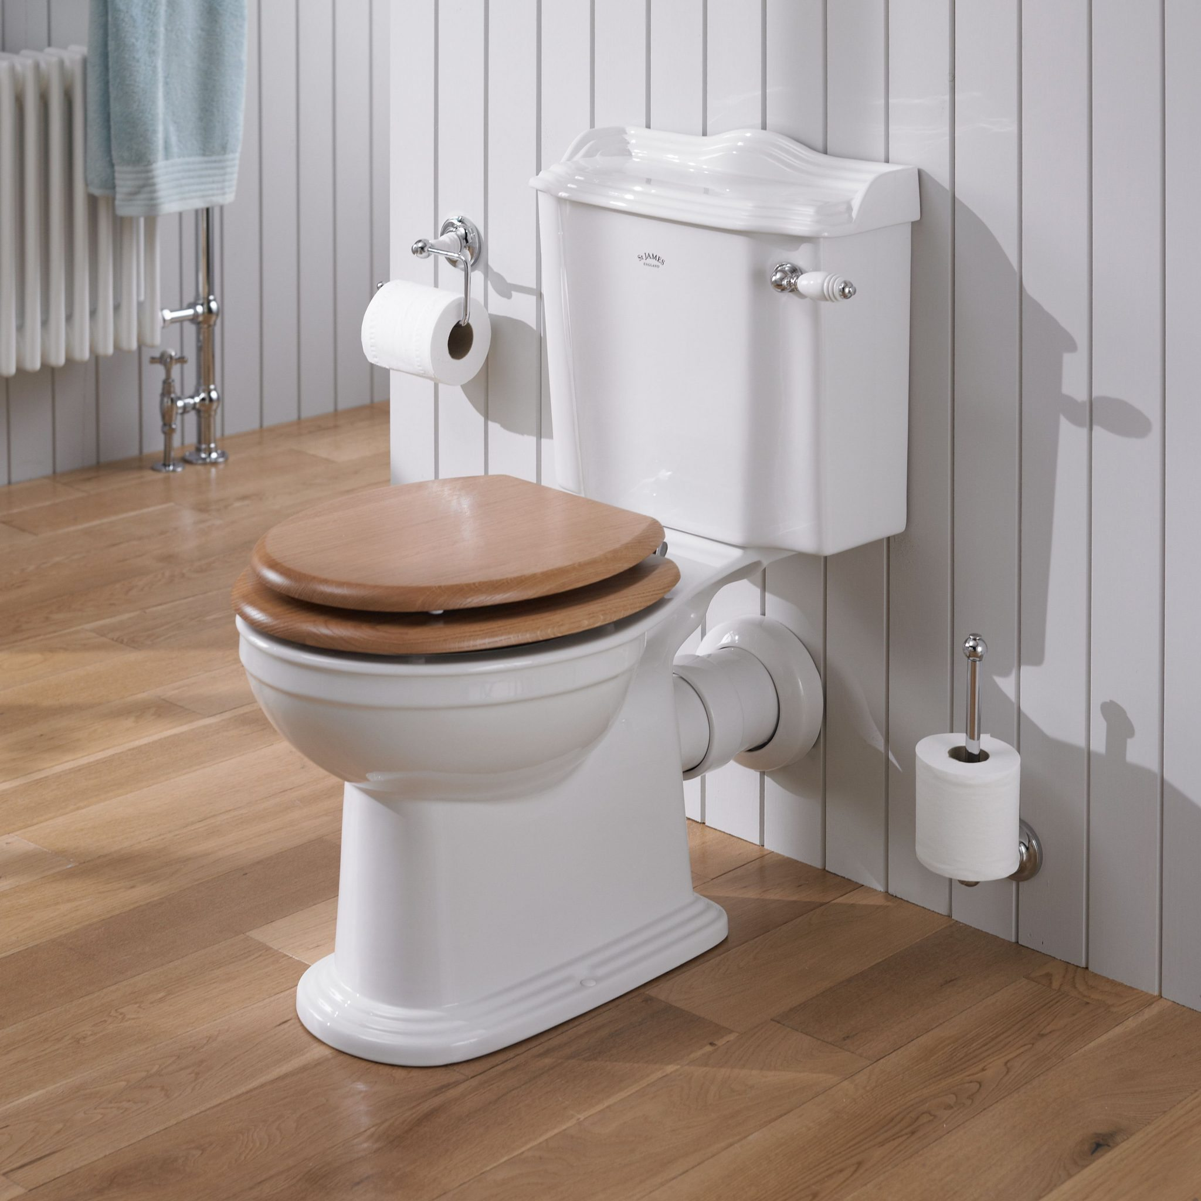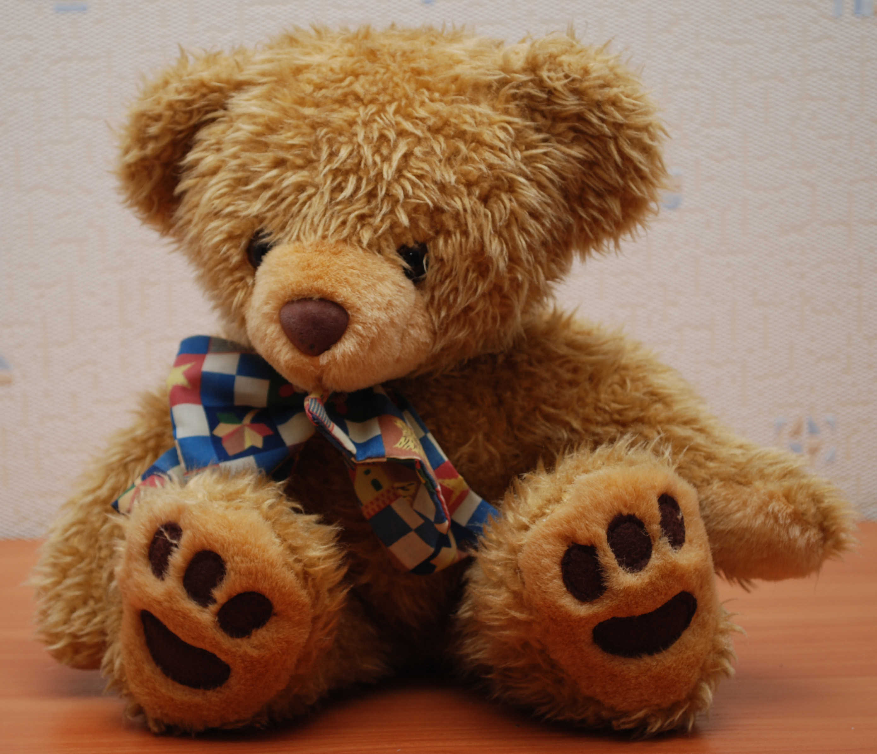
UTW | Understanding the world: Exploring colour mixing – You will need to gather some equipment together first.  - A low dish with milk.  - Liquid food colouring.  - Washing up liquid mixed with water.  - Cotton buds  Put some drops of food colouring, (blue, red and yellow) into the milk. Try to keep the colours apart from each other as you drop them in the milk.  Put the cotton buds into the washing up liquid mixture, swirl it around a little and then dip them in the milk, where the colour has been dropped in. Don’t swish the milk – just watch what happens when you hold it in. Repeat with a different cotton bud dipped in washing up liquid and explore what happens to the colours as they start to mix.  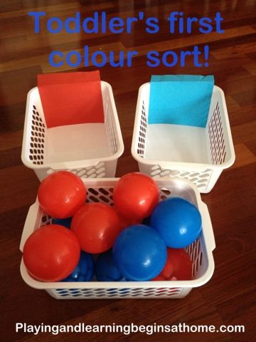  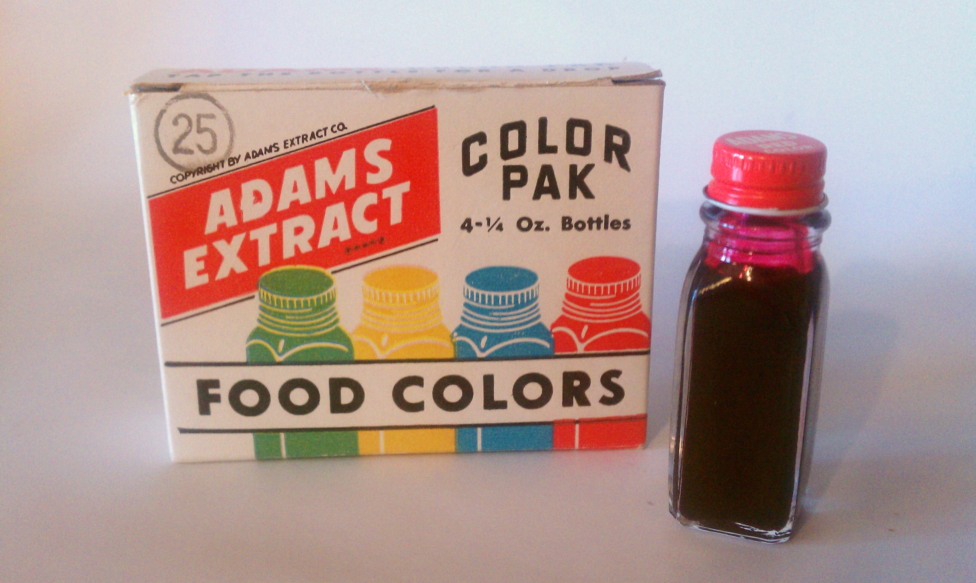
Mathematics | Sorting by colour – Gather together a selection of your toys – some bright and colourful ones –  and then sort them into piles by colour. How many red, blue, yellow and green ones do you have?  Maths, Shape, Space, Measure: Elephant Biscuits. Together with an adult, you could make some Elmer shaped biscuits. When cool, decorate them as brightly as you want, sprinkles, sugar coated buttons… You could share the biscuits with someone in your house when you sit and share a book, or watch the story of Elmer online. There is a version read by the author, David McKee, https://www.youtube.com/watch?v=ZFrD18XLmlM  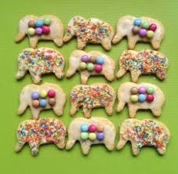  Collecting Data – Play a game with colours and a dice. Use the grid to record what you have thrown on the dice – which is the most thrown number? Each number needs a different colour:  1= blue, 2 = green, 3 = yellow, 4 = orange, 5 = red, 6 = purple. Take it in turns with a partner to throw the dice. Use the grid attached to record the numbers you throw. Colour in a square on the grid with the matching colour each time you throw that number. The game ends when you reach the top of one column.  Colours: Find a rainbow in your garden – When you go outside to get your fresh air this week spot colours around you. Could you collect or take pictures of objects you spot of different colours. Arrange them into a rainbow.  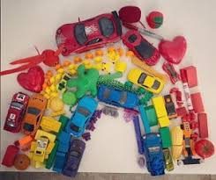
EA&D | Explores colour and how colours can be changed.  Activity: Make a shades wheel dark to light by mixing white to a chosen colour painting one section at a time adding a little white each time you paint a section.  (Watch the video attached to see Mrs Lane demonstrate.)    Explore colour and painting skills.  Activity: Paint or colour Elmer’s patchwork colours.  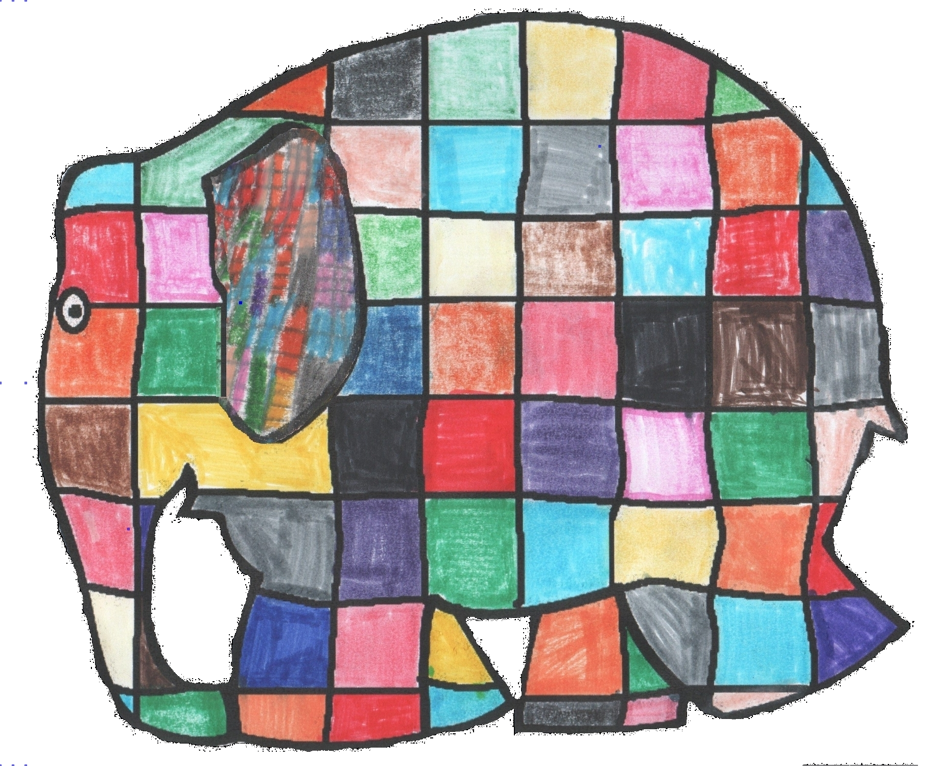  (See Attached Link)  Explores colour and how colours can be changed.  Activity: Do you know the colours that you find in a rainbow?  Listen to the song to learn the colours (Jack Hartmann) https://www.youtube.com/watch?v=9mruaPD xoEw  And now paint your own rainbow using the attached outline.  C:\Users\User\Downloads\Colour the rainbow activity sheet.pdf

LETTERS  and  SOUNDS  Phase  - & 2 | - Alphabet song https://www.youtube.com/watch?v=BELlZKpi1Zs  - White boards and pens- writing initial sounds ‘s’, ‘a’, ‘t’, ‘i’, ‘p’, ‘n’ correct formation.  - I spy with my little eye game Phase 1 Phonics I Spy Game (Initial Sounds Game) - YouTube  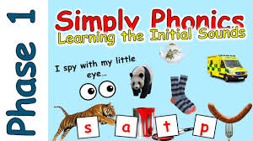  - Initial sound hunt – Find objects around your home that begin with the sound ’t’  - Sounds game Matching pairs of sounds. https://www.phonicsplay.co.uk/resources/phase/1



