 | Monday 8th | Tuesday 9th | Wednesday 10th | Thursday 11th | Friday 12th
Letters and sounds | Listen to:  https://www.youtube.com/watch?v=_s-1sxzjPX8&t=2s – Jolly Phonics Song  https://www.youtube.com/watch?v=e2dx65u59aw - Tricky Word Song  Activity –  Help the wizards learn the sound h  https://www.bbc.co.uk/bitesize/topics/zf2yf4j/articles/zvhvy9q | Listen to:  https://www.youtube.com/watch?v=_s-1sxzjPX8&t=2s Jolly Phonics Song  https://www.youtube.com/watch?v=e2dx65u59aw - Tricky Word Song  Activity –  Help the wizards learn the sound b  https://www.bbc.co.uk/bitesize/topics/zf2yf4j/articles/zbnb382 | Listen to:  https://www.youtube.com/watch?v=_s-1sxzjPX8&t=2s Jolly Phonics Song  https://www.youtube.com/watch?v=e2dx65u59aw - Tricky Word Song  Activity –  Help the wizards learn the sound f & ff  https://www.bbc.co.uk/bitesize/topics/zf2yf4j/articles/zrfrgwx | Listen to:  https://www.youtube.com/watch?v=_s-1sxzjPX8&t=2s Jolly Phonics Song  https://www.youtube.com/watch?v=e2dx65u59aw - Tricky Word Song  Activity –  Help the wizards learn the sound l & ll  https://www.bbc.co.uk/bitesize/topics/zf2yf4j/articles/z4v4cqt | Listen to:  https://www.youtube.com/watch?v=_s-1sxzjPX8&t=2s Jolly Phonics Song  https://www.youtube.com/watch?v=e2dx65u59aw - Tricky Word Song  Activity –  Help the wizards learn the sound s & ss  https://www.bbc.co.uk/bitesize/topics/zf2yf4j/articles/zkbk92p
Reading | Please try and read with your child as much as you can. With they reading to you or you can also read stories to them. You need to discuss the features of a book e.g. front cover, blurb, author, what they think the story is going to be about. While your reading a story stop at points and ask questions about what you have already read to check understanding and listening. Also ask children what they think might happen next.  We have recorded a video of us reading a story to the children. It will be on the website weekly for you to watch.  You can also use the following Oxford Owl website (https://www.oxfordowl.co.uk/for-home/find-a-book/library-page/) who are currently offering a free eBook Library for parents to use at home. Please click the join us tab at the top of the page to create a FREE account.  Listen to Miss Kiely and Miss Dibble read Doris the Loris
PE | Join Joe wicks Monday, Wednesday and Friday at 9am for Pe with Joe. You will find him on youtube the Body Coach TV. https://www.youtube.com/user/thebodycoach1

Overview | AM  Listening game with Miss Dibble and Miss Kiely!  You will need the Elmer picture cards ready to join in.  PM  The Rainforest (Part 1)  We will be going on an imaginative journey deep into the Brazilian Rainforest to meet some songbirds, eat some fruit and do a lot of musical learning along the way!  https://classroom.thenational.academy/lessons/the-rainforest-part-1-c8r6cc | AM  To identify key parts of the rainforest  In this set of lessons we learn about the Rainforest. We identify parts of the Rainforest and consider what makes it a good habitat for so many species. We end the lesson by creating a rainforest in a jar using natural objects. I wonder who will live in your rainforest.  https://classroom.thenational.academy/lessons/to-identify-key-parts-of-the-rainforest-74rk6r  PM  Join Andy in his Cbeebies Wild Rainforest workout! https://www.youtube.com/watch?v=67zBQyX3etY | AM  To identify different animals that live in the rainforest  In today’s lesson, we join Mrs Garrard to learn about the different animals that live in the rainforest. We learn about the four different layers of a rainforest and some of the different species of animals that make the rainforest their home. We think about why certain animals are most suited to different layers of the rainforest. Finally, we choose our favourite rainforest animal and make a mask. https://classroom.thenational.academy/lessons/to-identify-different-animals-that-live-in-the-rainforest-c9k62c  PM  The Rainforest (Part 2)  We will revisit the colourful rainforest and further explore our voices by improvising birdsongs, dance to some Brazilian drumming and make up some funky fruit rhythms. https://classroom.thenational.academy/lessons/the-rainforest-part-2-64wk8t | AM  Rainforest Animals  In today's lesson, we will be learning about the rainforest, and what types of animals live there. We will have a go at moving like these animals and try to remember all of the different ways that they move, with a fun rainforest spin the wheel activity at the end! The three key areas that this lesson links to are understanding the world, expressive arts and design, and physical development.  https://classroom.thenational.academy/lessons/rainforest-animals-71k64d  PM  The Rainforest (Part 3)  In our final trip to the rainforest, we will use our imagination to listen to the sounds of the rivers of the rainforest. we will strengthen our sense of pulse through a canoeing song and mix up another delicious fruit salad with your own ideas for rhythm patterns.  https://classroom.thenational.academy/lessons/the-rainforest-part-3-cgv3ae | AM  Listen to Miss Kiely and Miss Dibble read Noah’s ark.  PM  Join in with Stezzi the Parrot for some exciting yoga!  https://www.youtube.com/watch?v=LIBz0IdOFiQ

Creative activities | Design your own Rainforest animal. | Create a sponge painted Elmer!  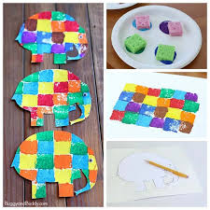 |  | Milk jug Elmer  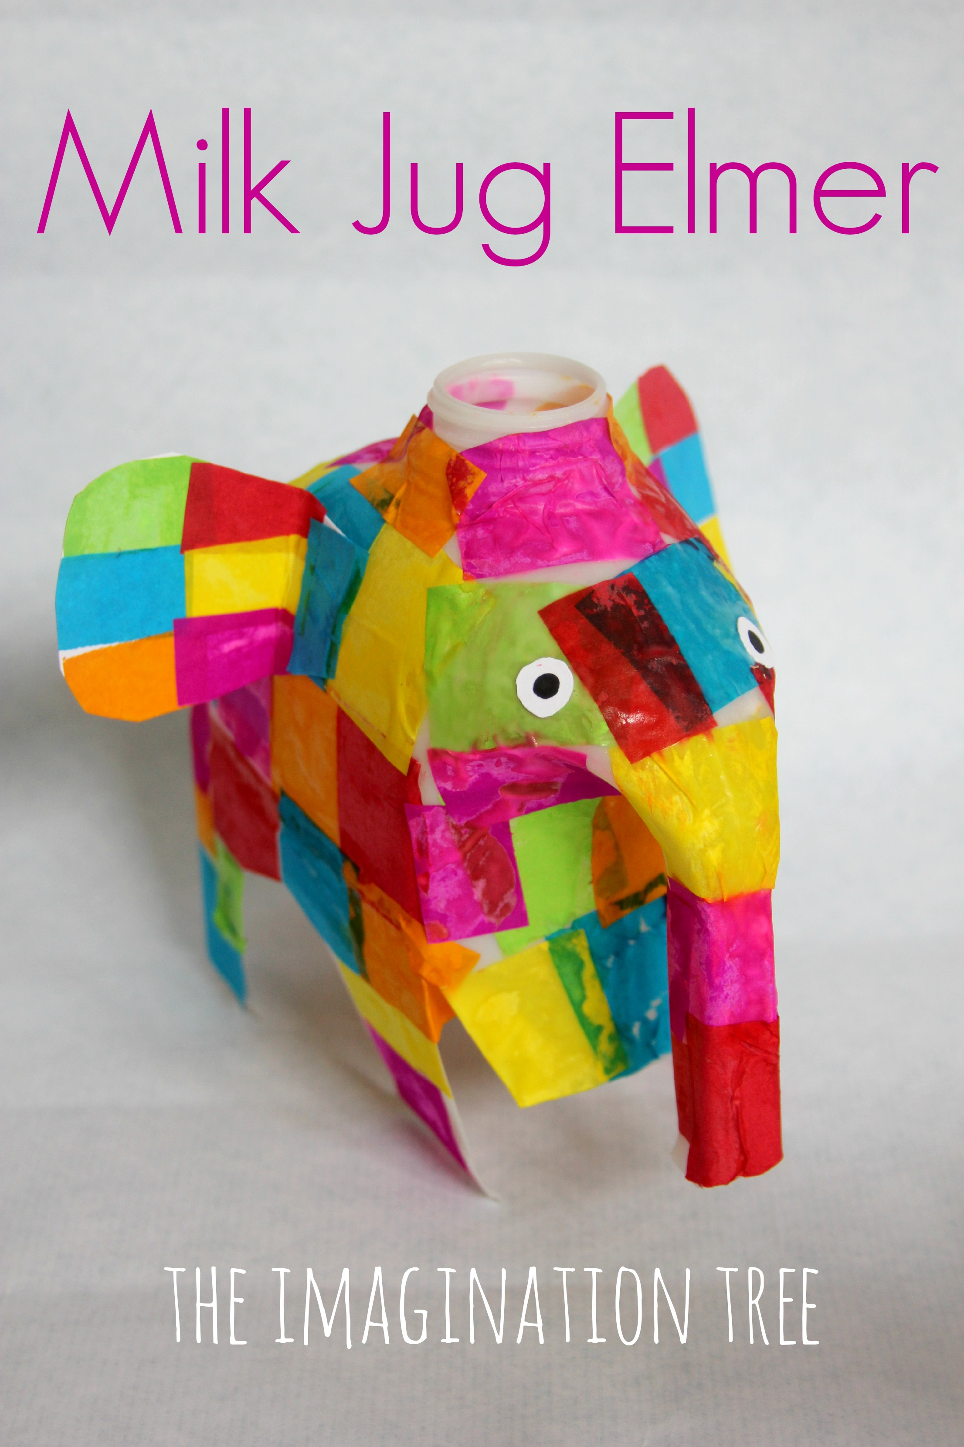 | Hand print Zebra or Giraffe  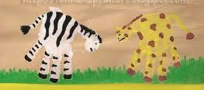 |  | Paint a Rainbow
Maths | Exploring and discussing time and the seasons  In this lesson children will explore time through the days of the week, months of the year and the seasons.https://classroom.thenational.academy/lessons/exploring-and-discussing-time-and-the-seasons-6mwp8c  Find the activity sheet that you will need for this lesson saved on our website or in your pack. | Exploring and discussing the days of the week and daily events  In this lesson children will explore the days of the week and the activities they may do on each day. https://classroom.thenational.academy/lessons/exploring-and-discussing-the-days-of-the-week-and-daily-events-6ngkgc Find the activity sheet that you will need for this lesson saved on our website or in your pack. |  | Using everyday language to talk about and sequence daily events  In this lesson children will talk about and sequence the events they may do in a day as well as tell a time story.  https://classroom.thenational.academy/lessons/using-everyday-language-to-talk-about-and-sequence-daily-events-60tkad  Find the activity sheet that you will need for this lesson saved on our website or in your pack. | Using ordinal language when sequencing events and measure short periods of time  In this lesson pupils will order events in nursery rhymes using ordinal language.  https://classroom.thenational.academy/lessons/using-ordinal-language-when-sequencing-events-and-measure-short-periods-of-time-6nh6at  Find the activity sheet that you will need for this lesson saved on our website or in your pack. |  | Consolidating learning  In this lesson children will consolidate their learning on time through reasoning questions.  https://classroom.thenational.academy/lessons/consolidating-learning-64rpct  Find the activity sheet that you will need for this lesson saved on our website or in your pack.
Literacy | To listen and join in with the Story of Mouse Deer  In this lesson, we will be introducing a new story with a new setting.  https://classroom.thenational.academy/lessons/to-listen-and-join-in-with-the-story-of-mouse-deer-6gvpad | To map the Story of Mouse Deer and explore the setting  In this lesson, we will be mapping the Story of Mouse Deer with a focus on setting.  https://classroom.thenational.academy/lessons/to-map-the-story-of-mouse-deer-and-explore-the-setting-6gu6ar | To step out the story of Mouse Deer and explore the setting  In this lesson, we will be stepping the story and developing the language to describe the setting.  https://classroom.thenational.academy/lessons/to-step-out-the-story-of-mouse-deer-and-explore-the-setting-6dhp2c |  | To join in with a choral telling of Mouse Deer  In this lesson, we will learn how to join in with a choral telling of a story.  https://classroom.thenational.academy/lessons/to-join-in-with-a-choral-telling-of-mouse-deer-74vket | To tell the story of Mouse Deer independently  In this lesson, we will be supporting pupils to tell the story independently.  https://classroom.thenational.academy/lessons/to-tell-the-story-of-mouse-deer-independently-6wt64t
Problem Solving | Story sequencing Elmer | Can you find…..?  Use the poster and instruction page. |  | What Am I?  Have a try at reading the cards if it is too tricky. See if your child can describe the picture to you without telling you what it is. | Jungle and Rainforest I spy.  Can you use counters/ pennies or an object to cover the animal you are counting to help you recognise you’ve counted it already. Then add them up at the end. |  | Can you list the animals that may have gone on the Ark? You can also try to draw them too!
Physical | Jungle Josh exercise  https://www.youtube.com/watch?v=tisHfZszJXI | Dough Dance Disco  Use your playdough from last week!  https://www.youtube.com/watch?v=o9D5lfqZF3o |  | Pencil Control activity  Make sure you take your time and concentrate! | Join in with the Jungle Safari Fitness challenge! https://www.youtube.com/watch?v=PxG0m15pgQw |  | Create a 3D Rainbow!
UTW | To understand the impact of cutting down trees on the rainforest  In this set of lessons we learn about the impact of climate change. In this lesson with Miss Hughes, we have an introduction to the changes happening to our planet and take a closer look at deforestation. We think of things we can do to help our planet and learn creative ways to recycle by creating art made of recycled paper at the end of the lesson.  https://classroom.thenational.academy/lessons/to-understand-the-impact-of-cutting-down-trees-on-the-rainforest-crt6at | To understand the issue of global warming on the polar habitat  In today's lesson, we join Miss Sidenius in learning about the impact of global warming on the polar habitat. We focus on the impact that this will have on the wildlife and carry out an ice experiment to demonstrate the changes occuring due to global warming.  https://classroom.thenational.academy/lessons/to-understand-the-issue-of-global-warming-on-the-polar-habitat-6rw64t |  | To understand what I can do about climate change  In today’s lesson, we join Mrs Garrard to explore the effects of climate change. We learn about some of the causes of climate change and think of changes that we can make to our behaviour in order to save our planet. Finally, we create a poster to promote caring for our planet.  https://classroom.thenational.academy/lessons/to-understand-what-i-can-do-about-climate-change-crv68d  https://classroom.thenational.academy/lessons/to-understand-what-i-can-do-about-climate-change-crv68d | Shaving Foam Rain clouds Experiments. Use the instructions to help you!  Use the prompt cards to ask and answer questions during the experiment. |  | Order Noah’s Ark story cards.  You may need a grown ups help to help you read them!

