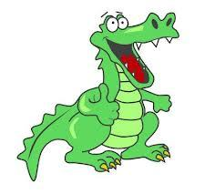
Week beginning 8.2.21 Weekly Timetable for Year 1 (1MW and 1GS)
We are trying to provide a wide range of activities, please do not feel like you have to do all of them.
Some fun extra activities to try at home:
Make a crocodile using a construction materials
Crocodile mindfulness colouring sheet (page 1)
Crocodile teeth scissor activity sheet.
Conversation ideas: What are you good at? Is there something you would like to learn to do? Which animal you would like to be?
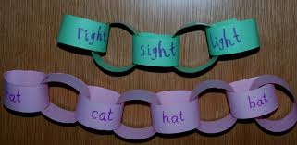
Make a paperchain containing rhyming words.

Challenge – How many rhyming words can you think of that rhyme with cat, dog, map, wall, tan and night?
Try going for a nature walk every day and see what you can see and hear.
We would love to see some photos of your child’s work, so please email them to us
vanessa.skinner@grahamjamesacademy.co.uk faye.gilmore@grahamjamesacademy.co.uk michelle.walker@grahamjamesacademy.co.uk
Take care and stay safe.
From the Year 1 Team

 | Letters and Sounds  20 mins | Reading time  10/15 mins | Maths Time  25 mins |  | Spellings  10 mins | English/Topic  30 mins | Other subjects or activities  25 mins
M | Phase 5 – today we are learning the sound ew (long oo sound) like in blew, chew, grew, screw, crew and flew.  Play roll and read game – you will need a dice – roll a dice and read the word that matches that number on the die – carry on until all, or most of the words have been read.  Phase 3 – recap the sounds ch and sh. Children could watch Geraldine on youtube or play games linked to that sound on phonics play.  Children to complete ch and sh worksheet. | Reading  This week we are providing a few simple year one reading comprehensions that go over all the reading skills (each reading skill has a different dog).  Children to complete - The Odd Coin reading sheet. | White rose maths  Counting to 50 by making 10’s.  Watch the white rose video using the link below.  https://vimeo.com/500465193  Practise counting to 50.  Practise grouping objects in tens (to 50).  Practise counting in tens to 50 – or to 100. |  | Spellings  This weeks spelling are:  Here  There  Ask  School  Friend  House  Children to read each word in turn then to spell each word – make sure you let them see the correct spellings so that today they can copy them! | English  This week we are looking at a poem and thinking about words that rhyme.  Read the poem ‘If you should meet a crocodile’  Can you hear the rhyming words?  Can you highlight or underline them in the text?  Discuss where they are in the poem ie at the end of every other line. | Yoga  Colonel Crockles the Crocodile | A Cosmic Kids Yoga Adventure!  https://www.youtube.com/watch?v=obzFP6eEGAg&list=PL8snGkhBF7nhEquR7wXbzIXjFrlXsze_H&index=13  Art  Make your own crocodile. Here are some ideas below.  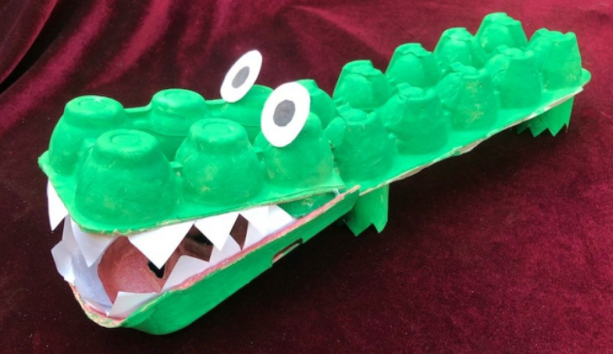  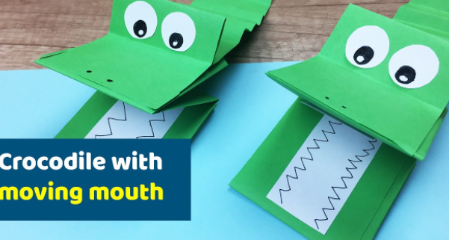  https://www.youtube.com/watch?app=desktop&v=LiH-27QeiGU
T | Phase 5 – today we are learning the sound ew (making the ‘you’ sound) like in stew, few, new, dew, pew, knew and nephew.  Use the phoneme spotter postcard to read, then find all the words with the ew sound in them. Children can then have a go at spelling some of the words they found.  Phase 3 – recap on the sound sh.  Children to complete the real and nonsense word sheet for the sound sh.  Challenge –  Children to write their own sentences using the real words on the back. | Reading  Find a story that rhymes e.g.  The Gruffalo  Each Peach Pear Plum  The Cat in the Hat  You may have the book at home or you can watch one of our videos. | White Rose Maths  Numbers to 50  Watch the below using the link:  https://vimeo.com/500466597  Then complete the activity sheet. |  | Spellings  Write each of your words in bubble writing.  ask | English  Discuss words that rhyme e.g. use the rhyming matching game cards or watch the following YouTube clip.  https://www.youtube.com/watch?v=RVophT8naUM  Then complete the cut and stick rhyming activity sheet. | Science  Lesson 4  Use Oak National Academy  Key Stage 1 – Science – Seasons and changes – How can you measure rainfall?  https://classroom.thenational.academy/lessons/how-can-you-measure-rainfall-cguk6d  Materials needed –  2 litre bottle  Black marker pen  Ruler  Sellotape
W | Phase 5  Today we are learning the sound ey (this sound normally goes at the end of a word) like in trolley, money, honey, donkey, key and turkey.  Watch Geraldine and practice reading the words.  Phase 3 – recap the sounds th and ng. Children could watch Geraldine on youtube or play games linked to that sound on phonics play.  Children to complete th and ng worksheet. | Reading  Children to complete – Pop To the Shops sheet. | White Rose maths  Count forwards and backwards within 50.  Follow the link below:  https://vimeo.com/500467345  Then complete the activity sheet. |  | Spellings  Practise spelling each word but using fancy writing when they write it.  there  ask | English  Continue working on words that rhyme, and then complete the writing rhyming words sheet where children have a word to start with and then have to think of 3 words that rhyme with it. | Art/Topic  How to draw a cartoon crocodile (alligator)  https://www.youtube.com/watch?v=2Z7-FTqXAXA  PSHE  Discuss different feelings/emotions with your child. Ask them to think about what makes them feel happy Children to complete - I am happy sheet.
Th | Phase 5 – children to practice reading the words from the previous day. Then complete the real and nonsense sheet for the sound ey.  Children to write the real words on the back.  Challenge – write your own sentences using the ey words.  Phase 3 – recap on the sound th.  Use the phoneme spotter story to read, then find all the words with the th sound in them. Children can then have a go at spelling some of the words they found. | Reading  Children to play this rhyming game:  https://education.abc.net.au/res/i/g.php?url=collection/rhymes/?animal=shark | White rose maths  Tens and ones  Watch the video using the link below  https://vimeo.com/500467998  Then complete the activity sheet. |  | Spellings  Create a word search using this week’s spellings. | English - Poetry  Discuss putting actions to the poem to turn it into a performance.  Go through the power point – ‘Performing a poem’ for ideas.  Then children to work with the crocodile poem and put their own actions to the key or important words. | Wellbeing time  YouTube – Meditation  Cosy Cats (Peace Out: Guided Meditation for Kids) | Cosmic Kids  https://www.youtube.com/watch?v=2TFuFd4iFOY  PSHE  Use Oak National Academy  Key Stage 1, RHE (PSHE)  Happy Families – lesson 4  https://classroom.thenational.academy/units/happy-families-3335  Letter formation power point – children to practice writing lower case letters.
F | Phase 5 - Practise any sound from the week – either spelling a word with each sound or play a game e.g. sentence substitution, rocket rescue, make a match and sentences – all on phonics play.  Phase 3- children to complete the roll and read sheet for the sound ng.  Play roll and read game – you will need a dice – roll a dice and read the word that matches that number on the die – carry on until all/or most of the words have been read.  Children to write their words on the back or use them in a sentence. | Reading  Read your favourite book to a family member or teddy.  Do you have a favourite rhyming book? | Maths  Practise writing numbers to 50.  Making sure the tens and ones are the correct way round.  Some children will also be able to write the numbers in words.  Games to play:  Top marks – paint the squares  https://www.topmarks.co.uk/learning-to-count/paint-the-squares  Topmarks – helicopter rescue  https://www.topmarks.co.uk/learning-to-count/helicopter-rescue |  | Spellings  Test your child on the spellings for the week!  Make it fun though as some of them are quite tricky. | Grammar and Punctuation lesson  From now on, we will have a lesson dedicated to grammar.  Children may need a little bit of help/reminding with some of the activities.  Please complete Grammar sheet page 3. | Music  Use Oak National Academy  Key Stage 1 – Music – Pulse – lesson 5- Maintaining pulse and finding the strong beats –  https://classroom.thenational.academy/units/pulse-769c

