If you should meet a crocodile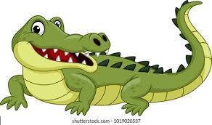
If you should meet a crocodile,
Don't take a stick and poke him;
Ignore the welcome in his smile,
Be careful not to stroke him.
For as he sleeps upon the Nile,
He thinner gets and thinner;
And whenever you meet a crocodile
He's ready for his dinner.

