11.02.21 LO: to learn how to use expanded noun phrases.
I have used an expanded noun phrase. | I have used commas correctly.
I have included the correct punctuation.  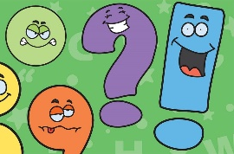 | I have formed my letters correctly.  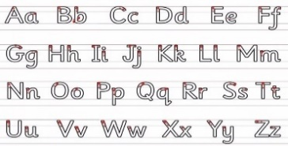
Challenge- I can underline all of the expanded noun phrases I have used (at least 5).
Greater depth – I have started to join some of my writing correctly.
Words of the week – exquisite bewildered magnificent
The Mixed Up Kitpupraffe
On a smooth, silky towel sat a tatty, bewildered kitpupraffe. It wondered how it should spend this delightful, happy day. The sun was shining gloriously and although it was chilly, it was a bright, wonderful morning. Part of the animal wanted to play with some long, curly string. Another part of the animal wanted to go on an energetic, muddy walk. The final part of the animal longed to reach up high to eat the crisp, green leaves from the trees.
But it realised it could not do all of these things at once and it must decide which to do first. It was so confusing being a mixed-up animal. Kitpupraffe wished she was a normal, happy animal.
However, just as she began feeling sad, a cheeky, magnificent monkey came swinging along. Kitpupraffe wished she was a clever, mischievous monkey who could go on adventures. Next came a beautiful, fluffy rabbit hopping along. Kitpupraffe wished she was a cute, energetic rabbit. Then there came an exquisite, colourful peacock. Kitpupraffe wished she was a gorgeous, pristine peacock.
The kind, fun animals gathered around kitpupraffe and told her to listen carefully. They explained how every animal and living thing in the world is different but unique. Nobody is the same but this is what makes us special. They told her that you need to be proud of who you are and to focus on the positives. The peacock was excellent at flying but could not hop like the rabbit or swing like the monkey. The rabbit was fantastic at hopping but could not fly like the peacock or swing like the monkey. The monkey was amazing at swinging from trees but could not hop like the rabbit or fly like the peacock.
Kitpupraffe learned an important lesson that day and only wished to be herself. She was no longer a miserable, confused mixed up animal and was now a proud, cheerful animal who was excited to spend the day doing all things kitten, puppy and giraffe like!

