12.2.2021- L.O. to interpret and construct a simple tally chart.
I can draw the correct tally marks for a number. | I can count in 5s to work out a tally amount.
I can work out the difference in a tally chart. | I can construct a tally chart using problem solving skills.
Draw the correct tally marks to go with these numbers:

8

17

25
TRY THIS:
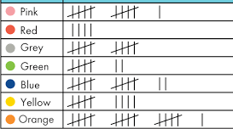
Write the correct number next to each row in the tally chart:
11
4
10
7
12
9
16

CHALLENGE
Use the tally chart above to answer these questions

- Which colour was the least popular? red
- Which colour was the most popular? orange
- How many more children chose orange compared to grey? 6
- Which colour was 2 less popular than yellow? green
- Which colour was 3x as popular as red? blue
Greater Depth
Complete a tally chart using this information:
Favourite chocolate 3 choices – milk, white, dark
Total number of children = 30

Milk |  | 16
White |  | 8
Dark |  | 6
Milk = the most children chose, double the amount of children who chose white

White = half the number of milk

Dark = 2 less than white

