12.2.2021- L.O. to interpret and construct a simple tally chart.
I can draw the correct tally marks for a number. | I can count in 5s to work out a tally amount.
I can work out the difference in a tally chart. | I can construct a tally chart using problem solving skills.
Draw the correct tally marks to go with these numbers:

8

17

25
TRY THIS:
Write the correct number next to each row in the tally chart:
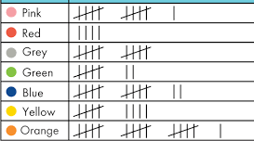
CHALLENGE
Use the tally chart above to answer these questions

- Which colour was the least popular?
- Which colour was the most popular?
- How many more children chose orange compared to grey?
- Which colour was 2 less popular than yellow?
- Which colour was 3x as popular as red?
Greater Depth
Complete a tally chart using this information:
Favourite chocolate 3 choices – milk, white, dark
Total number of children = 30

Milk = the most children chose, double the amount of children who chose white

White = half the number of milk

Dark = 2 less than white

