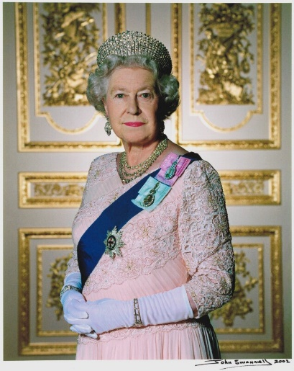
Week beginning 1.2.21 Weekly Timetable for Year 1 (1MW and 1GS)
We are trying to provide a wide range of activities, please do not feel like you have to do all of them.
Some fun extra activities to try at home:
How to make a crown – Art for kids hub on YouTube
Use some different construction materials to create your own palace/castle
Dress up as a king or queen for the day
Make a split pin Grenadier Guard
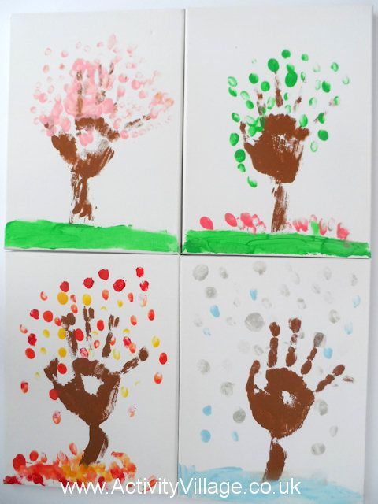
Science lesson – Your child might like to make a picture to show how trees change across the seasons.
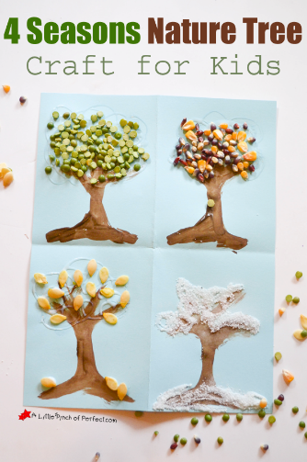

Try going for a nature walk every day and see what you can see and hear.
We would love to see some photos of your child’s work, so please email them to us
vanessa.skinner@grahamjamesacademy.co.uk faye.gilmore@grahamjamesacademy.co.uk michelle.walker@grahamjamesacademy.co.uk
Take care and stay safe.
From the Year 1 Team

 | Letters and Sounds  20 mins | Reading time  10/15 mins | Maths Time  25 mins |  | Spellings  10 mins | English/Topic  30 mins | Other subjects or activities  25 mins
M | Phase 5 – today we are learning that wh makes a w sound as in wheel, what, whistle, whisper and when.  Play roll and read game – you will need a dice – roll a dice and read the word that matches that number on the die – carry on until all,or most of the words have been read.  Phase 3 – ear sound as in year, fear, tear, near, hear, gear and beard.  Watch Geraldine Giraffe focus ear sound – then practise reading some of the ear words above. | Reading We are looking at Predicting Pip this week in reading.  Take a look at the front cover of the story: Marvin wanted more.  Look for the front cover on Google. Ask your child to predict what they think the story is about. They can watch/listen to it after - https://www.youtube.com/watch?v=kksMTGh11e8 | Maths  White Rose Home Learning – Spring week 4 – Related facts addition and subtraction (lesson 3).  https://whiterosemaths.com/homelearning/year-1/spring-week-4-number-addition-and-subtraction-within-20/  Sheet – white rose related facts sheet. |  | Spellings  This weeks spelling are:  friend  of  here  no  put  go  Children to read each word in turn then to spell each word – make sure you let them see the correct spellings so that today they can copy them! | History/English  This week we will be learning about Queen Elizabeth II. Go through the power point about Queen Elizabeth II (twinkl) with your child and discuss what they have found out.  Dictate these sentences for your child to write:  The Queen has nine thrones.  The Queen has four children.  Corgis are her favourite dog.  Children will need some help with the spellings.  Children should say the sentence aloud first then write it and read it after to check it makes sense.  ** Please make sure children have a capital letter for the start of a sentence and a name, they need to use finger spaces and end with a full stop. | Yoga  Cosmic Kids Yoga on YouTube  Kids Yoga All About Rockets! Yoga Club week 23  https://www.youtube.com/watch?v=8cLWrEOxWHc  Letter formation power point – children to practice writing lower case letters.  Or you could use:  https://www.ictgames.com/mobilePage/skyWriter/index.htmln  https://www.doorwayonline.org.uk/activities/letterformation/
T | Phase 5 – wh making a h sound like in who, whose, whole and whoever.  Watch Geraldine Giraffe wh sound.  Then play phonics play game – with phase 5 wh sound (this goes over wh making w and h sounds).  Phase 3 – working on the air sound as in – air, fair, hair lair and pair.  Then complete the air real and nonsense word activity sheet. | Reading  Superheroes reading sheet.  Children to complete the different questions on the sheet. | White Rose Maths  Greater and less than symbols to compare numbers  e.g.  14 > 3  4 < 10  Listen to song on YouTube  https://www.youtube.com/watch?v=M6Efzu2slaI  Sheet – greater than, less than and equal to sheet - from Twinkl. |  | Spellings  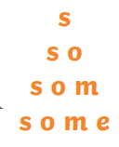  Write each of your words like a pyramid: | English  Read the fact sheet about Buckingham Palace (page 21 London Landmarks information).  Children to write a fact about Buckingham Palace e.g.  Buckingham Palace has 240 bedrooms and 80 bathrooms.  It has a swimming pool.  It has a cinema.  ** Please make sure children have a capital letter for the start of a sentence and a name, they need to use finger spaces and end with a full stop. | Science  Weather and seasonal change.  Use Oak National Academy and work through -  Key stage 1 - Science – seasons and change – what do we know about the weather? Lesson 3 – How do trees change across the seasons.  https://classroom.thenational.academy/lessons/how-do-trees-change-across-the-seasons-chhk2r  Number formation power point – children to practice writing numbers 0-10.
W | Phase 5 – oe as in toe, Joe, doe, foe, goes and tomatoes.  Use the phoneme spotter postcard to read, then find all the words with the oe sound in them. Children can then have a go at spelling some of the words they found.  Phase 3 – today the children are learning the ure sound, this is quite a tricky sound.  Ure as in pure, cure, secure, lure, mature.  Play game on phonics play with phase 3 ure sound. | Reading  Children to look at the snowman sequencing sheet and make a prediction on what might happen next.  Children to draw their idea in the box. | Maths  White Rose Home Learning – Spring week 4 – Compare number sentences – lesson 4.  https://whiterosemaths.com/homelearning/year-1/spring-week-4-number-addition-and-subtraction-within-20/  e.g. 4 + 2 is greater than 1 + 1, because 4 add 2 makes 6 and 1 add 1 makes 2.  6 > 2  Sheet – compare number sentences sheet. |  | Spellings  Write each of your words using dots. Then, join the dots with a coloured pencil to make your word. | English  Children to write what they would do if they were king/queen for the day (crown boarder sheet provided).  e.g. If I were Queen for the day I would try on all my fancy clothes and jewels.  If I were King for the day I would ride my horses and sit on my throne.  ** Please make sure children have a capital letter for the start of a sentence and a name, they need to use finger spaces and end with a full stop. | Art/Topic  ART –  How to draw a crown emoji  https://www.youtube.com/watch?v=Z2y1HELaytc  Art for kids hub – Youtube  Letter formation power point – children to practice writing upper case letters.  PSHE  This week is Children’s Mental Health Week.  Children to complete - I am amazing sun sheet.  You could use this an an opportunity to discuss how your child is feeling. Talk about what things we can try to make us feel better is we are feeling a bit sad (or if someone else is). Make a nice hot chocolate, watch a nice film (Inside Out goes over different feelings and emotions). Play a nice game or cuddle up and have a story.  YouTube also has lots of children’s meditation exercises – these are really nice for calming down time.
T | Phase 5 – continue working on the oe sound from yesterday.  Dictate a sentence for children to write e.g. A boy called Joe hurt his toe.  Challenge – children to think of their own sentence with one of the oe words.  Phase 3 – go over the sounds of the week and then complete the sheet with ear, air and ure. | Reading  Reading Comprehension  Dogs  Please help your child if they need any help reading the text.  You could read it to them first or ask them to read parts/words with you. | Maths  Addition and subtraction  Go through the power point if you are able to and solve the problems as you go.  or  There are also a few activity sheets involving addition and subtraction as well, and a code breaker challenge! |  | Spellings  Write each of your words across then down, sharing the first letter.  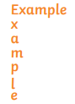 | English/DT  Children to design/draw a crown and use adjectives (describing words) to write a sentence about it e.g.  My crown is beautiful and sparkly.  It has purple gems and it is made of gold.  ** Please make sure children have a capital letter for the start of a sentence and a name, they need to use finger spaces and end with a full stop. | Wellbeing time  YouTube  Cosmic kids zen den – mindfulness  The bye bye boat  https://www.youtube.com/watch?v=A0kaS7jny_I  PSHE  Use Oak National Academy  Key Stage 1, RHE (PSHE)  Happy Families – lesson 3 – my special circles.  https://classroom.thenational.academy/units/happy-families-3335  Letter formation power point – children to practice writing lower case letters.
F | Practise any sound from the week – either spelling a word with each sound or play a game e.g. sentence substitution, rocket rescue, make a match and sentences – all on phonics play. | Reading  Watch a short movie/tv program and ask your child to predict what they think will happen at the end. | Maths Game Day  Complete some or all of the games:  Numbots  Topmarks website – hit the button game  Topmarks – robot addition  Topmarks – the daily 10 (within this game you can choose different maths concepts).  Ict games .com – save the whale – number bonds game  Ict games .com – twilight take away |  | Spellings  Test your child on the spellings for the week!  Make it fun though as some of them are quite tricky. | Grammar and Punctuation lesson  From now on, we will have a lesson dedicated to grammar.  Children may need a little bit of help/reminding with some of the activities.  Please complete Grammar sheet page 1. | Music  Use Oak National Academy  Key Stage 1 – Music – Pulse – lesson 4 - Physicalising pulse in different ways  https://classroom.thenational.academy/units/pulse-769c  Handwriting  Children to fill the crown picture with handwriting patterns. The children are very good at this  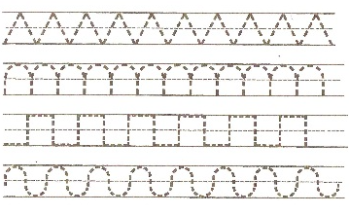

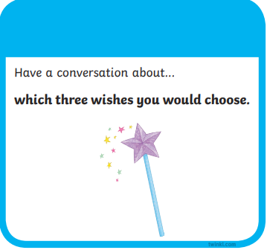
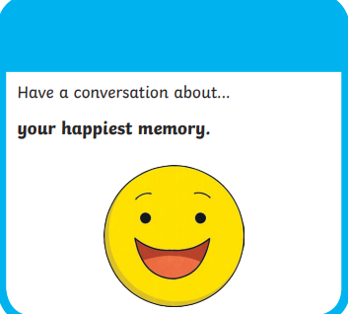
Conversation ideas:
