04.02.21 LO: to write about real things and make revisions to my work.
I have written facts about dinosaurs.  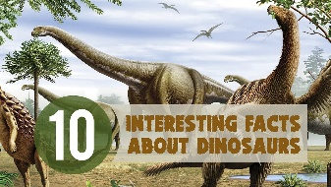 | I have made at least one revision to my writing.
I have included the correct punctuation. | I have formed my letters correctly.  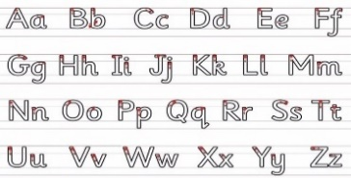
Challenge- I have written consistently in the past tense.
Greater depth – I have started to join some of my writing correctly.
Words of the week – extinct fierce evolved

