

**Dinosaurs**

­­

**All about dinosaurs…**

**Dinosaurs lived…**

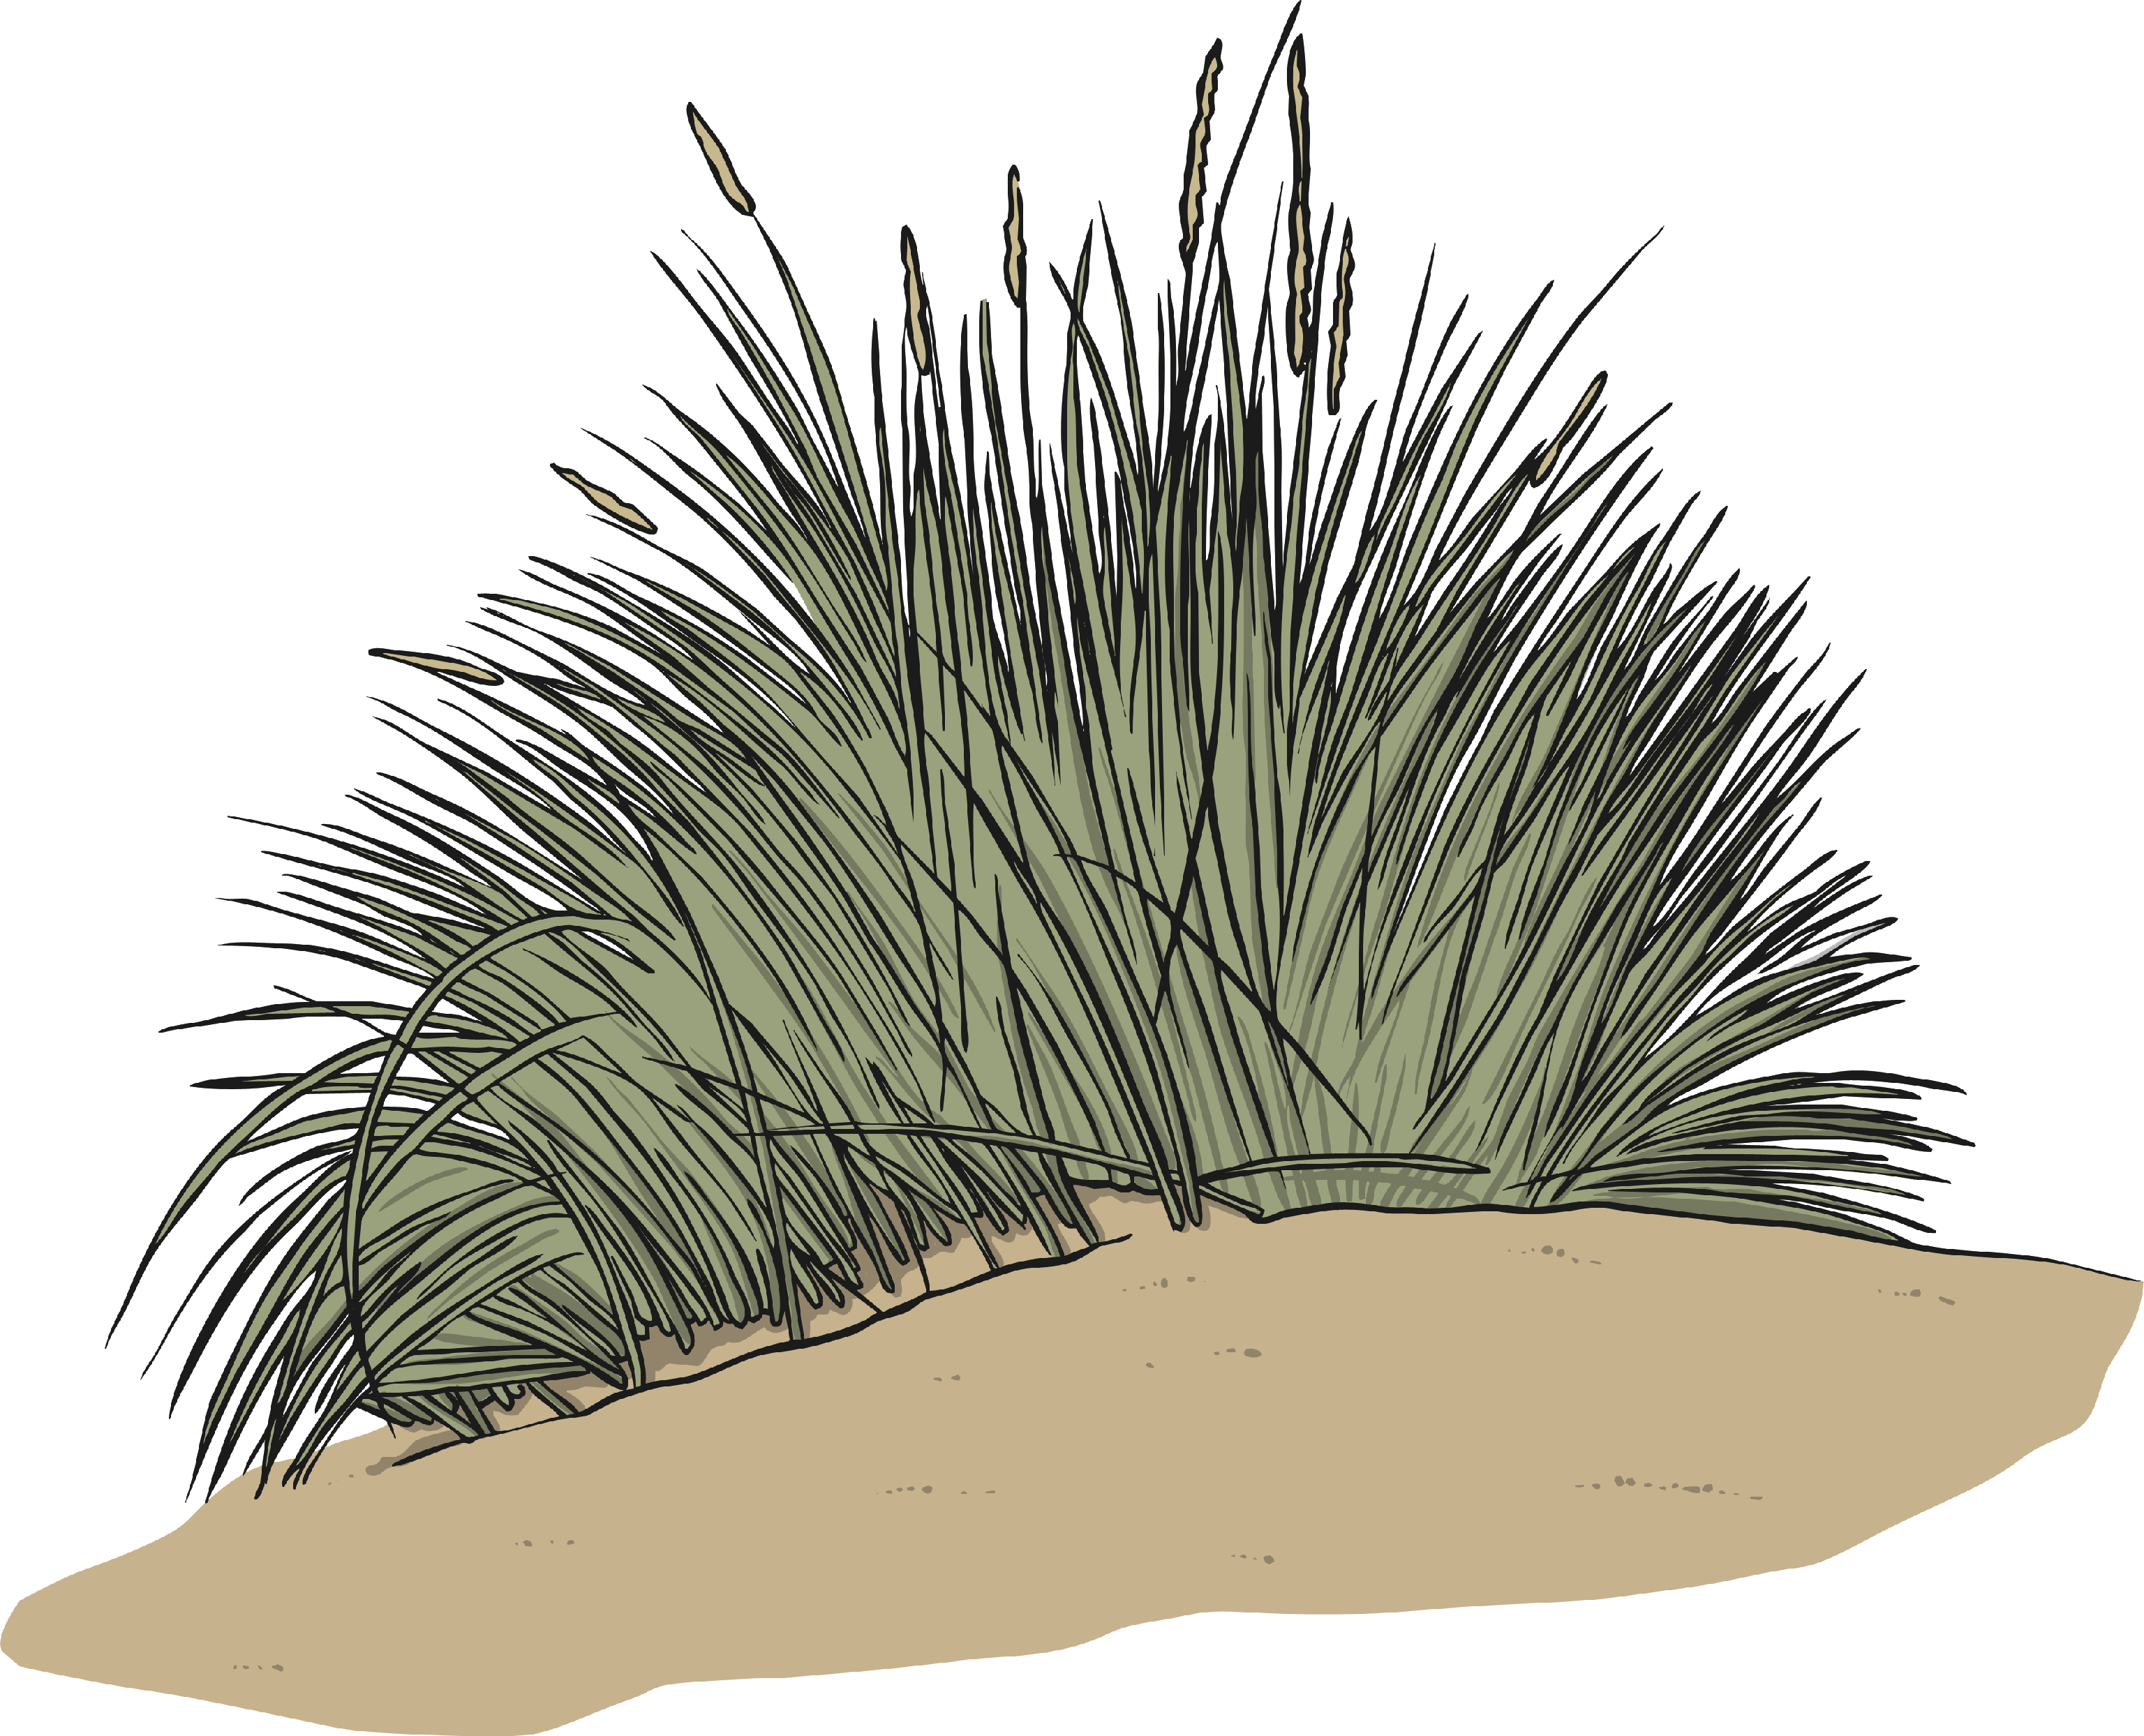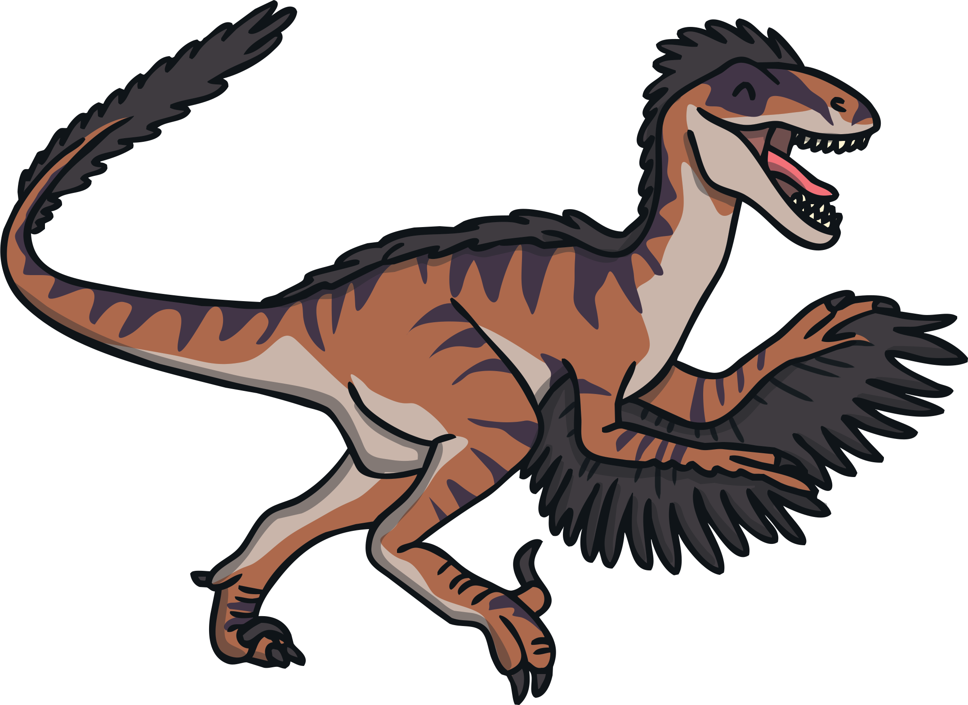



**Dinosaurs**

­­

**Carnivores…**

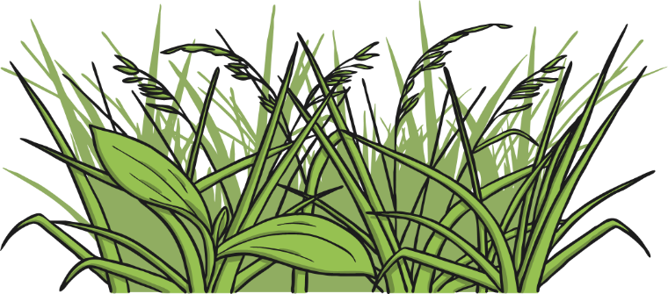

**Dinosaur diets…**

**Herbivores…**

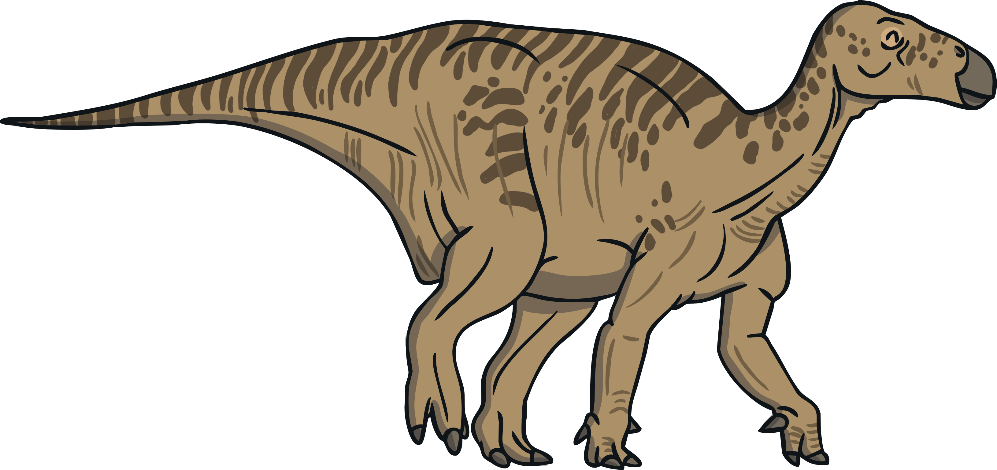



**Dinosaurs**

**Tyrannosaurus Rex**

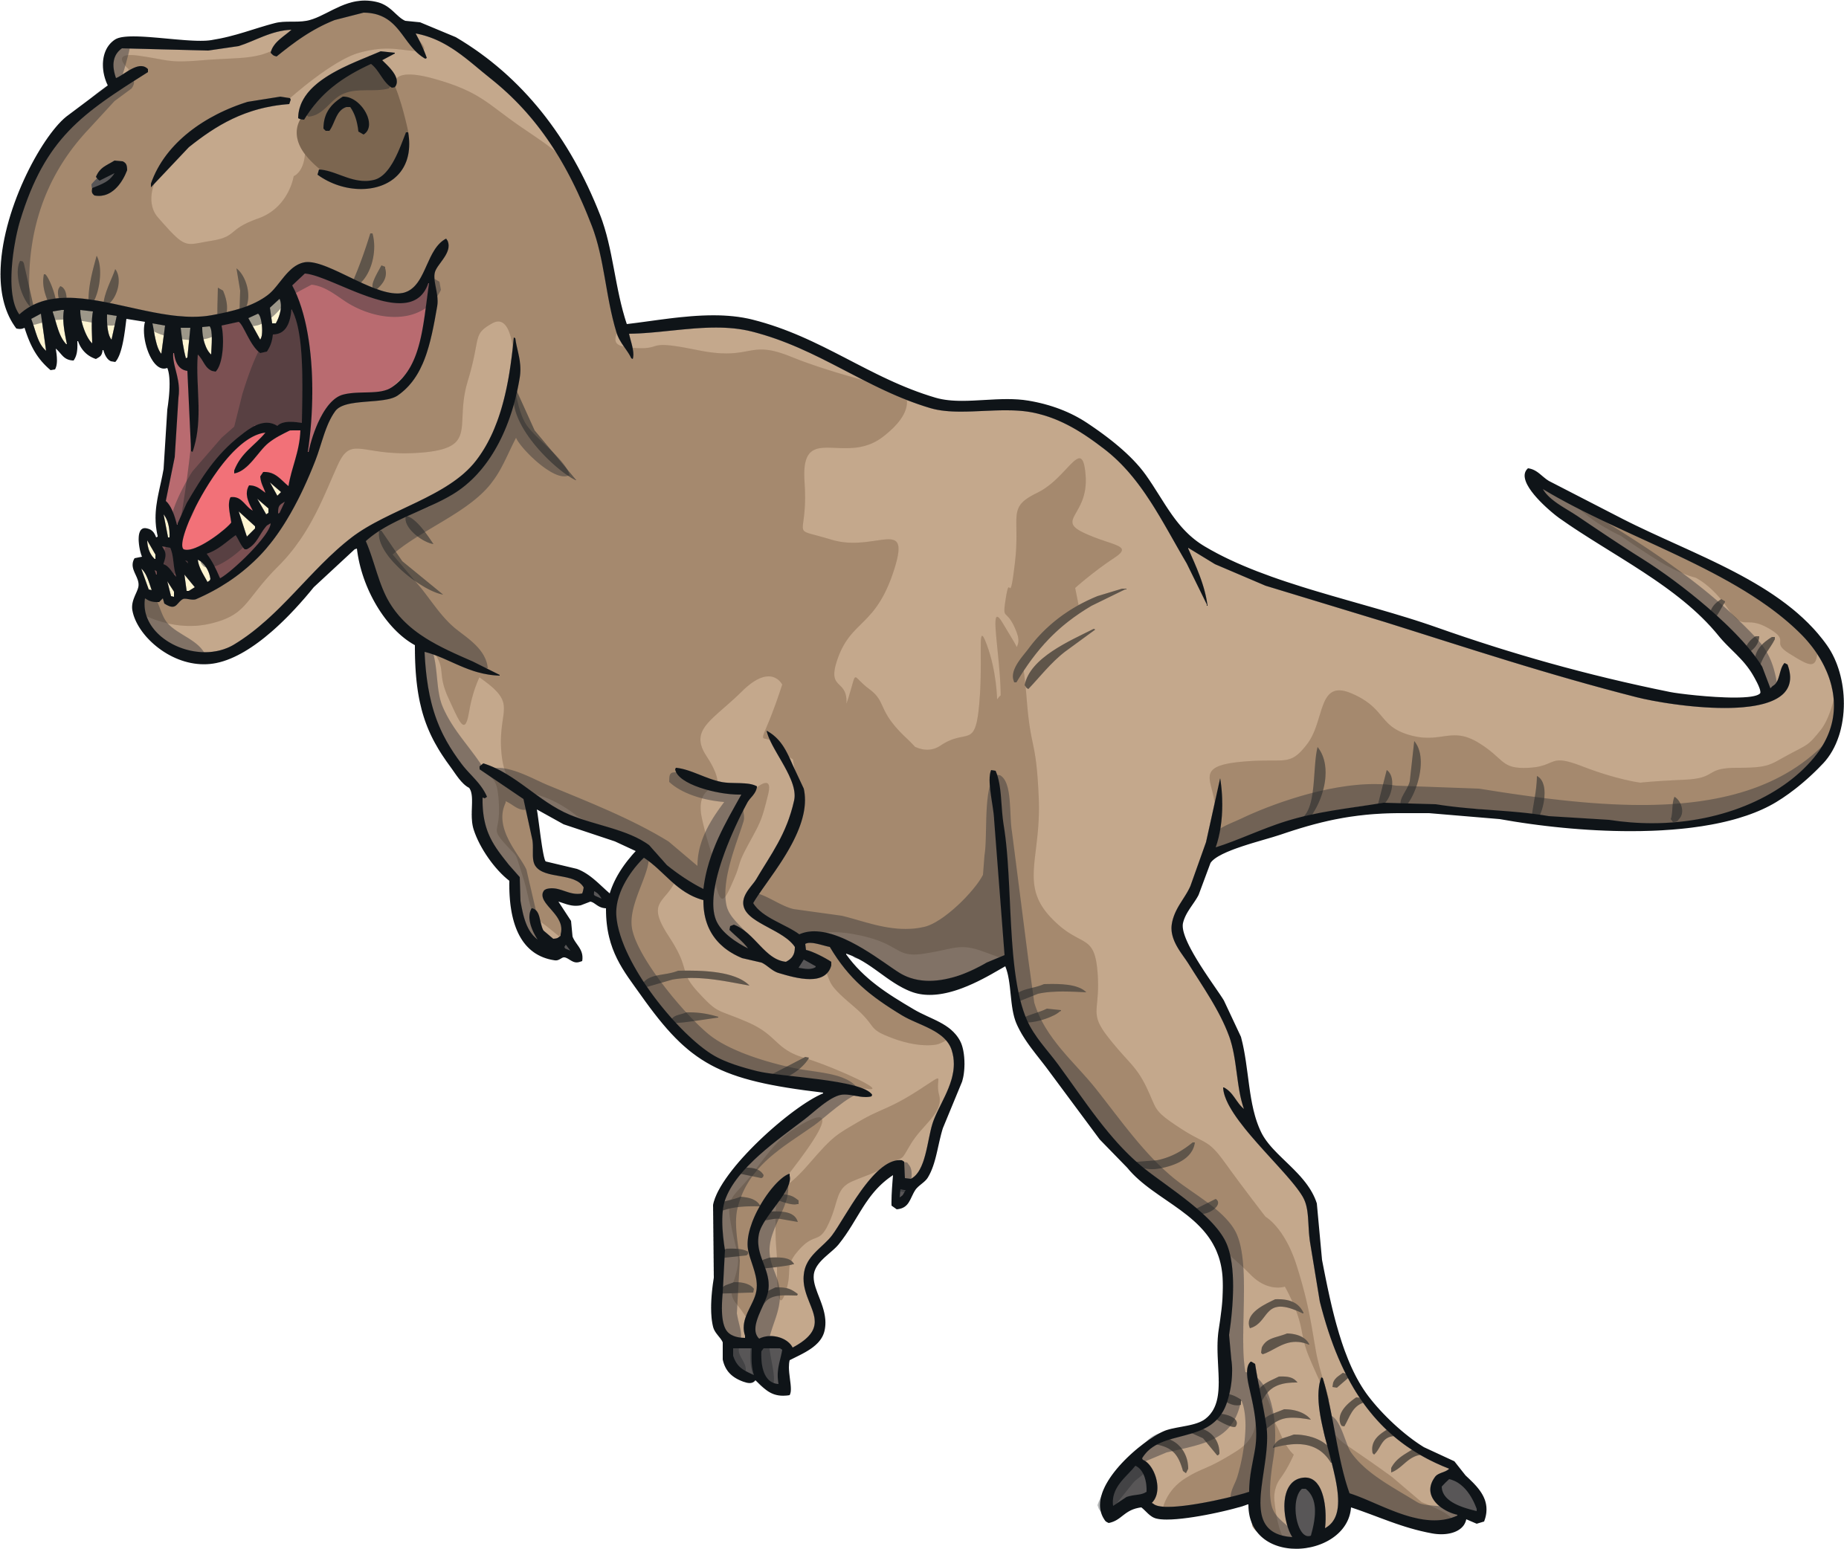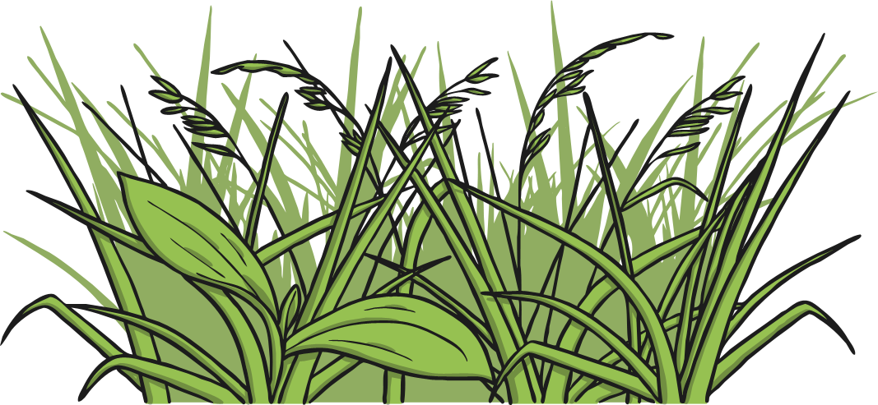

**Types of dinosaurs…**