Wednesday 3rd February 2020
LO: To generate points to use in our persuasive letter.

Why is school uniform a good thing?

Now choose the two points from your list that you think are the most persuasive and write some explanations and evidence. Remember you could talk to your family for ideas.

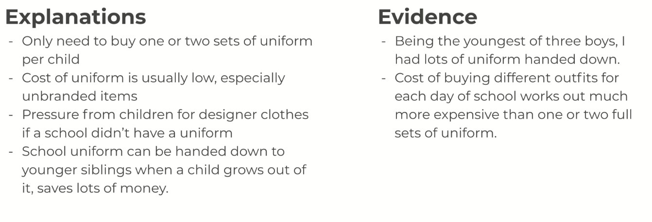
Example:

Point 1:
________________________________________________________________
Explanations:
________________________________________________________________________________________________________________________________________________________________________________________________________________________________________________________________________________________________________________________________________________________________

Evidence:
________________________________________________________________________________________________________________________________________________________________________________________________

Point 2:
________________________________________________________________
Explanations:
________________________________________________________________________________________________________________________________________________________________________________________________________________________________________________________________________________________________________________________________________________________________

Evidence:
________________________________________________________________________________________________________________________________________________________________________________________________

