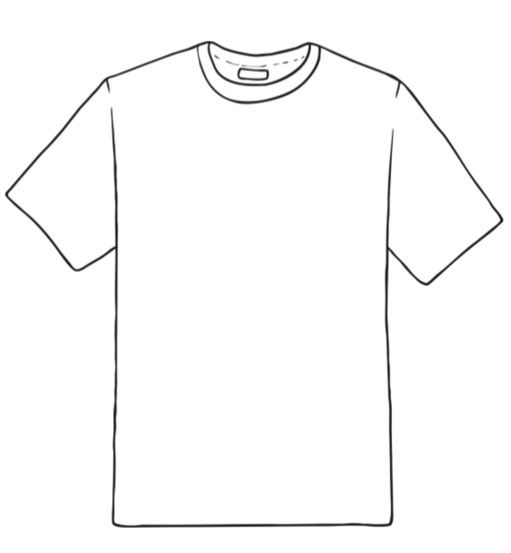
Use this template to create a t-shirt design that represents you

