Friday 5th February 2021
LO: To plan a persuasive letter.

Warm up task:
Can you justify your opinion using the conjunction ‘because’? Using one or more of the following topics, can you persuade me?
e.g. I think homework should be banned because it will give families more time to do things together.
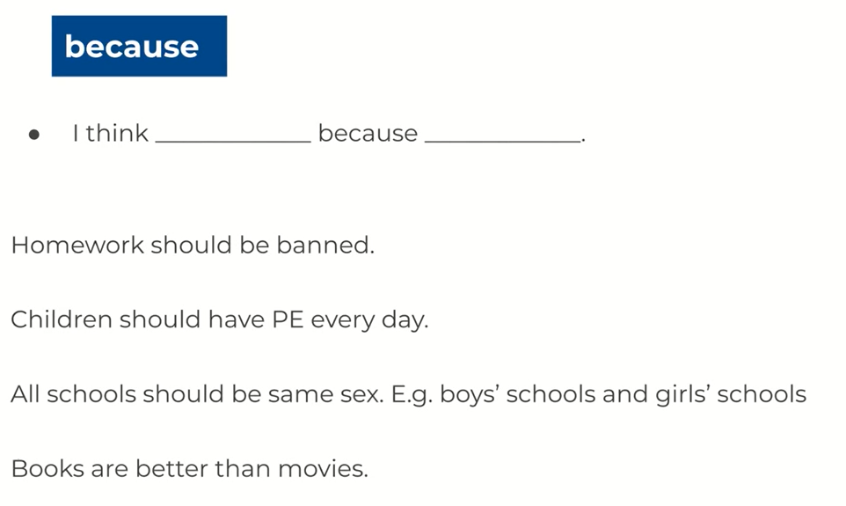
______________________________________________________________________________________________________________________________________________________________________________________________________________________________________________________________________________________________________________________________________________________________
Structuring your argument:

P.E.P.S.
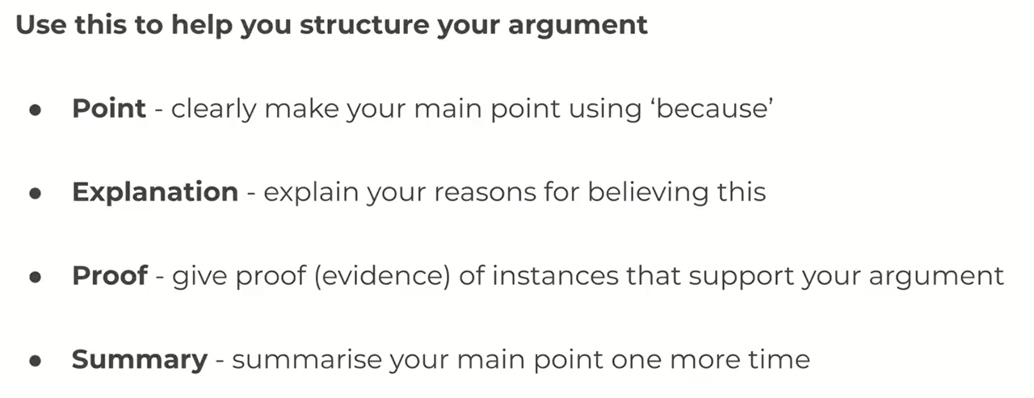

Example:
School uniform should be compulsory, as it is cheaper for parents.
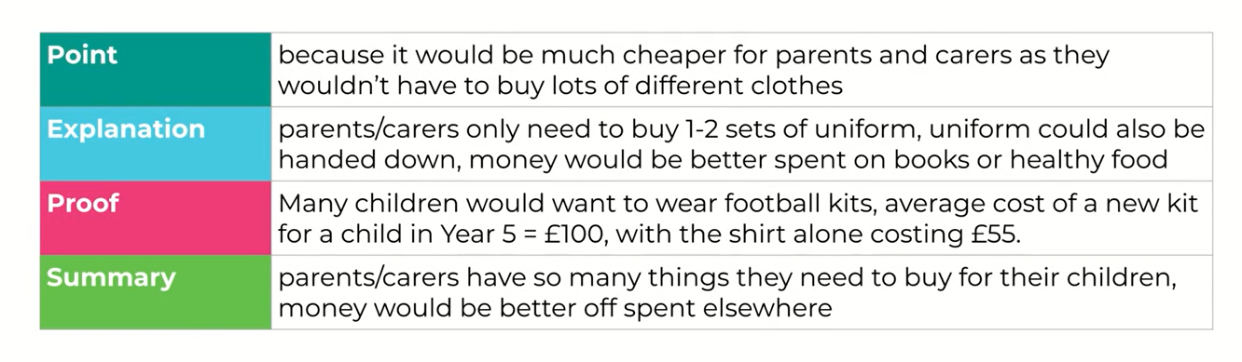

Look back at your planning sheet that you completed on Wednesday. Can you use the P.E.P.S. structure to organise your two points?

Point 1:

Point
Explanation
Proof
Summary

Point 2:

Point
Explanation
Proof
Summary

