Wednesday 3rd February 2021
Think about how these characters would speak and move.
Use the adverb word maps to come up with some actions and work with a family member to act them out!
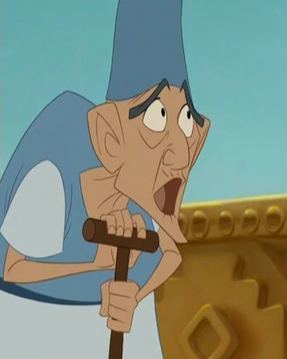
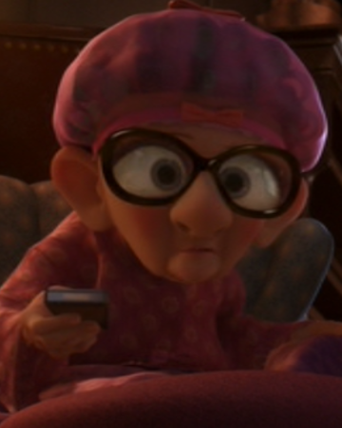

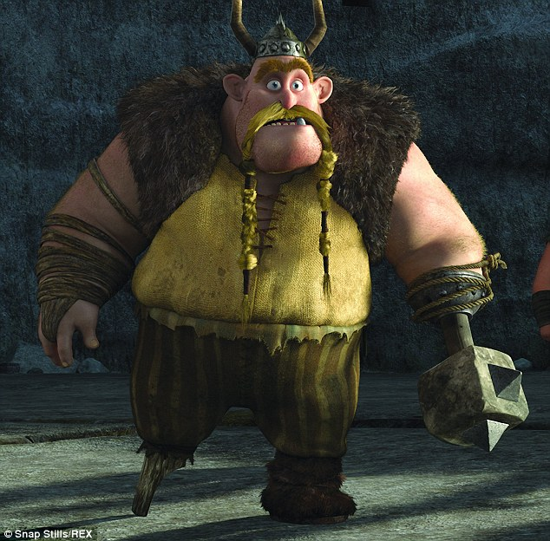

Now try to write some sentences!
For example: The Viking hobbled slowly with his iron arm hanging down and swinging when he walked.
_________________________________________________________________
_________________________________________________________________
_________________________________________________________________
_________________________________________________________________
_________________________________________________________________

