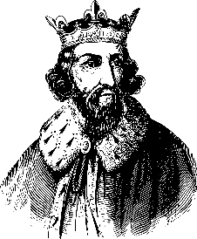
Why was Alfred so great?
Great Anglo-Saxon kings included Offa of Mercia (who built Offa's Dyke) and Edwin of Northumbria (who founded Edinburgh or 'Edwin's burh'). But the most famous of all is Alfred, the only king in British history to be called 'Great'.
Alfred was born in AD849 and died in AD899. His father was king of Wessex, but Alfred became king of all England. He fought the Vikings, and then made peace so that English and Vikings settled down to live together. He encouraged people to learn and he tried to govern well and fairly.

King of the English
Alfred became king in AD871. His elder brothers had each been king in turn before him, and he had been fighting the Vikings all his life. Alfred went on fighting the Vikings when all seemed hopeless. Finally, he won an important battle at Edington in Wiltshire in AD878. After that, some Vikings agreed to live in peace, though fighting still went on.
Alfred's capital was Winchester. In AD886, his army captured London (which had belonged to Mercia before the Vikings seized it). By now Alfred was called 'King of the English' on his coins. This shows how important he was.

Stories about Alfred
One story says Alfred went to Rome at the age of 4, to meet the Pope. When he came home, his mother promised a handsome book to the first of her sons who could read it to her. Alfred learned it by heart, recited it, and got the book.
Later the young King Alfred had to hide from the Vikings, on a marshy island called Athelney in Somerset. A famous story tells how while sheltering in a cowherd's hut, the king got a telling-off from the man's wife. Why? He let her cakes (or bread) burn.

How Alfred governed
King Alfred was advised by a council of nobles and Church leaders. The council was called the witan. The witan could also choose the next king. Alfred made good laws. He had books translated from Latin into English, and translated some himself. He told monks to begin writing the Anglo-Saxon Chronicle.
Alfred built warships to guard the coast from Viking raiders. He built forts and walled towns known as burhs. He split the fyrd (the part-time army) into two parts. While half the men were at home on their farms, the rest were ready to fight Vikings.

