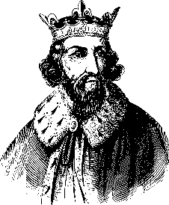
Fill in the gaps with the words from the word bank below
Great Anglo-Saxon kings included King ________ and King Edwin.
But the most famous of all is Alfred, the only king in British history to be called _________.

Alfred was born in AD849 and died in AD899. His father was king of Wessex, but Alfred became king of all ___________.

Alfred's capital was Winchester. In AD886, his army captured London (which had belonged to Mercia before the Vikings seized it). By now Alfred was called _________________________ on his coins. This shows how important he was.

A famous story tells how while sheltering in a cowherd's hut, the king got a telling-off from the man's wife. Why? He let her ________________ (or bread) burn.

Alfred made good laws. He had books translated from __________ into English, and translated some himself. He told monks to begin writing the ________________.

Alfred built ______________ to guard the coast from Viking raiders. He built forts and walled towns known as burhs.

Offa Great Anglo-Saxon Chronicle cakes
England Latin King of the English warships

ANSWERS
Great Anglo-Saxon kings included King Offa and King Edwin.
But the most famous of all is Alfred, the only king in British history to be called Great.

Alfred was born in AD849 and died in AD899. His father was king of Wessex, but Alfred became king of all England.

Alfred's capital was Winchester. In AD886, his army captured London (which had belonged to Mercia before the Vikings seized it). By now Alfred was called King of the English on his coins. This shows how important he was.

A famous story tells how while sheltering in a cowherd's hut, the king got a telling-off from the man's wife. Why? He let her cakes (or bread) burn.

Alfred made good laws. He had books translated from Latin into English, and translated some himself. He told monks to begin writing the Anglo-Saxon Chronicle.

Alfred built warships to guard the coast from Viking raiders. He built forts and walled towns known as burhs.

