|  |  |  |  |  |  |  |
| --- | --- | --- | --- | --- | --- | --- |
| **Year 5 2021 – Spring Term – February 1st – 5th**  **Home Learning Week Five**  **If you have any questions, troubles or worries please email us** at [eleanor.sargeant@grahamjamesacademy.co.uk](mailto:eleanor.sargeant@grahamjamesacademy.co.uk) and [robin.williams@grahamjamesacademy.co.uk](mailto:robin.williams@grahamjamesacademy.co.uk)  You can complete the work in any order that works best for you and your family. Click on the blue links to watch the videos and find the rest of the work on the website.  We will be uploading videos that will help with work, set challenges or explain new concepts. Please watch both of our videos. | | | | | | |
|  | **Session 1 – Maths Sessions** |  | **Session 2 – Literacy Sessions** |  | **Session 3 – Foundation Sessions** | |
| **MON** | Maths TTRS:  This week we have set you all a challenge of playing 5 minutes of TTRS everyday (or 25 minute total). We wonder which class will complete it first?  Maths White Rose Lesson 1  Fractions Greater Than One Worksheet  Video: <https://vimeo.com/498362964> | **B** | PE/Wellness – Be active  Children should be active on average for 60 minutes of moderate intensity a day.  Examples of moderate intensity activities: walking, riding scooter, skateboarding, rollerblading, walking the dog and [cycling](https://www.cyclinguk.org/).  Watch PowerPoint: PE Joe Wicks top tips why we need to exercise.  Please see Children’s Mental Health Week Worksheets | **L** | Spellings  To use and spell homophones and near homophones (Part 2)  Complete worksheets. If you do not know the meaning of a word look it up.  What is a homophone? <https://classroom.thenational.academy/lessons/to-investigate-homophones-6wuk6c?activity=video&step=1>  Then practise your handwriting using the KS2 Booklet | |
| **TUE** | Maths Lesson 2  [BBC Bitesize Lesson](https://www.bbc.co.uk/bitesize/articles/z4ypscw)  Watch the videos carefully, complete the worksheets then play the BBC Game. | **R** | T1 Spag Lesson 4  To explore relative clauses  [To explore relative clauses (thenational.academy)](https://classroom.thenational.academy/lessons/to-explore-relative-clauses-6xjp4c?activity=video&step=1) | **U** | Reading/PSHE  NHS Reading Comprehension sheet  Read through the text carefully and answer the questions. You can choose whether you wish to do 1 star (slightly easier), 2 star or 3 star (slightly harder).  Next Step: Can you create a poster to say thanks to the NHS for all their hard work keeping us safe? | |
| **WED** | Maths White Rose Lesson 3  Improper fractions to proper fractions worksheet  Video: <https://vimeo.com/498991812> | **E** | T2 Spag Lesson 3  To explore the functions of fronted adverbials  [To explore the functions of fronted adverbials (thenational.academy)](https://classroom.thenational.academy/lessons/to-explore-the-functions-of-fronted-adverbials-6dhpcc?activity=video&step=1)  See - Fronted Adverbial Word Mat for support | **N** | Art  The Great Big Art Exhibition – launched by Sit Anthony Gormley, who is asking people to make an artwork and put it in their window or outside. The Angel of the North sculptor said the ambition was to create a countrywide show of imagination and optimism. He has suggested **animals** as the theme – this could be drawings, paintings, models or sculptures. See Mr Williams’ video for further explanation and inspiration. | |
| **T**  **H**  **U** | Maths White Rose Lesson 4  Proper fractions to improper fractions worksheet  Video: <https://vimeo.com/500361175> | **A** | T3 Spag Lesson 4  To explore the functions of apostrophes  [To explore the function of apostrophes (thenational.academy)](https://classroom.thenational.academy/lessons/to-explore-the-function-of-apostrophes-ctk38r?activity=video&step=1) | **C** | Design & Technology   * To write down a recipe of one of your favourite meals. * If an adult has time and the ingredients in your home, why not make your meal at home for your whole family . If you do, please take a photograph and send it to your teacher. * [Ricky's simple lockdown pasta dish - CBBC Newsround](https://www.bbc.co.uk/newsround/55771864) | |
| **F**  **R**  **I** | Maths White Rose Lesson 5  Number Sequences video  Video: <https://vimeo.com/500361688> | **K** | RE Writing  To write about the Jewish Religion. Use your learning over the last few weeks, plus anything you can remember from school to help too!  Watch the videos to help you set out your writing correctly:  [Part 1](https://classroom.thenational.academy/lessons/to-write-an-essay-about-judaism-part-1-6hj36d) video and then [Part 2](https://classroom.thenational.academy/lessons/to-write-an-essay-about-judaism-part-2-64r36e) video | **H** | RE Writing  Finish your writing and use the following to help improve your writing.  [Edit and improve your writing](https://classroom.thenational.academy/lessons/can-i-improve-my-essay-about-judaism-6xgkgd) video  When you have finished read your work to an adult, sibling or friend.  Or of course, you can send a picture to your teacher to take a look at! | Reading and Listening  Listen to Miss Sargeant and Mr Williams Read Demon Dentist.  Draw a picture to summarise the chapter. |

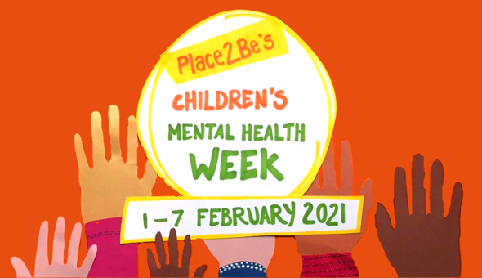

Watch virtual Assembly: <https://classroom.thenational.academy/assemblies/childrens-mental-health-week-2021>

Try a mindfulness challenge: Do a workout: Relax into a good book:

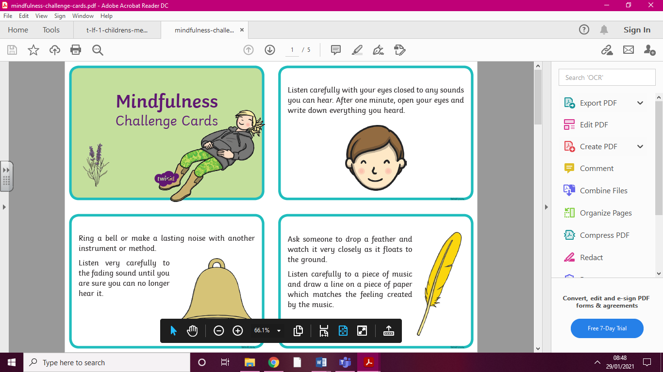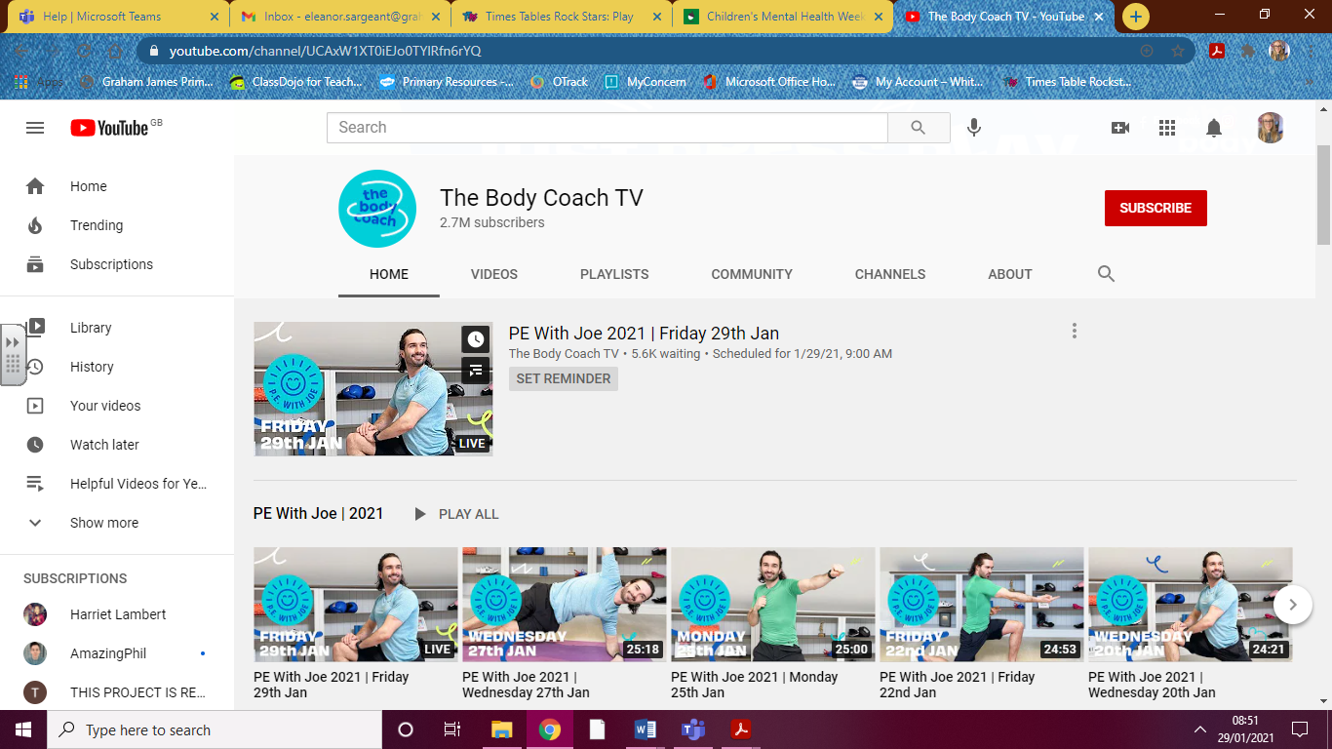

See the website for mental health and wellness support: <https://grahamjamesacademy.co.uk/mental-health-wellbeing/>