WEEKLY TIMETABLE YEAR 6 W/C 25th January 2021

 |  | Session 1 |  | Session 2 |  | Session 3 and Session 4
MON |  | Maths: Percentages – Lesson 1 - Percentages of an amount (1)  See worksheets attached  https://vimeo.com/497642809 |  | Science – Adaptations - Lesson 4 – What adaptations do nocturnal animals have?  Please take notes as you have a writing task this Friday  https://classroom.thenational.academy/lessons/what-adaptations-do-nocturnal-animals-have-6rw68r |  | Arithmetic – KS2 SATs Buster Book  Mixed questions – page 23  Spelling - KS2 SATs Buster Book  Words with ‘ough’ in – page 9  Please see Powerpoint attached  Additional sheets – Word search and handwriting practice
TUES |  | Maths: Percentages – Lesson 2 - Percentages of an amount (2)  See worksheets attached  https://vimeo.com/497643107 |  | Science – Adaptations - Lesson 5 –How are organisms adapted to live underwater?  Please take notes as you have a writing task this Friday  https://classroom.thenational.academy/lessons/how-are-organisms-adapted-to-live-underwater-c5k3gd |  | Arithmetic - KS2 SATs Buster Book  Adding decimals – page 24 and 25  Spelling – KS2 SATs Buster Book  The ‘f’ sound – page 10
WED |  | Maths: Percentages – Lesson 3 - Percentages of missing values  See worksheets attached  https://vimeo.com/498013311 |  | Science – Adaptations - Lesson 6 – How are organisms adapted to live in the deep sea?  Please take notes as you have a writing task this Friday  https://classroom.thenational.academy/lessons/how-are-organisms-adapted-to-live-in-the-deep-sea-74t64c |  | Arithmetic - KS2 SATs Buster Book  Subtracting decimals – page 26 and 27  Spelling – KS2 SATs Buster Book  Prefixes –un and de – page 11  Prefixes –im, in, il and ir – page 12  Reading – Non-Fiction – KS2 SATs Buster Book  Start: Inside the world of jam – page 22 to 31
THUR |  | Maths: Percentages - Lesson 4 - Year 6 Percentages assessment  See worksheet and please send this work in to your teacher once completed. |  | Science – Watch this video – Top 5 animal adaptations – BBC Earth  https://www.youtube.com/watch?v=ZT8YswmQuAg  Please take notes as you have a writing task this Friday |  | Times Tables:  TT Rockstars – 15 mins  Mathletics: 15 mins  Arithmetic - KS2 SATs Buster Book  Multiply by 10, 100 and 1000 – page 28 and 29  Reading – Non-Fiction – KS2 SATs Buster Book  Complete: Inside the world of jam – page 22 to 31
FRI |  | Maths: Percentage – Lesson 5 - Finding percentages of an amount (sheets)  See worksheets attached |  | Science/Writing/ICT – To design a magazine article.  To write effectively for a range of purposes and audiences.  - I can introduce the topic and explain what it is and why it happens (Adaptations)  - I can use simple devices to structure my work using headings, sub-headings and bullet points.  - I can organise my magazine article by using paragraphs or sections  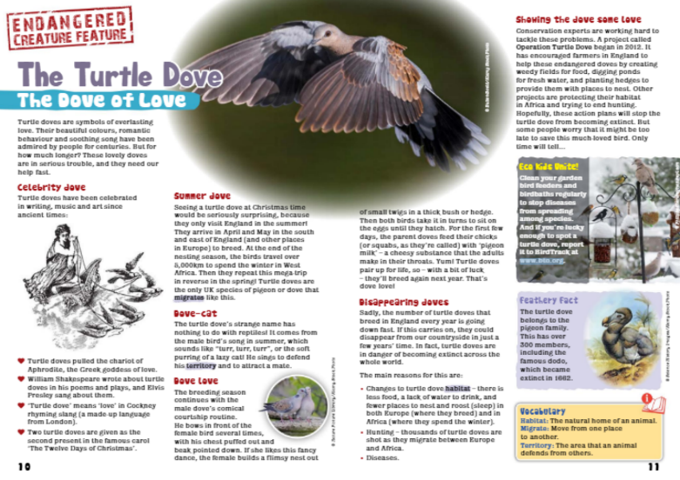  - I can use features of a magazine: pictures, diagrams and captions.  Challenge/Greater Depth  - I can use technical and subject specific vocabulary  - I can use a glossary  Once you have completed this assessment task, please send to your teacher

