Story Cubes
LO: To try to come up with a story using as many story cube dice as possible.
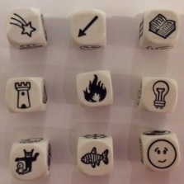
Step 1: Look carefully at each picture and write next to each picture your thoughts include descriptive words (adjectives) etc.
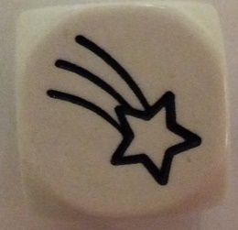 | 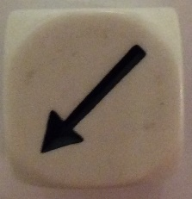 | 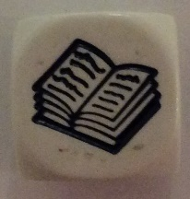
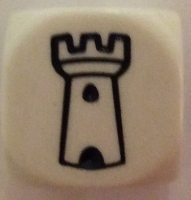 | 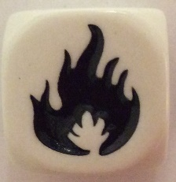 | 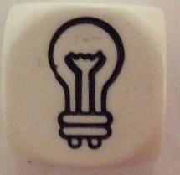
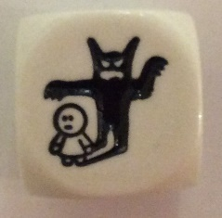 | 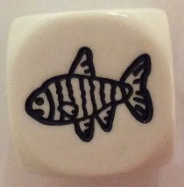 | 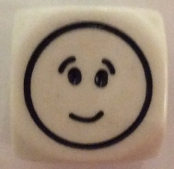

Step 2: Look at the story mountain picture to help you with your story.

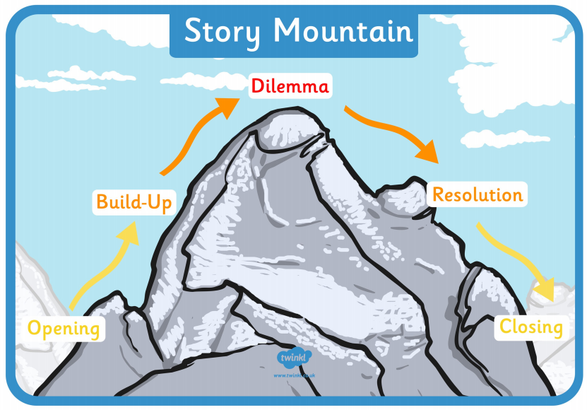

Step 3: Cut out your nine pictures and begin to arrange them in the order you are telling your story. You might want to place them on the story map above. Do not worry that you do not use all nine pictures.

Step 4: Retell your story to yourself a few of times. You will find with each retelling you will add more detail into your story.

Step 5: Performance to an audience –
- To your pet.
- To younger or older children in your house.
- To parents present in your house at the time of creating your masterpiece .
- To relatives or grandparents by making a short video.

