28.01.21 LO: To add ‘ies’ to nouns and verbs ending in consonant and then a ‘y’.
I have used at least 5 words ending in ‘ies’.  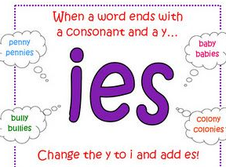 | I have written in the form of a playscript.  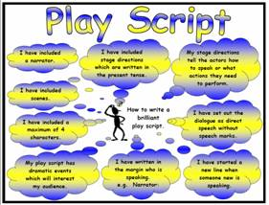
I have included at least 2 characters and a narrator. | I have formed my letters correctly.  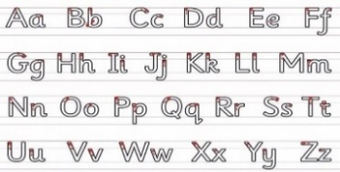
Challenge- I have spelt all year 1 and 2 words correctly.
Greater depth – I have started to join some of my writing correctly.
Words of the week – narrator scene cities
The Amazing McDonalds
Characters
- Miss Pulfer
- Miss Roberts
- Lovely McDonalds Lady
- Narrator

Scene 1 – At school
Narrator: It was a Friday afternoon at Graham James Primary Academy and two beautiful, hardworking teachers had just finished letting their fantastic students out to their families. They had listened to all of their wonderful stories about their weekends and it gave one of the teachers a brilliant idea.

Miss Roberts: Would you like to get dinner at McDonalds?

Miss Pulfer: Well I was going to have some blueberries and cherries for my snack but McDonalds sounds much better. Yes definitely! I just need to quickly tidy up.

Narrator: Miss Pulfer tries to tidy up the classroom and put away the wet play ponies and bunnies that are all over the floor.

Miss Roberts: Are you ready yet?

Miss Pulfer: Yes I’m coming, I just need to grab my blueberries and cherries from the fridge.

Scene 2 – At McDonalds

Lovely
McDonalds Lady: What would you ladies like to order?

Miss Roberts: Please can I have some chicken nuggets, chips and a milkshake.

Narrator: Miss Pulfer copies Miss Roberts and orders exactly the same.

Miss Pulfer: Can I have the same please.

Narrator: The Lovely McDonald’s Lady carries their bag of food over to them and they pass over all of their pennies to pay for their food.

Scene 3 – At Miss Pulfer’s house

Narrator: They drove back to Miss Pulfer’s house to eat their delicious dinner.

Miss Roberts: That was really tasty!

Miss Pulfer: Yes it sure was! We have ice lollies for dessert.

Miss Roberts: Oh lovely! I just hope your puppies don’t jump up and lick them!

Narrator: They sat and ate their ice lollies and watched a film together. The puppies snuggled on their lap and once it had finished Miss Roberts drove home.

