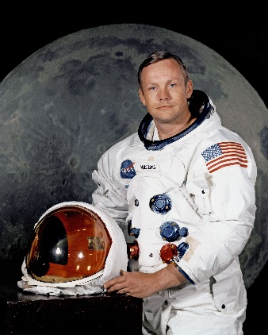
Week beginning 25.1.21 Weekly Timetable for Year 1 (1MW and 1GS)
We are trying to provide a wide range of activities, please do not feel like you have to do all of them.

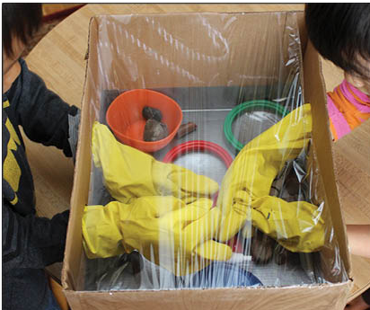
Some fun activities to try at home:
Make your own astronaut glove box – take a look at the link below:
https://www.giftofcuriosity.com/diy-astronaut-glove-box/

Squeezy bottle rocket
Create a squeezy bottle rocket using an empty sports bottle or an empty sauce
bottle.
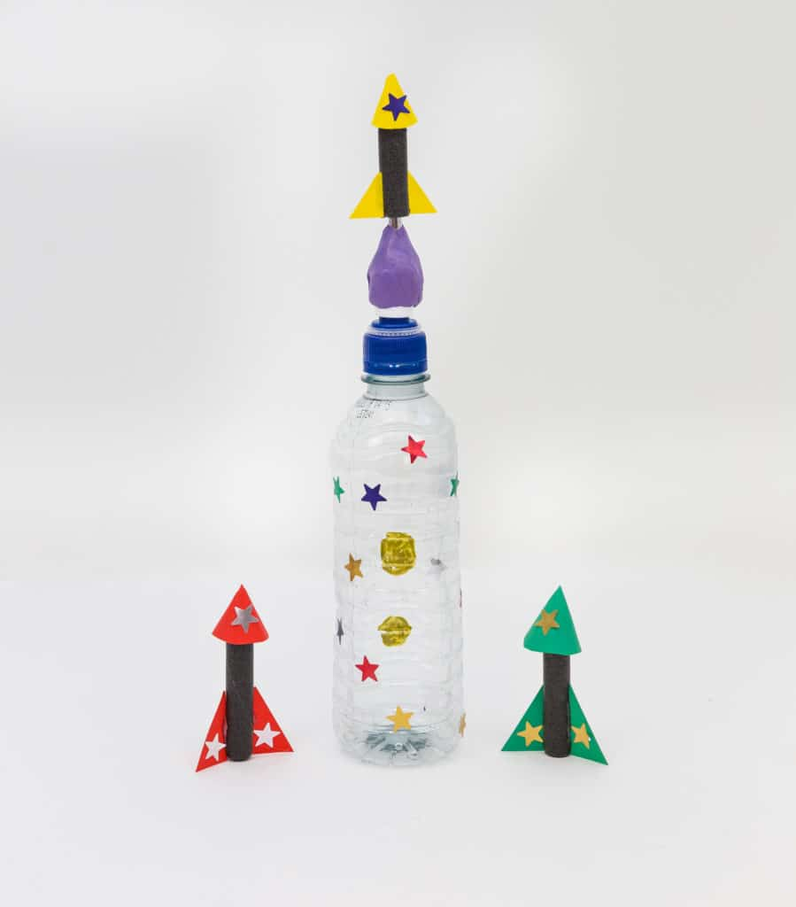
https://www.science-sparks.com/how-to-make-a-squeezy-bottle-rocket/

Astronaut action figure or teddy bear
Create an astronaut suit for your action figure or teddy bear. Maybe they could join you in your reading corner for reading on Friday.

We would love to see some photos of your child’s work, so please email them to us
vanessa.skinner@grahamjamesacademy.co.uk faye.gilmore@grahamjamesacademy.co.uk michelle.walker@grahamjamesacademy.co.uk
Take care and stay safe.
From the Year 1 Team

 | Letters and Sounds  20 mins | Reading time  10/15 mins | Maths Time  25 mins |  | Spellings  10 mins | English/Topic  30 mins | Other subjects or activities  25 mins
M | Phase 5 – aw like in paw, claw, jaw, law, saw, raw, yawn and drawer. Children to practice reading the words and play buried treasure.  Phase 3 – ur like in fur, burn, burp, hurt, surf, turn and turnip. Practice reading the words. Then complete the ur real and nonsense word sheet. Children to write the real words on the back of the sheet. | Reading  This week our reading skill is making inferences –  Children to verbally complete at least 2 of the inference picture and question cards. | Maths  White rose home learning – spring week 3 – lesson 3 - Subtraction – not crossing 10.  https://whiterosemaths.com/homelearning/year-1/spring-week-3/  Watch the video and after you have completed the snowman word problem stop the video and complete the worksheet – subtraction not crossing 10. |  | Spellings  This weeks spelling are:  push  pull  over  where  one  love  Children to read each word in turn then to spell each word – make sure you let them see the correct spellings so that today they can copy them! | History/English  Go through the Twinkl Neil Armstrong power point.  Dictate these sentences for your child to write:  He was the first man on the moon.  Neil Armstrong was a famous astronaut.  Children will need some help with the spellings.  Children should say the sentence aloud first then write it and read it after to check it makes sense.  ** Please make sure children have a capital letter for the start of a sentence and a name, they need to use finger spaces and end with a full stop. | Yoga  Cosmic Kids Yoga on YouTube  The very hungry caterpillar  https://www.youtube.com/watch?v=xhWDiQRrC1Y  Letter formation power point – children to practice writing lower case letters.  Or you could use:  https://www.ictgames.com/mobilePage/skyWriter/index.htmln  https://www.doorwayonline.org.uk/activities/letterformation/
T | Phase 5 - today work on spelling aw words from the previous day by completing the aw real and nonsense work sheet. Children to write the real words on the back of the sheet.  Phase 3 – ow like in cow, how, down, bow, row, town and towel.  Children to practice reading the words. Children to then complete the ow phoneme spotter story. Children need to read the story and colour/under line all the ow words and write them on the back of the sheet. | Reading  Reading comprehension-  Neil Armstrong  Children to read the information and answer the questions. | White Rose Maths  White rose home learning – spring week 3 – lesson 4  Subtraction – counting back – using a number line or track to count back/take away.  https://whiterosemaths.com/homelearning/year-1/spring-week-3/  Watch the video clip and then complete the sheet – subtraction not crossing 10 (sheet with number tracks – counting back) |  | Spellings  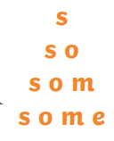  Write each of your words like a pyramid: | English  Go through Twinkl – Amazing Astronauts power point.  After you have gone through the power point with your child, discuss what they have found out about astronauts.  Children to write one or more sentences about astronauts -  Astronauts live in a space station.  Astronauts wear a spacesuit.  Astronauts get to choose their favourite foods before they go into space.  Children will need help to spell some of the words.  ** Please make sure children have a capital letter for the start of a sentence and a name, they need to use finger spaces and end with a full stop. | Science  Weather and seasonal change.  Use Oak National Academy and work through -  Key stage 1 - Science – seasons and change – what do we know about the weather? Lesson 1  https://classroom.thenational.academy/lessons/what-do-we-know-about-the-weather-6ct30c  Can your child make up their own weather forecast? If you can record it and email it in (if it is short) that would be great .  Number formation power point – children to practice writing numbers 0-10.
W | Phase 5 – ph like in Phillip, dolphin, alphabet, phonics, elephant and phantom. Children to practice reading the words and play buried treasure.  Phase 3 – oi like in oil, boil, coil, foil, join, coin, soil and poison.  Children to practice reading and writing the words.  Children to write the questions –  Can you surf on a coin?  Can oil boil?  Explain to children that this is a question so it needs a question mark and an answer. | Reading  Children to verbally complete at least 2 of the inference emotion picture and question cards. | Maths  Continue taking away using a number line.  Watch Teacher video.  Children to complete number line subtraction sheets. |  | Spellings  Write each of your words using dots. Then, join the dots with a coloured pencil to make your word. | English  Children to write a list of things they would take to space in their rocket (sheet available). | Art/Topic  Art – drawing an astronaut  Youtube – Art for kids hub - How to draw an astronaut.  https://www.youtube.com/watch?v=HjnRYnSEuG4&t=355s  There is also how to draw a rocket if your child would prefer that.  https://www.youtube.com/watch?v=BIp4zpYfFdU  Letter formation power point – children to practice writing upper case letters.
T | Phase 5 - today work on spelling ph words from the previous day by completing the phoneme spotter postcard. Children need to read the postcard and find the ph words by colouring/underlining them in and then writing them on the back.  Phase 3 – er (this sound normally goes at the end) like in hammer, letter, rocker, dinner, supper, summer, banner and better. Children to practice reading and writing the words. Then write the questions –  Can a hammer chop wood?  Can ducks see fish in rivers? | Reading  Reading comprehension-  The Three Billy Goats Gruff  Children to read the story and answer the questions. | Maths  To solve word problems involving subtraction  If you had 10 glass bottles and three of them smashed how many would you have left?  Talk through the word problem with your child and discuss how to write the calculation and how to solve it e.g. 10-7 = 3 – Watch Teacher video.  Complete at least four of the subtraction word challenge cards. |  | Spellings  Write each of your words across then down, sharing the first letter.  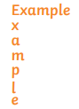 | English/DT  Design a spaceship sheet.  Can your child design their own spaceship and label the key parts.  Children can use crayons, pencils or felt tips.  Can your child write a sentence about their spaceship?  ** Please make sure children have a capital letter at the start, finger spaces and end with a full stop. | Wellbeing time  YouTube  Cosmic kids zen den – mindfulness  Superpower listening  https://www.youtube.com/watch?v=jJ9zpRAPIuI  PSHE  Use Oak National Academy  Key Stage 1, RHE (PSHE)  Happy Families – lesson 2 – my family network.  https://classroom.thenational.academy/units/happy-families-3335  Letter formation power point – children to practice writing lower case letters.
F | Practise any sound from the week – either spelling a word with each sound or play a game e.g. sentence substitution, rocket rescue, make a match and sentences – all on phonics play. | Reading  Children to create a reading corner and read to a teddy or family member.  Please send us a photo of your reading corner | Maths Game Day  Complete some or all of the games:  https://www.sheppardsoftware.com/math/subtraction/fruit-splat-game/  https://www.topmarks.co.uk/maths-games/hit-the-button - number bonds - up to 20 – subtraction within 20.  https://www.ictgames.com/mobilePage/funkyMummy/index.html |  | Spellings  Test your child on the spellings for the week!  Make it fun though as some of them are quite tricky. | English  Children to complete - Label the rocket parts sheet.  Children to read the key words and then cut and stick or write them in the correct places. | Music  Use Oak National Academy  Key Stage 1 – Music – Pulse – lesson 3  https://classroom.thenational.academy/units/pulse-769c  Handwriting  Children to fill a rocket with handwriting patterns. The children are very good at this  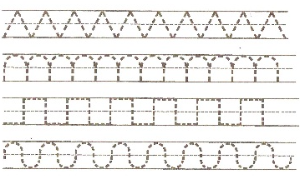

PE/Ideas to keep your child active:

