 |  |  |  | Monday 25th |  | Tuesday 26th |  |  | Wednesday 27th |  | Thursday 28^{h} |  | Friday 29th
 | Letters and sounds |  |  | Listen to:  Jolly Phonics Song- https://www.youtube.com/watch?v=_s-1sxzjPX8&t=2s  Tricky Word Song -  https://www.youtube.com/watch?v=e2dx65u59aw  Activity:  Bumble Farm Rhyming words PowerPoint.  Can you help Farmer Faye find the matching rhyming words? |  | Listen to:  Jolly Phonics Song- https://www.youtube.com/watch?v=_s-1sxzjPX8&t=2s  Tricky Word Song -  https://www.youtube.com/watch?v=e2dx65u59aw  Activity:  Rhyming Words Home Learning Sheet.  Can you draw a line to match the words that rhyme? |  |  | Listen to:  Jolly Phonics Song- https://www.youtube.com/watch?v=_s-1sxzjPX8&t=2s  Tricky Word Song -  https://www.youtube.com/watch?v=e2dx65u59aw  Activity:  Farm-Themed Phase 2 Say It, Join It, Write It Worksheet.  Look at the picture. Say the word. Join the letters to build the word, then write the word in the boxes. |  | Listen to:  Jolly Phonics Song- https://www.youtube.com/watch?v=_s-1sxzjPX8&t=2s  Tricky Word Song -  https://www.youtube.com/watch?v=e2dx65u59aw  Activity:  Play Phonopoly (Phonics Monopoly)  Use the given Game board, Score sheet, Challenge and Chance cards. |  | Listen to:  Jolly Phonics Song- https://www.youtube.com/watch?v=_s-1sxzjPX8&t=2s  Tricky Word Song -  https://www.youtube.com/watch?v=e2dx65u59aw  Activity:  Tricky Word – Phase 2 Letter Formation Practise.  Can you practice writing the tricky words?
 | Reading |  |  | Please try and read with your child as much as you can. With they reading to you or you can also read stories to them. You need to discuss the features of a book e.g. front cover, blurb, author, what they think the story is going to be about. While your reading a story stop at points and ask questions about what you have already read to check understanding and listening. Also ask children what they think might happen next.  We have recorded a video of us reading a story to the children. It will be on the website weekly for you to watch.  You can also use the following Oxford Owl website (https://www.oxfordowl.co.uk/for-home/find-a-book/library-page/) who are currently offering a free eBook Library for parents to use at home. Please click the join us tab at the top of the page to create a FREE account.  We have also uploaded some eBooks onto the website for you to use. Please try to select a book that is similar to your child’s reading book.  The books are:  - Kit and Sam  - It is…  - Kit and Same got…  - Cats and Dogs  - Let’s Go!  - Pop and Puff  - Level 2a Ben
Overview |  |  | AM  Listen to Miss Dibble and Miss Kiely reading the story Wake-Up Time on Bumble Farm.  Can you identify the rhyming words in the story and make the noises like the farm animals.  PM  Listen to the following video, Can you guess the Farm Animal from the sound? https://www.youtube.com/watch?v=6yqi46uE6nA |  | AM  To know the names for the offspring animals  In this set of lessons we will learn how animals grow. In this lesson with Miss Hughes, we will think about animals that live on a farm and learn to identify their offspring. At the end of the lesson, you will test your new knowledge by matching the baby animals to the adult animals. https://classroom.thenational.academy/lessons/to-know-the-names-for-the-offspring-animals-not-human-6mr36r  PM  Can you guess the farm animals Miss Dibble and Miss Kiely are describing on the What am I? video. |  | AM  To know what farm animal offspring need to grow  In today's lesson, we join Miss Sidenius in learning about how farm animals grow, including what different farm animals need to grow. We end the lesson with a fun task creating some potato print chicks, just like you might see on a farm. To extend this lesson, you could talk about other baby animals that you might find on a farm.  https://classroom.thenational.academy/lessons/to-know-what-farm-animal-offspring-need-to-grow-68v62c  PM  To name and describe different feelings  In this set of lessons, we will begin to identify our feelings. In today’s lesson with Miss Hughes, we will think about what our face looks like when we experience different feelings and identify some things that lead us to these feelings. We will develop a ‘feelings chart’ that helps us to express these and give us strategies to manage them. Display this chart somewhere safe so you can use it throughout each day. https://classroom.thenational.academy/lessons/to-name-and-describe-different-feelings-6rt34d |  |  |  | AM  To sequence the life cycle of an animal  In today’s lesson we join Mrs Garrard to learn about animal life cycles. We will learn vocabulary associated with life cycles and to end the lesson, we will make a representation of a baby animal.  https://classroom.thenational.academy/lessons/to-sequence-the-life-cycle-of-an-animal-6hk38c  PM  To act out different feelings  In this lesson, we join Miss Sidenius to think about how we can recognise different emotions by looking at people's facial expressions. We will create our own feeling puppets and have a go at acting out different feelings. You can extend this lesson by using the puppets to express feelings when you are finding it difficult to do so with words.  https://classroom.thenational.academy/lessons/to-act-out-different-feelings-c9gp4d | AM  Yoga time on the Farm - https://www.youtube.com/watch?v=YKmRB2Z3g2s&t=39s  PM  To represent different feelings  In this lesson, we join Mrs Garrard to learn about different feelings. We will attribute a colour to each feeling and think of things that make us feel that particular emotion. Finally, we will create feelings monsters to represent our feelings.  https://classroom.thenational.academy/lessons/to-represent-different-feelings-cdhp8e
Creative |  | Can you make a model of a farm animal? Maybe you could use building bricks or empty packaging to make your model. We would love to see your creations! |  |  | Use your hands to make a Handprint Chicken with Chicks. |  |  | 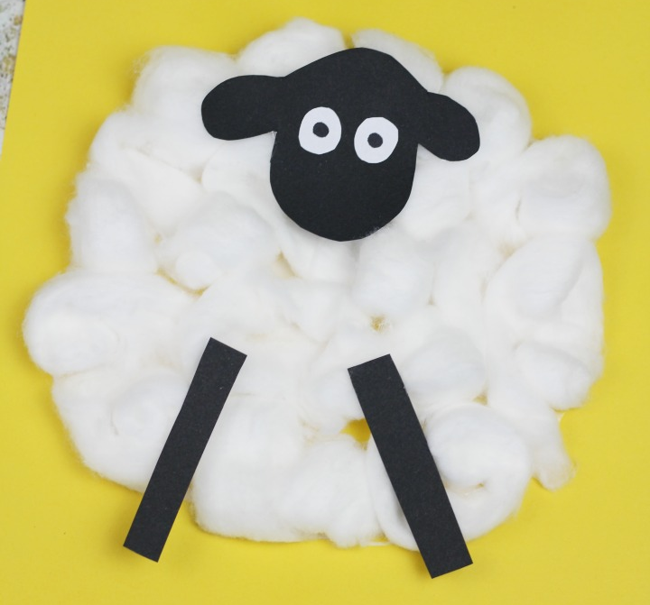  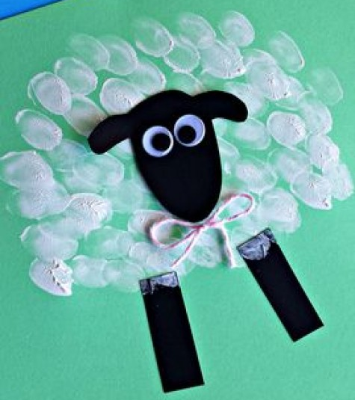  Can you use cotton wool or finger prints to make a fluffy sheep? |  | Can you create your own farm? What animals will you have on your farm? Don’t forget about the animals homes? |  | 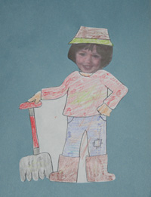  Can you draw yourself  as a Farmer?
Maths |  | Understanding the concept of subtraction as take away (Part 1) In this lesson, we will explore the concept of subtraction as take away through telling 'first, then and now' stories.  https://classroom.thenational.academy/lessons/understanding-the-concept-of-subtraction-as-take-away-part-1-cmu32r |  |  | Understanding the concept of subtraction as take away (Part 2) In this lesson, we will continue to explore the concept of subtraction as take away through telling 'first, then and now' stories.  https://classroom.thenational.academy/lessons/understanding-the-concept-of-subtraction-as-take-away-part-2-6nk3et |  |  | Adding and subtracting using a number track. In this lesson, we will practise adding and subtracting using a number track and manipulatives to help us.  https://classroom.thenational.academy/lessons/adding-and-subtracting-using-a-number-track-crv6at |  | Can you practise your subtraction skills by completing the Farm Subtraction Sheet? |  | Can you use the number line to answer the subtraction sums?
Literacy |  | To listen and join in with a story. In this lesson, we will be joining in with The Little Red Hen.  https://classroom.thenational.academy/lessons/to-listen-and-join-in-with-a-story-c5h36t |  |  | To sing and map a story. In this lesson, we will be singing and mapping a story.  https://classroom.thenational.academy/lessons/to-sing-and-map-a-story-6wukgd |  |  | To focus on character. In this lesson, we will be stepping the story and focusing on character.  https://classroom.thenational.academy/lessons/to-focus-on-character-cnk3jr |  | To reenact a story focusing on character. In this lesson, we will be re-enacting the story focusing on character.  https://classroom.thenational.academy/lessons/to-reenact-a-story-focusing-on-character-6gu32t |  | To tell the story independently, focusing on character. In this lesson, we will practice activities to prepare students to tell the story independently.  https://classroom.thenational.academy/lessons/to-tell-the-story-independently-focusing-on-character-crtpac
Problem Solving |  | In the ‘Wake-Up Time on Bumble Farm’ story, Farmer Faye is very surprised when Rooster wakes her up late and she looks at the clock. Have a look at some different clocks. What numbers can you see? What time do you get up in the morning? |  |  | Can you match the animals and their babies?  Access this lesson using pin code: SD0217  at Twinkl Go |  |  | Can you spy and count the farm animals? I spy and count to 10. |  | Can you follow the Winter Challenge cards to find the objects from around your house and garden? |  | Can you using the Blocks to build the farm animals?  Access this lesson using pin code: SD0217  at Twinkl Go
Physical |  | Can you draw a picture of your favourite farm animal? Can you write about them too? You could write about what they look like, or what happened to them in the story. |  |  | Can you trace over the patterns and farm animal words on the Farm Handwriting Sheet? |  |  | Can you join in with the Farm Animal Exercise? https://www.youtube.com/watch?v=iHJ2fW3iJVE |  | Can you do what Peppa Pig says from the Peppa Pig Copying Game Cards? |  | Have fun with Just Dance Kids Old MacDonald Had a Farm.  https://www.youtube.com/watch?v=nBIjRY3ad_U  All around the Farm – Directional Words.  https://www.youtube.com/watch?v=ykmFyHJq6FY&t=29s
UTW |  | Can you use the pictures to sequence the story Wake up time on Bumble Farm in the right order? |  |  | With an adult look through the PowerPoint – On the Farm Animal Homes.  Can you now match the pictures of the Farm Animals with their correct Home? |  |  | Can you cut out the pictures of the young and match it to their correct mother? |  | Sing the Nursery Rhyme Old MacDonald had a farm. What animals will you choose to have on the farm? Don’t forget the actions! |  | Can you match the shadow to the correct animal?  Access this lesson using pin code: SD0217  at Twinkl Go

