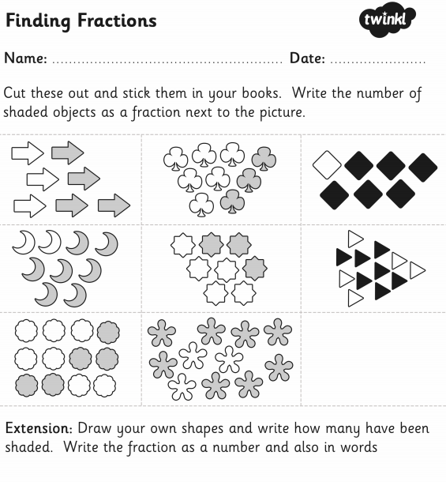
Answers:
- 4/7
- 3/9
- 6/7
- 7/9
- 3/8
- 7 /12
- 5/12
- 8/11

