1. Just add ‘**ly’**

bold + **ly** = bold**ly**

brave + **ly** =

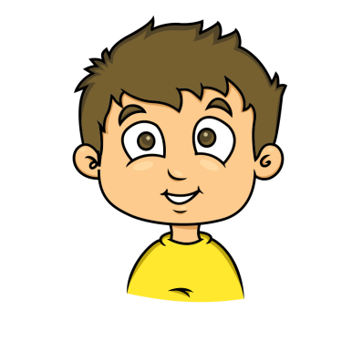calm + **ly** =

clear + **ly** =

clever + **ly** =

dead + **ly** =

deep + **ly** =

exact + **ly** =

glad + **ly** =

1. Just add ‘**ly’**

hour + **ly** = hour**ly**

keen + **ly** =

kind + **ly** =

live + **ly** =

loud + **ly** =

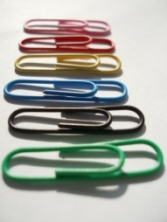kind + **ly** =

main + **ly** =

most + **ly** =

neat + **ly** =

1. Just add ‘**ly’**

nice + **ly** = nice**ly**

part + **ly** =

quick + **ly** =

quiet + **ly** =

quietreal + **ly** =

rude + **ly** =

sad + **ly** =

silent + **ly** =

slow + **ly** =

1. Just add ‘**ly’**

soft + **ly** = soft**ly**

swift + **ly** =

usual + **ly** =

week + **ly** =

wild + **ly** =

year + **ly** =

slow + **ly** =

sudden + **ly** =

tight + **ly** =

1. Just add ‘**ly’**

beautiful + **ly** =

cheerful + **ly** =

graceful + **ly** =

helpful + **ly** =

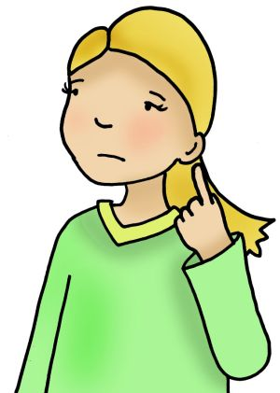hopeful + **ly** =

painful + **ly** =

peaceful + **ly** =

playful + **ly** =

thankful + **ly** =