**How to make a jam sandwich**

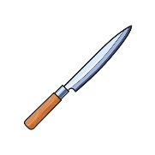MCj02904840000[1]

MCj02328300000[1]**You need:** bread butter MCj02642520000[1] knife jam MCj02904370000[1] plate

1. First, carefully and sensibly pick up the cold knife.
2. Next, spread the yellow butter neatly and smoothly across the bread.
3. After that, gently spread the sticky red jam thoroughly across the butter.
4. Then, simply place the second piece of soft bread softly on top.
5. Next, slowly cut the sandwich in half with the knife.
6. Finally, place the sandwich calmly on a pretty plate and eat quietly.