21.01.21 LO: To use adverbs ending in ‘ly’ correctly.
I have used adverbs ending in ‘ly’ in my writing.  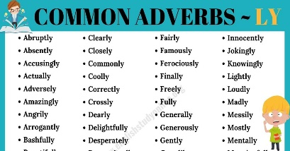 | I have written in the form of instructions.
I have used adjectives to describe. | I have formed my letters correctly.  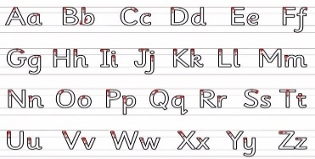
Challenge- I have spelt all year 1 and 2 words correctly.
Greater depth – I have used at least 5 bossy (imperative) verbs.
Words of the week – gently thoroughly beautifully

