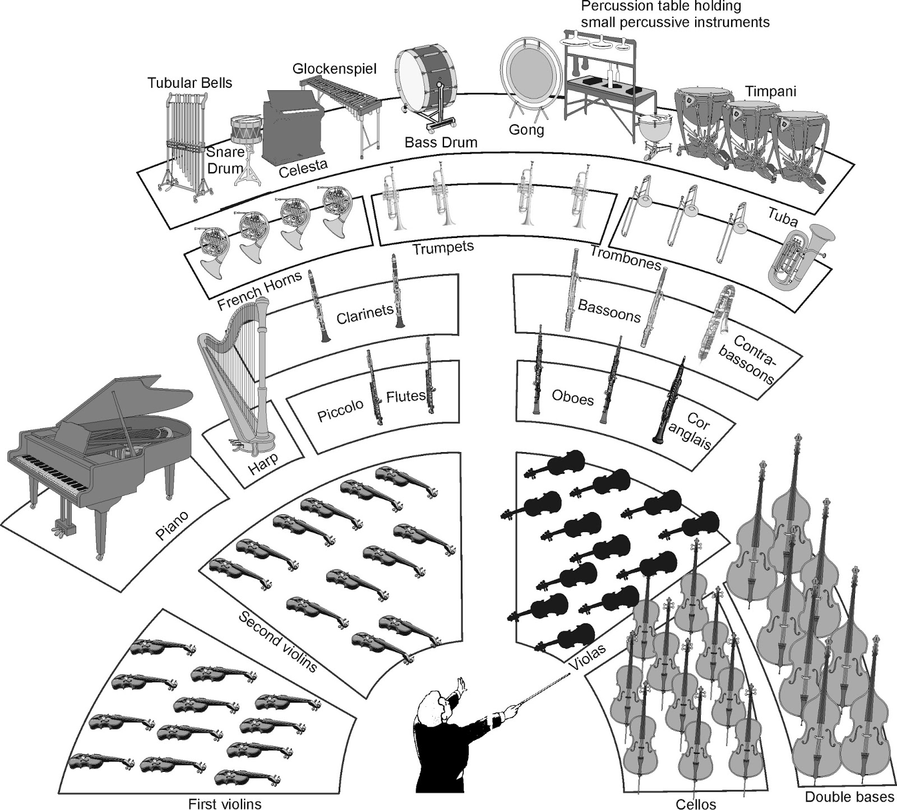

**Colour in the 4 different sections of the orchestra**

**Brass = Yellow**

**Percussion = Red**

**Strings = Green**

**Woodwind = Blue**