Day and Night
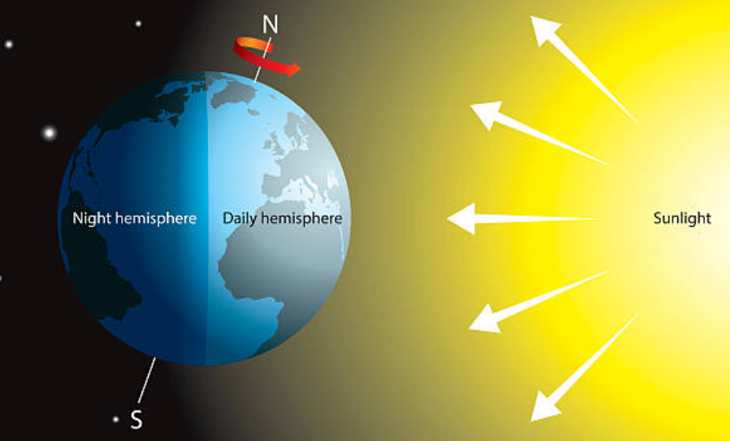
The Earth is a ___________, which spins as it ________ around the Sun. One side of the Earth ________ the Sun, while the other side faces away into ________. The side facing the Sun is bathed in light and heat – we call this ________. The side facing away is cooler and ________, and experiences _________. Because the Earth is constantly spinning, the line between day and night is always moving around the _________. A day on Earth lasts 24 hours – that is how long it takes for the planet to spin around once.
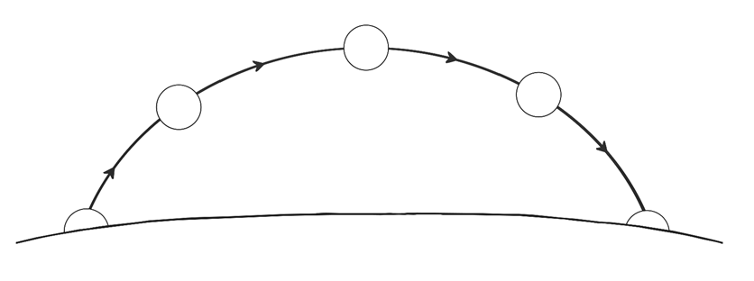
Earth
sky
Sun
From Earth, the ________looks like it moves across the sky in the daytime and appears to __________at night. This is because the Earth is _________towards the east. The Earth spins about its axis, an imaginary line that runs through the middle of the Earth between the North and South_________.
space | travels | daytime | planet
night | darker | faces | sphere
Sun | poles | disappear | spinning

Answers:
The Earth is a _sphere_, which spins as it _travels_ around the Sun. One side of the Earth _faces_ the Sun, while the other side faces away into _space_. The side facing the Sun is bathed in light and heat – we call this _daytime_. The side facing away is cooler and _darker_, and experiences _night_. Because the Earth is constantly spinning, the line between day and night is always moving around the _planet_. A day on Earth lasts 24 hours – that is how long it takes for the planet to spin around once.

From Earth, the Sun looks like it moves across the sky in the daytime and appears to disappear at night. This is because the Earth is spinning towards the east. The Earth spins about its axis, an imaginary line that runs through the middle of the Earth between the North and South poles.

