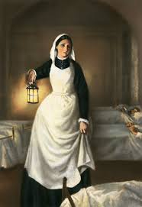
Weekly Timetable for Year 1 (1MW and 1GS)
Timings are approximate – just try and do what your child can, remember anything is better than nothing.
We have included any links that you might want to use, or do what works for you and your child.
In Letters and Sounds children work in different groups when in school, children that work with Miss Walker are working on phase 5 phonics, and all other children are working on phase 3. Your child should know which group or phase they are on.
We have attached a range of power points to support your child in letters and sounds e.g. flashcards, sentences and words to read. Miss Walker’s group can work on phase 3 and 4 power points (phase 5 power points are not suitable yet as they have not covered all the sounds).
YouTube has a Home Learning Letters and Sounds resource which is good for phonics, there are also hundreds of different clips to show each sound and words and pictures for that sound. So if your child is learning the phase 5 ay sound, just type that in and lots of resources will pop up on YouTube. Geraldine Giraffe is a good clip to show diff words containing the sound – there is a short clip for every sound. The children love Geraldine!
There are also lots of phonics games for each sound on: phonics play (buried treasure game, Odd and Bob, Dragons Dens) and ictgames.com.
There are six spelling words to learn for the week. Make sure your child can read them first then work on spelling them. We use the letter names when working on out spelling words as they often have different spelling patterns.
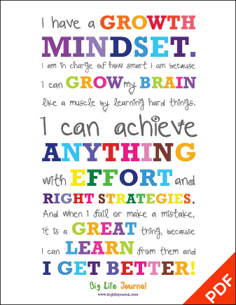
**Please email us if you are unsure of anything or your child is struggling. You should have our direct school email address. Resources needed: Florence Nightingale power point, history of nursing power point, hospitals now and then power point and Science experiment sheet. We have also included some other spelling activities for you to try at home.
We hope that the timetable below will support you and your child. As we said above, please don’t feel you need to do it all, try your best! The children are really good in school at giving everything a good go, and not giving up. Remind them of that.
We have tried not to include sheets, as we are aware that not everyone has a printer.
Take care and stay safe.
From the Year 1 Team

 | Letters and Sounds  20 mins | Reading time  10/15 mins | Maths Time  25 mins |  | Spellings  10 mins | English/Topic  30 mins | Other subjects or activities  25 mins
M | Miss Walker’s group  Phase 5 oy – boy toy joy enjoy Roy loyal oyster destroy. Watch Geraldine Giraffe then practise reading the words above.  Phase 3 – ai- wait, hail, jail, pain, sail and rain. Children to read and write the words. Play buried treasure on phonics play. | This week our reading skill is vocabulary.  When you have read your book choose 2 words and discuss what they mean. If you can think of other words that have the same meaning. | White Rose Maths  Home Learning  Activity week  Day 1 – Do you want to build a snowman? |  | This weeks spelling are:  house some come was by my  Children to read each word in turn then to spell each word – make sure you let them see the correct spellings so that today they can copy them! | History – To learn about Florence Nightingale  Watch BBC magic grandad on YouTube  Discuss with your child a few facts you have found out about Florence Nightingale.  There are also lots of different clips giving information about Florence that you could watch. | Cosmic Kids Yoga on YouTube  Popcorn and the Pirates  Letter formation power point – children to practice writing lower case letters.
T | Phase 5 oy – today work on spelling oy words from the previous day and then play phase 5 buried treasure on phonics play with the oy sound.  Phase 3 – ee – see, jeep, deep, weep, feet, meet, keep and seem. Children to read and write the words. Play picnic on Pluto – phonics play. | Find a new place to read your book e.g. build a fort and read in there, read under the covers. | Maths  Day 2  Snowflakes, snowflakes all around |  | Play  Look  Cover  Spell  Check  with each spelling word. | History/English  Go through the Twinkl Florence Nightingale power point.  Children then to write a fact about Florence e.g. Florence Nightingale carried a lamp when she checked on her patients.  ** Please make sure children have a capital letter for the start of a sentence and a name, they need to use finger spaces and end with a full stop.  Children should read their sentence through as they are writing and read it after to check it makes sense. | Science  To conduct a simple experiment – you task is to find out the quickest way to melt an ice cube.  There is a sheet available too to support with how to do this.  Number formation power point – children to practice writing numbers 0-10.
W | Miss Walker’s group – phase 5 ir - girl fir bird shirt skirt first third thirteen.  Watch phase 5 ir sound (clip on YouTube).  Phase 3 – igh – high, sigh, might, night, fight, tights and right. Children to watch Geraldine and practise reading and writing the words. Can your child write one in a sentence? | Reading  Act out your book (if it is a story) to a member of your family. | Maths  Day 3 Wrap up warm |  | Spellings  Use different coloured pens or pencils and to write each spelling words in different colours. | Children to choose a spelling word and write it in their own sentence.  Encourage children to think what they want to write, then say it out loud first, then to work with you (if possible) to write it down.  When they have their idea written down encourage them to read it through to check it makes sense.  ** Please make sure children have a capital letter at the start, finger spaces and end with a full stop. | Art  To draw a nurse using YouTube -  how to draw a cartoon nurse – Art for Kids Hub.  Letter formation power point – children to practice writing upper case letters.
T | Phase 5 children to practise spelling some of the words from the previous day.  Phase 3 – oa- coat, road, soap, boat, goat, oak and boatman.  Children to practice reading and writing the words. Can your child write one in a sentence? | Reading  If you can record your self reading your book and then listen to it to see how your reading sounds. | Maths  Day 4 Dashing through the snow |  | Spellings  Practise spelling each word but using fancy writing when they write it. | History  Twinkl power point  The History of Nursing  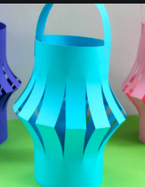  Task:  If you have a spare piece of paper see if you can make a paper lantern. There are clips on YouTube to show you. | Wellbeing time  YouTube  Cosmic kids zen den – mindfulness  Yes You Can!  (this links with developing a growth mindset)  Letter formation power point – children to practice writing lower case letters.
F | Practise any sound from the week – either spelling a word with each sound or play a game. | Reading  Here is a list nice stories to listen to on YouTube:  The True story of the 3 little pigs  Pete the cat: I love my white shoes  The Magical Snowman  Be Brave Little Penguin  ** Choose a story and then after you have listened to it discuss some of your favourite words or phrases. | Maths  Special delivery |  | Test your child on the spellings for the week!  Make it fun though as some of them are quite tricky. | History  Twinkl power point  Hospitals now and then  After you have gone through the power point with your child discuss some of the changes.  Task: create a miniature hospital, either with lego, construction materials or an empty cereal box. | Music  Use Oak National Academy  Key Stage 1 – Music – Pulse – lesson 1.  https://classroom.thenational.academy/units/pulse-769c  Number formation power point – children to practice writing numbers 0-10.

PE/Ideas to keep your child active:
