14.01.21 LO: To use adverbs ending in ‘ly’ correctly.
I have used adverbs ending in ‘ly’ in my writing.  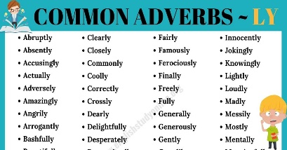 | I have broken my writing up using full stops and capital letters.
I have spelt year 1 and 2 common exception words correctly.  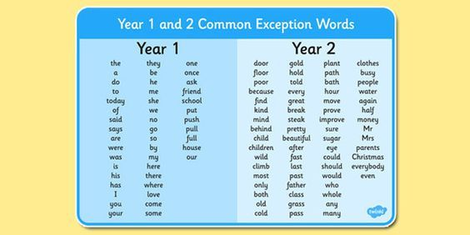 | I have formed my letters correctly.  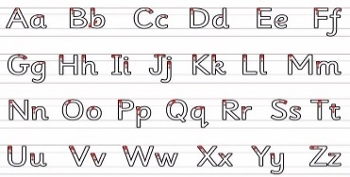
Challenge- I have self-corrected at least two spelling errors.
Greater depth – I have used inverted commas in my writing for speech.
Words of the week – furiously mysteriously anxiously

L.O. - To use the suffix ‘ly’ to turn adjectives into adverbs.

One bright and early morning a little bear cub strolled peacefully into the middle of the forest. On his way he stumbled across a large, brown, wooden object. He wondered inquisitively to himself and quietly mumbled, “what could this be?” The bear began to shyly touch the object as carefully as he could. But, PLONK! The object made a terribly loud noise. The bear ran away as quickly as he could.
However, he returned to the same place the next day to see if the object had mysteriously disappeared. Luckily the object was still there in the same spot and he examined the object again and furiously tapped the keys with his stubby paws. The bear cub kept going back for days, weeks, months and years. The bear cub patiently practised the piano until eventually he could play beautifully.
When he was sure of his talents, he invited his bear friends to listen to him play. The bear waited anxiously for their response and was very happy when his friends told him they loved his music. “You’re wonderfully talented!” said one of the bears.
Then one day…

