8.1.2021 LO: To recognise and use symbols for pounds and pence. To combine amounts to make a particular value.
I can recognise values of different coins. | I can recognise values of different notes.
I can combine amounts to make a particular value. | I can apply my knowledge of numbers.
Write the value next to each set of coins.
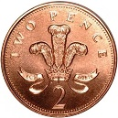 =

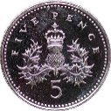 =
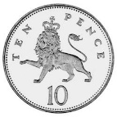 =
TRY THIS:

Write the value next to each set of notes.
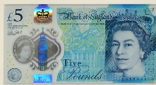 =

=
CHALLENGE
Tim needs 85p to buy a toy he wants. Write or draw what coins he could use to buy the toy.

Greater Depth
Find as many different ways of making £2.27p as you can.

