Shipston High School

Salary: L18 – L31 (Group 5)
Job Type: Full Time, Permanent
Start Date: 01 September 2026
Apply by: 10.00 am Thursday 12 February 2026

Job overview

Headteacher

01 September 2026

L18 – L31: £78,702 - £107,131

Shipston High School, Darlingscote Rd, Shipston-on-Stour, Warwickshire, CV36 4DY

Tel: 01608 661833

Advert
Are you looking to go to the ‘next level’? We are!
Shipston High School is seeking an ambitious and inspirational Headteacher with the vision, energy and determination to lead a good school to the next stage of its development. With a committed and skilled staff team already in place, the school is well positioned to build on its strengths, address its challenges and secure an excellent future for its students.
Located south of Stratford-upon-Avon on the edge of the Cotswolds, Shipston is part of a thriving and growing community. We are proud of our strong local links and are committed to ensuring the school plays a central role in the life of the community it serves.
We are looking for a values-driven leader with a clear and compelling vision for high-quality education who can foster an environment in which both students and staff are supported to thrive.

The Role
The Governors are seeking to appoint a dynamic, caring and forward-thinking Headteacher who will:
- Provide clear, strategic and inspirational leadership for the whole school community
- Motivate and inspire students, staff and families by promoting high expectations, a love of learning and respect for shared values
- Build on existing strengths by nurturing every student, supporting staff development and embedding a culture of continuous improvement
- Work collaboratively with staff and the Governing Board to shape and deliver the school’s future direction
- Champion a student-centred curriculum that values enrichment, personal development and preparation for life beyond school

The Successful Candidate Will Be Someone Who:
- Demonstrates compassionate, inclusive leadership grounded in strong values
- Has excellent interpersonal skills and a proven ability to build positive relationships with students, staff, parents, governors and the wider community
- Believes deeply in the potential of every young person and is committed to enabling all students to flourish academically, socially, emotionally and spiritually
- Leads by example and is committed to high standards in all aspects of school life

You Will Also:
- Have a clear vision and strategic plan for school improvement
- Bring recent and relevant senior leadership experience within a secondary school setting
- Show a strong commitment to equality, diversity and the school’s vision and values
- Be dedicated to securing the very best outcomes and opportunities for students and their families
- Possess the ability to inspire, motivate and unite the whole school community

What We Offer:
- A warm, welcoming and values-led school where students feel happy, safe and encouraged to achieve their best
- A committed, caring and professional staff team who share a passion for excellence and nurturing young people
- Strong partnerships with parents, families and the wider community, creating a genuine sense of belonging and shared purpose
- Supportive and engaged governors, alongside opportunities for professional development and leadership growth
Application Process
To apply, please complete the SHS Application Form and send it to Lydia Ernst (Lernst@shipstonhigh.co.uk) accompanied by a supporting letter setting out your suitability and preparation for this post, including your reasons for applying, personal education philosophy and vision.

Application Deadline
The closing date for applications is 10.00 am on Thursday, 12 February 2026. Interviews will be held over two days on Thursday, 25 and Friday, 26 February 2026.

School Visits
We would love to welcome you to look around the school before the interview days. If you’d like to come and see the school, do please get in touch with us. To arrange a visit, contact the Headteacher’s PA, Charlotte Daubney, cdaubney@shipstonhigh.co.uk or Tel: 01608 661833

Attached documents
- SHS Headteacher Application Pack
- SHS Application Form

About Shipston High School
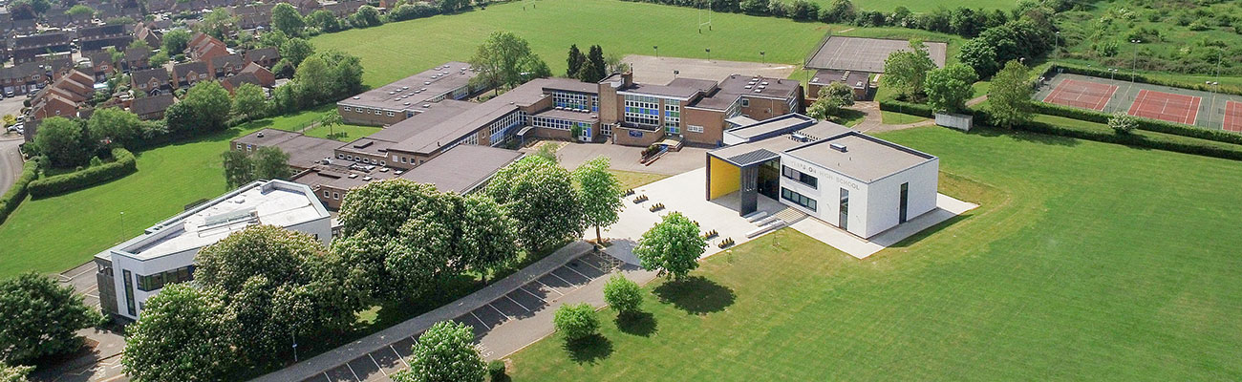


Shipston High School
Darlingscote Rd
Shipston-on-Stour
Warwickshire
CV36 4DY
England

01608 661832

Link: Shipston High School’s Website

Link: Shipston High School – Bing Maps

Shipston High School is a thriving and inclusive 11-16 co-educational secondary school with 534 students currently on roll. The school has a strong sense of identity, shaped by its history, its community and its ambitious outlook for the future. Serving Shipston-on-Stour and the surrounding rural villages of Warwickshire and the northern Cotswolds, the school brings together tradition and innovation to create a distinctive and welcoming learning environment.
At the heart of Shipston High School is a clear and purposeful mission: to prepare young people to play an active part in society by providing them with the exceptional skills, qualifications and attitudes that will benefit themselves and others, locally, nationally and internationally. This mission is underpinned by four core values - Learning, Respect, Ambition and Achievement - which guide daily life in the school and shape expectations for both students and staff
The school’s vision is ambitious and forward-looking. Shipston High School aims to offer an outstanding education in which all students make exceptional progress and are fully equipped for life, both personally and professionally, and as active members of their community. This vision is brought to life through a commitment to being a school that is growing, outward-facing, modern and exceptional. With the anticipated demand for places is looking to strengthen its role at the heart of a thriving local area. It works collaboratively with other schools, families and community partners, and continues to develop a contemporary learning environment fit for 21st-century education.
What truly sets Shipston High School apart is its people. Staff are known for building strong, supportive relationships with students while maintaining high expectations for achievement and personal development. Enrichment opportunities in sport, the arts and community engagement sit alongside academic learning, helping students grow in confidence, character and responsibility.
With a clear strategy for continued development set out in its current School Development Plan, Shipston High School is a school that knows its strengths, embraces challenge and is firmly focused on the future. It is a place where young people are encouraged to discover who they are, what they value and what they can achieve, and where the journey of improvement never stands still.
Ofsted Report 2023: Good
“Pupils are at the centre of school life at Shipston High. They uphold the school’s values of learning, respect, ambition and achievement in their actions. Learning is valued highly by all, and there are positive relationships between staff and pupils. Pupils are mature, polite and considerate of others.”

Link: Shipston High School 2023 Ofsted Report

