

Holy Trinity Primary School NW3

School Improvement Plan 2023-2024

***Isaiah 40: 31***

***Those who have hope in the Lord will renew their strength. They will soar on wings like eagles; they will run and not grow weary, they will walk and not be faint.***

*Our school vision is rooted in the book of Isaiah chapter 40 verse 31 which tells us that those who have hope in the Lord will renew their strength.*

*Our hope in God leads us to have high aspirations for our learning community. We value the uniqueness of each child, made in the image of God, and seek to provide a holistic, enriched curriculum and pastoral care, empowering everyone with the strength, knowledge and wisdom to succeed and flourish.*

***Strength for today, Bright hope for tomorrow***



SSE and SIP Process

Our School Self Evaluation (Separate document) and School Improvement Plan identifies the school improvement priorities for the year and how we plan to address them with maximum impact and maximum efficiency but with minimal cost. It addresses the key areas identified in the Ofsted School Evaluation Schedule. It is informed by on-going school self-review and self- evaluation as well as an annual review which the leadership team carry out throughout the year.

This review helps us to:

∙ Edit our School Self Evaluation in which we grade our own performance against national benchmarks

∙ Identify key issues for improvement throughout the school which form the basis of this SIP.

 We have focussed on the 2 main areas identified for development in our 2018 OFSTED and have improved on past performance:

* more children achieve a good level of development at the end of the Reception year
* teachers provide increasing support and challenge so that more pupils attain the higher standards in reading, writing and mathematics at the end of key stages 1 and 2

We have reviewed and refreshed our vision, identifying 3 core-drivers, around which to focus our work. These have been taken directly from the Church of England Vision for Education and have been selected for their relevance to our cohorts. These have been explored with teaching staff through a program of CPD, to maximise buy-in.

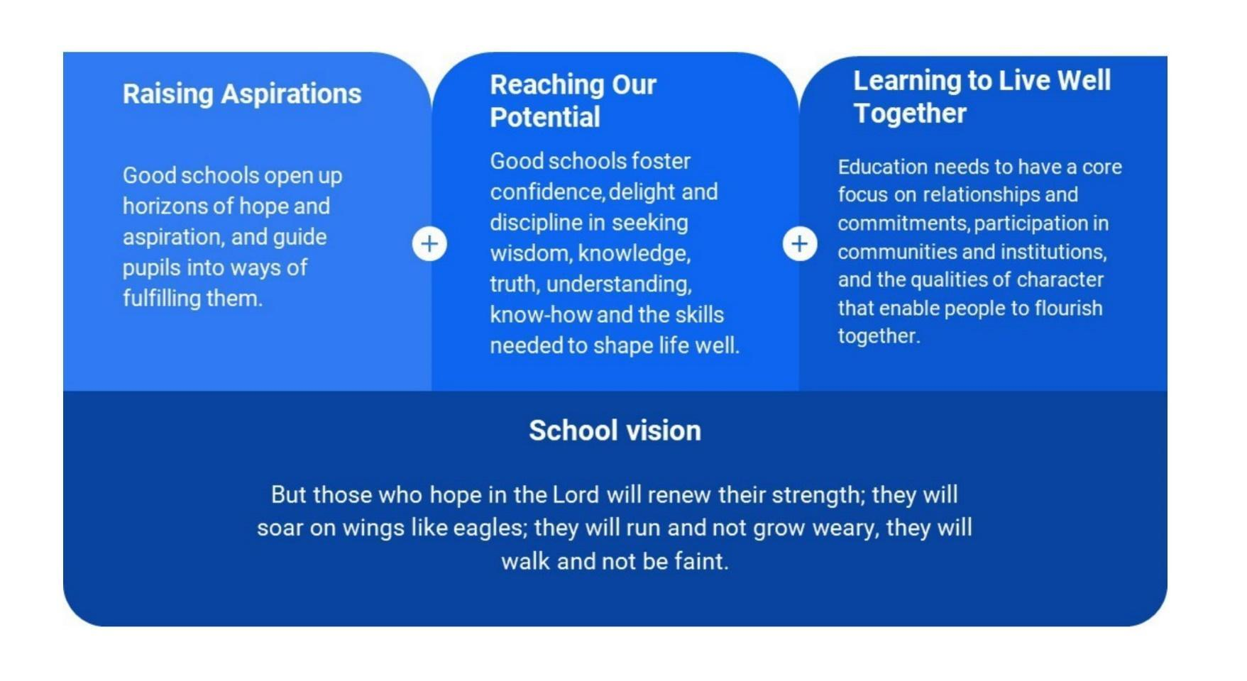

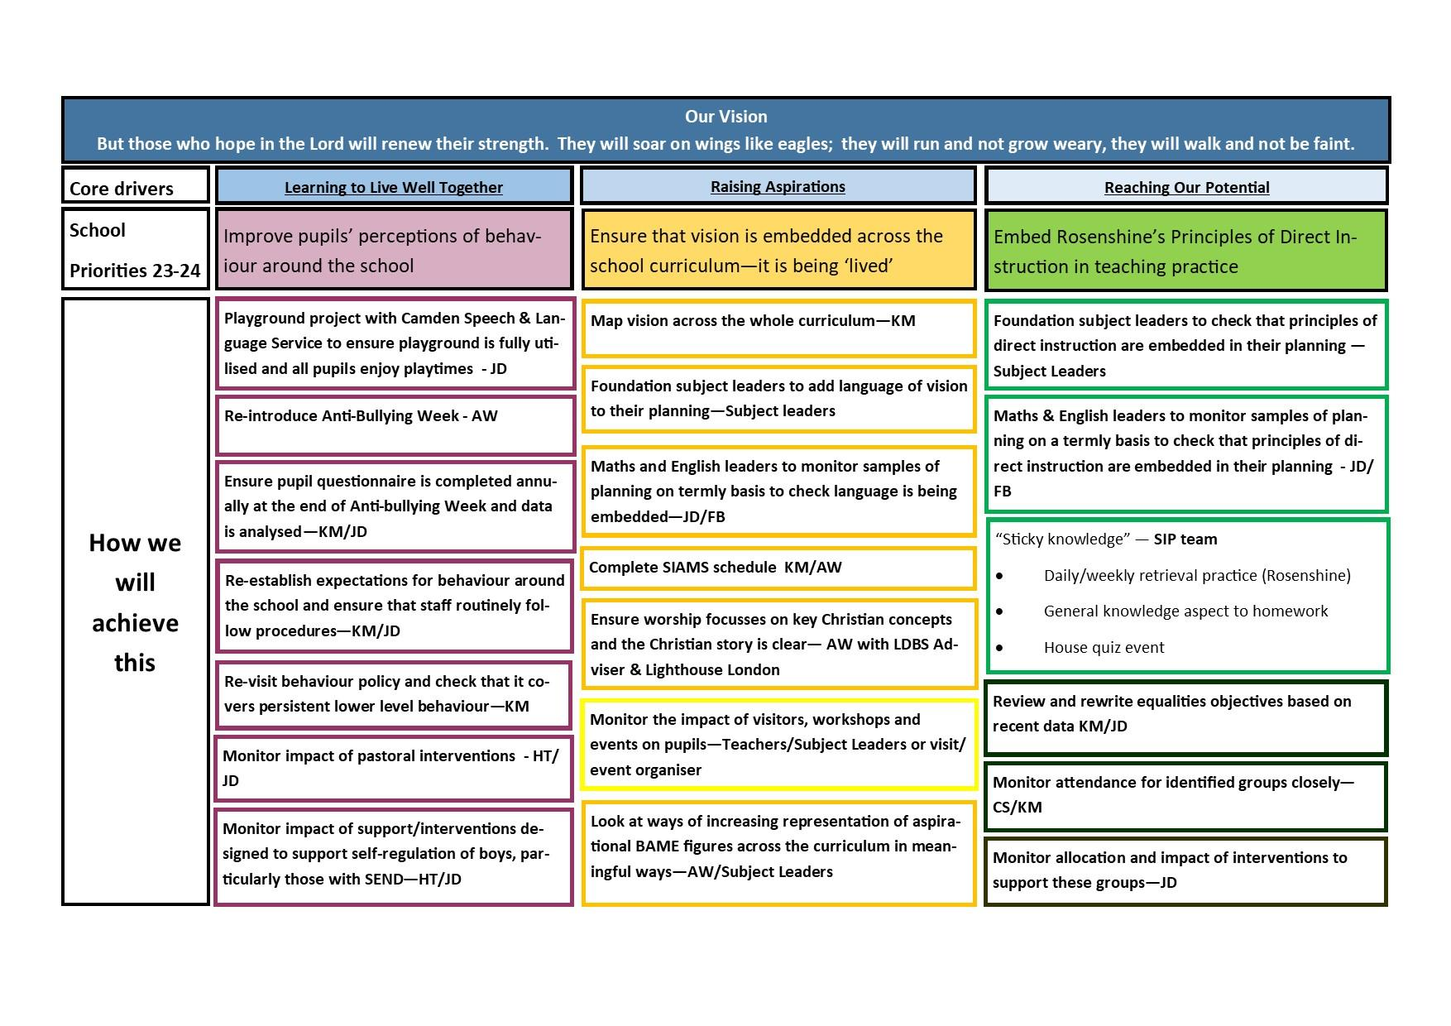

| **Whole School Priority 1: Improve pupils’ perceptions of behaviour across the school** | **LEADER: Keeley McCleave/Jess Dillon** |
| --- | --- |
| **Context:** Despite our belief that behaviour across the school is good (judgements that have been validated by CPP and LDBS Adviser), pupil questionnaires and pupil voice sessions reveal that pupils have a different point of view. Whilst pupils were overwhelmingly positive about their overall experience of school, pupils questioned still felt that behaviour was an issue, even when given a scaled score with clear examples. Pupils concerns were not based on incidents in the vast majority of cases, so we need to unpick what is driving them. Pupils’ views influence parents views, so it is important to understand what pupils are seeing & experiencing, so that we can avoid negative complaints. Very few parents completed the parent questionnaire and most of those did not complete it fully, but their views were consistent with the pupils. | |
| **Outcomes:**   * Pupils have a clearer understanding of what bullying is and how to respond to it * Pupils understand that pupils with SEND may behave in ways that are difficult to understand and may be disruptive, but are not intended to upset or hurt anyone * Pupils have a clearer understanding of the systems in place to monitor poor behaviour and what the sanctions are, including for persistent low-level behaviour * Staff follow the behaviour policy consistently and record keeping is tight * Pupil questionnaires are more positive * Parent questionnaires are more positive about behaviour | |

| **ACTIONS** | **WHO** | **WHEN** | **IMPACT / COMMENTS** |
| --- | --- | --- | --- |
| Anti-bullying week reintroduced, including Odd Socks Day | AW | November 13th - 17th |  |
| Pupil questionnaires completed during Anti-bullying Week | Class teachers | 17th November |  |
| Pupil questionnaires analysed – action plan made if necessary | KM | Autumn 1 |  |
| Behaviour policy and procedures made clear to pupils | Class teachers | November 13th - 17th |  |
| Parent questionnaires set out | KM | Autumn 1 |  |
| Parent coffee morning regarding behaviour policy/channel set up for parents that cannot attend to feedback | KM/JD | Autumn 1 |  |
| Parent questionnaires analysed – action plan made if necessary | KM | Spring 1 |  |
| Behaviour policy reviewed – procedures for consistent low-level behaviour outlined | KM/JD | Summer 2023 |  |
| Behaviour policy reviewed with staff during INSET | KM/JD | Autumn term INSET September |  |
| White slips monitored for evidence of persistent low-level behaviour | KM | On-going |  |
| Autism Awareness Week/Day to ensure that pupils understand the difference between truly disruptive behaviour and ASD pupils who are struggling to regulate | JD | Spring – check but think it will be last week of March/beginning of April |  |
| Build in opportunities for pupils to ‘serve’ others e.g. Harvest Festival for Streets Food Project, sponsored pilgrimage to raise money | KM | MacMillan Coffee Morning 29/09/23 |  |

| **Whole School Priority 2: Ensure that the vision is embedded across the school curriculum – it is being ‘lived’** | **Leader: Keeley McCleave** |
| --- | --- |
| **Context:** Staff and pupils know the vision and the language is being used across the school. LDBS adviser has said that the vision is clear from the website and is clearly being lived based on Head of School’s blog. The list of trips/visitors/workshops and partner events and experiences enjoyed by pupils is extensive and staff should be congratulated on this. However, pupils and parents do not realise that we are offering provision above what is expected and that this is a realisation of our school visual. More importantly, the vision and its impact is not apparent when scrutinising planning & books in particular.  Both Head of School and RE Leader attended training session about spirituality at LDBS. All staff attended INSET on spirituality led by LDBS Adviser. Next step is to define what spirituality means in our context and ensure that staff and pupils and articulate it and recognise it when it happens. | |
| **Outcomes:**   * Vision is clearly embedded in foundation subject planning * Evidence of the vision is clear in samples of English and Maths plans that are monitored termly * SIAMS schedule documents our progress realising this priority * All enrichment experiences are documented and evaluated by pupils in books * Staff evaluate impact of projects, events, visitors, and trips * A wider range of aspirational figures are evident across the curriculum and in experiences programme, including BAME | |

| **ACTIONS** | **WHO** | **WHEN** | **IMPACT / COMMENTS** |
| --- | --- | --- | --- |
| Subject leaderships re-allocated in light of staff changes   * KM to relinquish DT and Computing for the year * KM to look at History and Geography planning this year | SLT | September |  |
| Subject leaders highlight links to vision in their subject overviews and planning | Subject leaders | Autumn term |  |
| Threads of vision mapped throughout the curriculum | KM/Subject Leaders | On-going |  |
| Maths and English leaders to monitor samples of planning on a termly basis to ensure it is consistent with vision and language is embedded | FB/JD | On-going |  |
| SIAMs - questions on schedule completed and strengths and areas for development identified | KM/AW | On-going |  |
| RE assessment data analysed | KM/AW | Autumn |  |
| RE lessons observed with LDBS Adviser | KM/JD/Mary Thorne | Autumn |  |
| PDM dedicated to defining spirituality – see Arundel CE Primary School example | KM – staff input | Autumn |  |
| Spirituality afternoon/day to introduce pupils to concept and help them define for themselves | All staff | Autumn |  |
| Webpage dedicated to the schools approach to spirituality | KM | Autumn |  |
| Spirituality Book to record spiritual experiences of staff and pupils | KM | Autumn set up – add to termly |  |
| Teachers given opportunity to reflect on whether books reflect the ‘lived’ vision e.g. is the richness of the pupils experience evident? | KM/JD | Autumn |  |
| Decide how we want to document the richness of pupils’ experiences, including pupil voice | All staff | On-going |  |
| Keep an overview of pupil experiences across the school – check for equality across school | KM | On-going |  |
| Organise afterschool provision under headings e.g. physical/social/health development | JD | Autumn & then termly |  |
| Analyse engagement with breakfast club and afterschool clubs e.g. FSM take up | JD | Autumn & then termly |  |
| Look for opportunities to meaningfully include more aspirational BAME figures in the curriculum | KM/AW | On-going |  |
| Re-introduce Black History week as an interim measure | KM/AMcQ | Autumn |  |

| **Whole School Priority 3:** Embed Rosenshine’s Principles of Direct Instruction in teaching practice | **LEADER: Keeley McCleave** |
| --- | --- |
| **Context:** Whilst most of the principles are discreetly present in teaching practice, teachers need to be more aware of where they are using them and the impact they are having, to ensure that all pupils are reaching their potential. Teachers need to be empowered to adapt plans provided by subject leaders, schemes and White Rose. Retrieval practice needs to be embedded across the school to support pupils’ recall of basic facts.  Attainment data analysis continues to show that groups achieve broadly equally, which is very positive. However, historical gender trends still persist to a certain extent e.g. girls achieve higher results in reading & writing, boys achieve higher results in maths.  Whilst attendance data is disappointing, the impact on attainment has been minimal, which shows that the quality of teaching is high and intervention programmes are working. Attendance has historically been low at this school and COVID has exacerbated this. Many pupils have family abroad and COVID lockdown and rising flight prices are driving absence.  Various incentives were launched in 22-23 to improve attendance and a member of admin staff was designated as Attendance Officer, but impact has been limited. We approached the local secondary school to see if we could share an Attendance Officer with them, but this did not come to fruition. | |
| **Outcomes:**   * Subject leaders are clear where the principles of direct instruction have been written into their planning * Evidence of the principles of direct instruction in samples of English and Maths plans that are monitored termly * Termly house quiz event to encourage recall of key facts * Equalities objects reflect recent data and staff are aware of what they are * Attendance and outcomes for groups identified in equalities policy improve | |

| **ACTIONS** | **WHO** | **WHEN** | **IMPACT / COMMENTS** |
| --- | --- | --- | --- |
| Subject leaders ensure that planning is consistent with the principles of direct instruction |  |  |  |
| Maths and English leaders to monitor samples of planning on a termly basis to ensure that the principles of direct instruction are embedded in practice |  |  |  |
| Lesson observations/coaching focuses on embedding principles of direct instruction in practice |  |  |  |
| Subject leaders develop a set of curriculum questions for each year group (per term) for quiz events | SIP team | Autumn |  |
| SIP team organise termly house quiz event – parents can attend | KM/JD | Termly |  |
| **Equalities** | | | |
| Equalities objectives re-written to reflect current data trends | KM/JD | July 2023 using 2022 data |  |
| Impact of interventions for identified groups monitored | JD | On-going |  |
| Pupil voice sessions to identify what their perceptions of subjects are and why | KM/Subject leaders | On-going |  |
| **Attendance** | | | |
| Attendance action plan based on Camden Analysis booklet - see below | KM/CS | Autumn |  |
| SENDCO to identify pupils with SEND in groups identified in the report:   * Meet parents to discuss impact on pupil * Address barriers to attendance * Continue to monitor attendance of pupils | JD | On-going |  |
| Head of School to compile attendance data for parents - diagram how many days =% absence | KM | Autumn |  |
| Head of School & Attendance Officer have half termly meeting to identify pupils whose attendance is problematic | KM/CS | On-going |  |
| Head of School to meet with parents of children whose attendance is identified as problematic | KM | On-going |  |
| Head of School to speak to the School Nurse about referring pupils who are regularly absent due to sickness | KM | On-going |  |