# Pupil premium strategy statement

## This statement details our school’s use of pupil premium (and recovery premium for the 2022 to 2023 academic year) funding to help improve the attainment of our disadvantaged pupils.

## It outlines our pupil premium strategy, how we intend to spend the funding in this academic year and the effect that last year’s spending of pupil premium had within our school.

## School overview

|  |  |
| --- | --- |
| **Detail** | **Data** |
| School name | Holy Trinity CE Primary School |
| Number of pupils in school | 169 (updated Nov 22) |
| Proportion (%) of pupil premium eligible pupils | 52% (updated Nov 22) |
| Academic year/years that our current pupil premium strategy plan covers **(3 year plans are recommended)** | 2022/23 to  2025/26 |
| Date this statement was published | September 2022 |
| Date on which it will be reviewed | September 2023 |
| Statement authorised by | Laura Hall |
| Pupil premium lead | Jess Dillon |
| Governor / Trustee lead | Stephen Rust |

**Funding overview**

|  |  |
| --- | --- |
| **Detail** | **Amount** |
| Recovery premium funding allocation this academic year | £12,905 |
| Pupil premium funding allocation this academic year | £121,880 |
| Pupil premium funding carried forward from previous years (enter £0 if not applicable) | £0 |
| **Total budget for this academic year**  If your school is an academy in a trust that pools this funding, state the amount available to your school this academic year | £134,785 |

# Part A: Pupil premium strategy plan

## Statement of intent

|  |
| --- |
| We are an inclusive school that has ambitious expectations for all learners, including those who are disadvantaged. As a church school, we acknowledge that all our pupils are significant to God and value each child’s unique personality and background. We aim to develop their character, talents and abilities to the fullest in His name  Our intention is that all learners, irrespective of their background or the challenges they face, make good progress and achieve high attainment across all subject areas. We want them to leave school having had a well-rounded education that is rooted in cultural capital.  High-quality teaching is at the forefront of our approach. This is proven to have the greatest impact on closing the disadvantage attainment gap and at the same time will benefit the non-disadvantaged pupils in our school.  We pride ourselves in our ability to identify the needs of the children from a very early point and act appropriately. The whole staff take responsibility for disadvantaged pupils’ outcomes and aware of our school commitment to raise expectations of what they can achieve. For those who are already high attainers, we ensure that they are challenged in the work that they are set and continue to progress throughout their school career. |

## Challenges

This details the key challenges to achievement that we have identified among our disadvantaged pupils.

|  |  |
| --- | --- |
| **Challenge number** | **Detail of challenge** |
| 1 | On entry baseline assessments for disadvantaged pupils show low starting points in many areas of the EYFS Framework, with lower communication and language skills. |
| 2 | Limited opportunities/ life experiences beyond their home and immediate community. |
| 3 | Some pupils who are in receipt of Pupil Premium funding show less secure learning behaviours. Some pupils physically and emotionally lack self-belief, determination and resilience and can lack self-motivation and confidence to improve |
| 4 | Persistent absence is above national and local averages for disadvantaged pupils nationally. |
| 5 | On tract EXS + data for Reading, Writing and Maths combined is higher for non-pupil premium children than pupil premium children in most classes in 2021/2022  In Year 2 33% PP children were not on track compared to 12% of non-PP children  In Year 4 50% PP children were not on track compared to 46% of non-PP children  In Year 5 25% PP children were not on track compared to 23% of non-PP children  In Year 6 25% PP children were not on track compared to 14% of non-PP children |

## Intended outcomes

This explains the outcomes we are aiming for **by the end of our current strategy plan**, and how we will measure whether they have been achieved.

|  |  |
| --- | --- |
| **Intended outcome** | **Success criteria** |
| Improved Reading attainment among disadvantaged pupils. | Internal and external data to show that reading outcomes are broadly in line with non- disadvantaged children |
| Improved Maths attainment among disadvantaged pupils. | Internal and external data to show that maths outcomes are broadly in line with non- disadvantaged children |
| Improved Writing attainment among disadvantaged pupils. | Internal and external data to show that maths outcomes are broadly in line with non- disadvantaged children |
| Improved attendance for all pupils, particularly our disadvantaged pupils children are happy to come to school and are ready to learn | Sustained high attendance from 2024/24 demonstrated by:   * The overall absence rate for all pupils being above 95% * The percentage of all pupils who are persistently absent being in line with non PP children |
| Improved social, emotional health for all pupils, particularly our disadvantaged pupils. Children receive appropriate support and advice from services and families. | Sustained high levels of wellbeing as seen through:   * qualitative data from student voice, parent surveys and teacher observations * improvements in behaviour * reduction in bullying |
| To sustain an enriched curriculum, full of opportunities for Cultural Capital, for all pupils, particularly disadvantaged pupils. | Sustained enriched curriculum as seen through:   * Improvements in attainment across the curriculum * qualitative data from student voice, parent surveys and teacher observations |

## Activity in this academic year

This details how we intend to spend our pupil premium (and recovery premium funding) **this academic year** to address the challenges listed above.

£2000 CGP homework books (including stretch books)

£8000 Latin programme (50% of fee)

£54000 teacher salary(7% of salary)

£3000 towards supply teachers to cover costs of training

£5000 on courses for teacher development through Camden Learning

£300 standardised tests

£300 working memory project

### Teaching (for example, CPD, recruitment and retention)

Budgeted cost: £ 72,600

|  |  |  |
| --- | --- | --- |
| **Activity** | **Evidence that supports this approach** | **Challenge number(s) addressed** |
| Whole school project on Working Memory and ‘sticky knowledge’ to support retention. See SIP. | Supported by the 2019 Ofsted Framework’s emphasis on progression and retention and Working Memory and Learning: A Practical Guide for Teachers  by [Susan Gathercole](https://www.amazon.co.uk/s/ref=dp_byline_sr_book_1?ie=UTF8&field-author=Susan+Gathercole&text=Susan+Gathercole&sort=relevancerank&search-alias=books-uk) (Author), [Tracy Packiam Alloway](https://www.amazon.co.uk/s/ref=dp_byline_sr_book_2?ie=UTF8&field-author=Tracy+Packiam+Alloway&text=Tracy+Packiam+Alloway&sort=relevancerank&search-alias=books-uk) (Author) | 5 |
| Purchase of **standardised diagnostic assessments** (Rising Stars Assessments Y1- 5) | Standardised tests can provide reliable insights into the specific strengths and weaknesses of each pupil to help ensure they receive the correct additional support through interventions or teacher instruction:  [EEF Standardised Tests](https://educationendowmentfoundation.org.uk/tools/assessing-and-monitoring-pupil-progress/testing/standardised-tests/) | 5 |
| Teacher’s opportunities for **professional development courses** (Camden Learning) | Courses will help improve the quality of teaching in school by keeping teachers up to date with evidence based teaching and learning strategies.  [EEF Teacher Development](https://educationendowmentfoundation.org.uk/education-evidence/guidance-reports/effective-professional-development) | 5, 3, 1 |
| Participation in **The Latin programme** | We understand that tackling disadvantage is not only about supporting low attainers. We are aware that disadvantaged students who achieve highly in primary school are much less likely than their peers to receive top grades at GCSE. The Latin Programme do project, group work with our higher attaining children.  [EEF Middle and Higher Attainers](https://educationendowmentfoundation.org.uk/public/files/Publications/Pupil_Premium_Guidance_iPDF.pdf) | 5 |
| Focus on Early Reading and Phonics.  Purchase of **Essential Letters and Sounds**- a [DfE validated Systematic Synthetic Phonics programme](https://www.gov.uk/government/publications/choosing-a-phonics-teaching-programme) - to secure stronger phonics teaching for all pupils.  Purchase of new phonically decodable books including non-fiction and blending books. | Phonics approaches have a strong evidence base that indicates a positive impact on the accuracy of word reading (though not necessarily comprehension), particularly for disadvantaged pupils:  [EEF Phonics](https://educationendowmentfoundation.org.uk/evidence-summaries/teaching-learning-toolkit/phonics/) | 1, 5 |

MARK interventions: £1000

Resources for interventions: £500

2x HLTA salary (50%) £30,000

SEND provision map £2000

TA salary for class interventions (33%) £7,500

**Targeted academic support (for example, tutoring, one-to-one support structured interventions)**

Budgeted cost: £ 41,000

|  |  |  |
| --- | --- | --- |
| **Activity** | **Evidence that supports this approach** | **Challenge number(s) addressed** |
| Additional phonics sessions targeted at disadvantaged pupils who require further phonics support. We believe in ‘keeping up’, not ‘catching up’ | Phonics approaches have a strong evidence base indicating a positive impact on pupils, particularly from disadvantaged backgrounds. Targeted phonics interventions have been shown to be more effective when delivered as regular sessions over a period up to 12 weeks.  [EEF Phonics](https://educationendowmentfoundation.org.uk/evidence-summaries/teaching-learning-toolkit/phonics/) | 1, 5 |
| Teaching Assistant out of class 1 day a week to deliver Word Aware to KS1 and KS2 | [EEF Word Aware](https://educationendowmentfoundation.org.uk/projects-and-evaluation/projects/vocabulary-enrichment-intervention) | 1, 5 |
| High quality intervention in Reading and Maths for children making less than expected progress in KS1/ KS2 led by HLTAs (MARK intervention) | Small group and one-to-one pre and post teaching supports children in an individualised way and provides targeted academic support(EEF, 2019)  [EEF Interventions](https://educationendowmentfoundation.org.uk/support-for-schools/school-improvement-planning/2-targeted-academic-support) | 1, 5 |
| Additional teacher and teaching assistant time directed at:   * individual/ group ‘keep up’ phonics * individual or small group Maths and English booster groups with school time * teachers reading with bottom 20% | EEF reports research that small group tuition, such as our targeted booster sessions, can have a good impact on pupil progress:  [EEF Small group tuition](https://educationendowmentfoundation.org.uk/evidence-summaries/teaching-learning-toolkit/small-group-tuition/) | 5, 3 |



**Wider strategies (for example, related to attendance, behaviour, wellbeing)**

Budgeted cost: £ 21,700

|  |  |  |
| --- | --- | --- |
| **Activity** | **Evidence that supports this approach** | **Challenge number(s) addressed** |
| Improve the **attendance** of PP pupil’s through rewards and communication with parents.  This includes invitations to attend breakfast club and SLT time. | The DfE guidance has been informed. Rewards and incentives are highlighted as well as communication with parents.  [DfE Improving School Attendance](https://www.gov.uk/government/publications/school-attendance/framework-for-securing-full-attendance-actions-for-schools-and-local-authorities) | 4 |
| Support full participation of disadvantaged pupil in **extracurricular and enrichment activities** through financial contribution. This includes all clubs. | DfE Wellbeing for Education Recovery documents report the importance of a range of activates to promote emotional well-being:  [DfE Supporting Educational Well-Being](https://www.gov.uk/guidance/mental-health-and-wellbeing-support-in-schools-and-colleges#wellbeing-for-education-recovery) | 4, 2 |
| **Pastoral support worker** to work with vulnerable pupils and their families | National referrals to support mental health concerns in children are up 134%. Pastoral care in schools is essential in identifying families in need of support.  [DfE Supporting Educational Well-Being](https://www.gov.uk/guidance/mental-health-and-wellbeing-support-in-schools-and-colleges#wellbeing-for-education-recovery) | 3 |
| Support full participation of disadvantaged pupils in **school trips and residential** | The EEF shows that adventure learning has positive benefits on academic learning. They suggest that pupils who participate in adventure learning interventions make approximately four additional months  [EEF Adventure Learning](https://educationendowmentfoundation.org.uk/projects-and-evaluation/projects/adventure-learning).  Ofsted acknowledge that many disadvantaged pupils do not have access to cultural capital at home and highlight its importance to succeed in life.  [Ofsted 2019 Cultural Capital](https://www.gov.uk/government/consultations/education-inspection-framework-2019-inspecting-the-substance-of-education/outcome/education-inspection-framework-2019-a-report-on-the-responses-to-the-consultation) | 2 |

**Total budgeted cost:** £134,300

# Part B: Review of outcomes in the previous academic year

## Pupil premium strategy outcomes

This details the impact that our pupil premium activity had on pupils in the 2021 to 2022 academic year.

Reading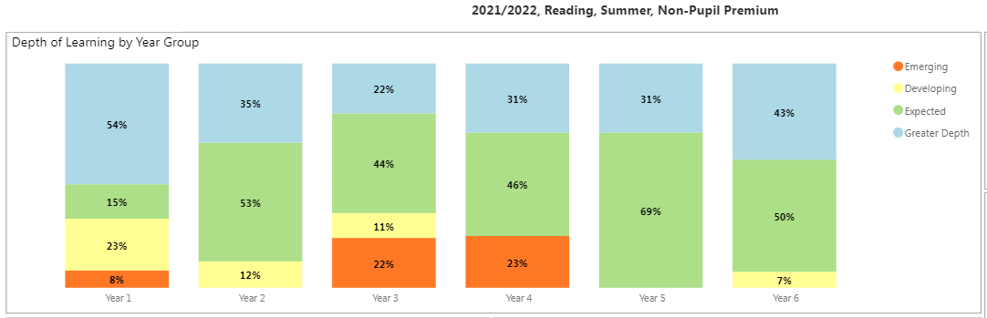

What does this tell us?

There is no significant difference in the attainment in Reading from Y1- Y6 due to PP funding

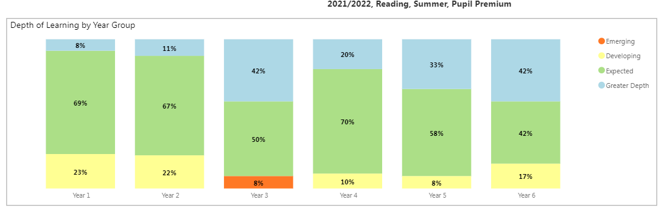

Writing

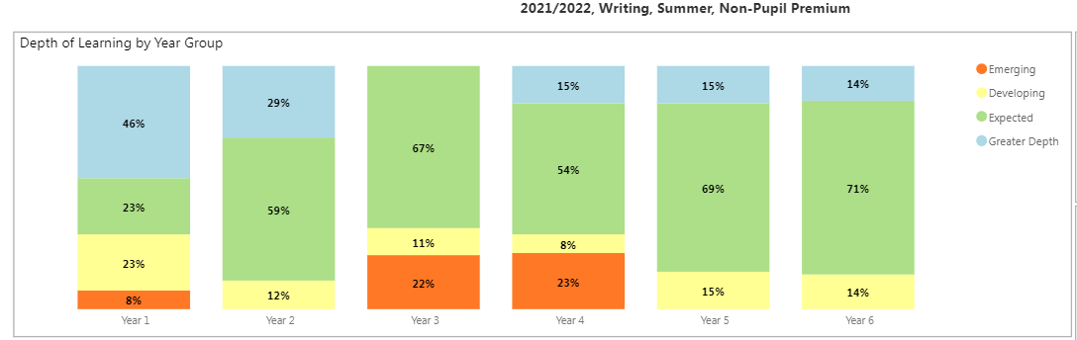

What does this tell us?

There is no significant difference in the attainment in Writing from Y1- Y6 due to PP funding

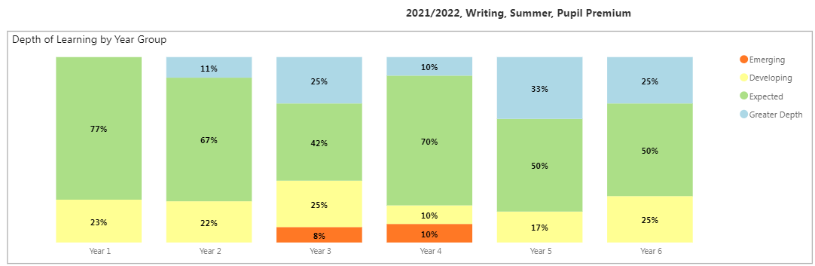

Maths

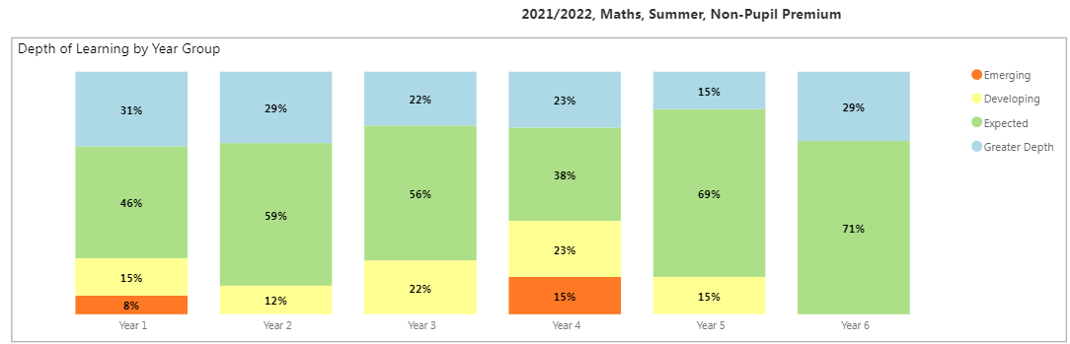

What does this tell us?

Need to target Y4 PP with more interventions

PP chn achieve lower GD in KS1

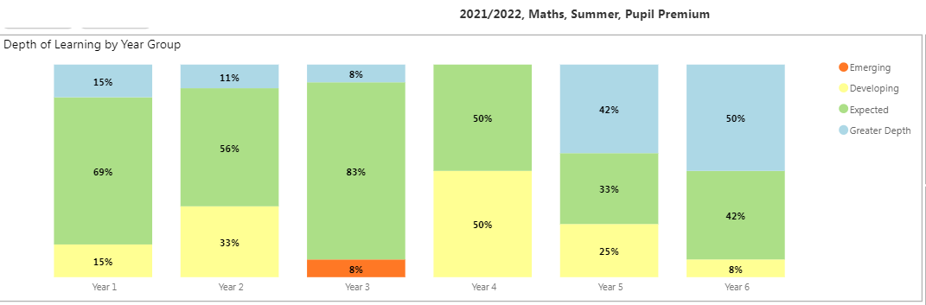

Attendance