Useful websites

Reading:
The best thing you can do is to read to someone, or listen to someone else read everyday.
If you want to also practise reading comprehensions questions then you can also go here:
https://readtheory.org/

For practising maths:
https://www.themathsfactor.com/
https://www.topmarks.co.uk/maths-games/hit-the-button

For writing
This website is great for practising grammar and vocabulary!
https://www.ealhub.co.uk/home-learning-area/
This websites posts a new picture and story starter ideas everyday. They also include grammar and sentence writing activities.
http://www.pobble365.com/

For getting active:
https://www.bbc.co.uk/teach/supermovers
https://www.gonoodle.com/
PE with Joe Wicks https://youtu.be/6v-a_dpwhro

Fun, practical indoor activities
https://www.scouts.org.uk/the-great-indoors/

Rainforest Project ideas

Animal Creation  Combine the features of two animals from  the rainforest to create your own new animal. Make a fictional fact file for it. What name would you give it? Which  features did you choose and why? | Story Writing  Create a story about the life of a child who survives  in the rainforest. How did they get there? Are there other tribes there? What will they see? What adventures does the character go on? Does it end happily?
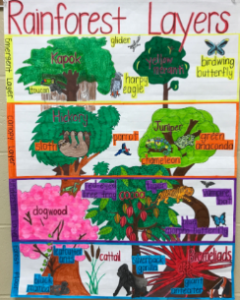  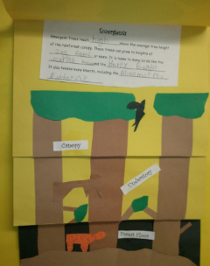  Draw and write  Research the different layers of the Rainforest and make you own Layers of the Rainforest flap book with a picture of each layer and facts underneath. | Facts  Create your own amazing facts about the rainforests.  Create ‘did you know?’ fact cards and teach your new found knowledge to your friends and family.  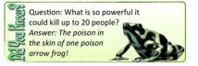
Card Games  Research different rainforest animals and make your own top trump cards. Challenge your family to play a game against you.  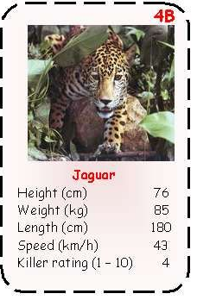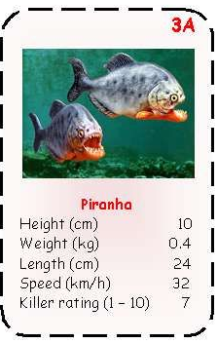 | Maths  Create your own Rainforest Maths word problems.  Challenge someone else to solve them!  E.g. Macaws lay eggs once a year, either 2 or 3 eggs each time.  Mia counts 19 Macaw eggs.  How many female Macaws have laid eggs in the area?  There are three possible answers.
Word search  Create your own rainforest wordsearch using key rainforest vocabulary  (e.g. equator, emergent, tropical …) | Craft  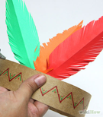  Research the types of headdresses worn by tribes living in the rainforest and have a go at making your own!

Year 3 Maths Games

*Some of these games are played with a dice. If you do not have dice at home you can still play these games. You can either make a dice or 1-6 number cards
*Where possible, I have made suggestions for how you can make each game extra challenging!
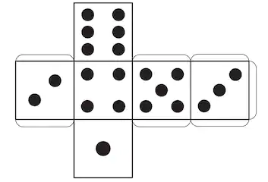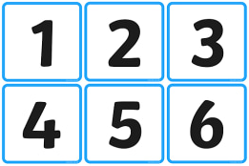

Torn-up Times tables
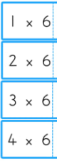
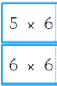
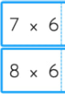
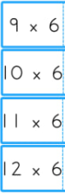
You will need: A4 piece of paper and a pencil
- Fold a piece of A4 paper into 8.
- On one side, write the times tables that you want to practise.
- On the other, write the answers.
- Tear the cards along the edges.

There are two ways to play:
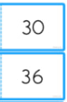
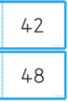
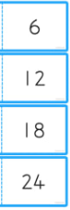
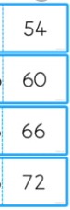
- Turn the cards over so you can see the times table but not the answer. Choose a times table for you partner to answer. If they get it right, they keep the card.
- Turn the cards over so you can just see the answer. Choose a number, your partner must say the times table that gives you that answer (division practise!)
You can make this game harder by multiplying each number by 10 so working out 1 x 60, 2 x 60 etc.

4 rolls to 100

You will need: Paper, pencils and a dice/ make your own 1-6 number cards

- Draw 2 boards as below.
- Each player takes it in turns to roll the dice.
- Decide whether you want to keep that number or multiply it by 10.
- (So if you roll a 6 you could keep it as 6 or x10 and make 60.)
- Record in first circle.
- Keep taking it in turns, and add the numbers as you go.
- Repeat for each player until all 4 circles complete.
- Player with total closest to 100 wins.

Shall I risk it?
You will need: Paper, pencils, 2 dice/ make your own 2 piles of 1-6 number cards.
Game for 2
- Player 1 rolls two 1-6 dice and adds the numbers, e.g. 2+3=6
- Player 1 keeps rolling and adding the numbers cumulatively, e.g.
6
6+7=13
13+4=17
17+8=25
- You can ‘stick’ at any point and hand the dice over to Player 2
- If you roll a 1 you revert to the score that you started the round on
- If you roll a double 1 you return to 0!
- The winner is first past 100!

21 down
You will need: Paper, pencils and a dice/ make your own 1-6 number cards

Each player starts with a score of 21
Each player takes a turn to roll the dice / choose a number card.
The number rolled is subtracted from 21
The first player to get exactly 0 wins.

Make it harder:
- Start from a bigger number (31, 41, 51…)
- Start at 100, use two dice (or two piles of number cards) and subtract 2-digit numbers.

