Holy Trinity CE Primary School

18th March 2020

RE: Home Learning

Dear Children, Parents and Carers,

All of us at Holy Trinity hope that all of our families are safe and well at this unprecedented time. We have taken every measure to keep our children and staff safe and we thank those parents who have self-isolated following government advice.

With so many children off school we have taken the decision to send out our Home Learning packs. These can be found on our website under the new tab, ‘Home Learning’

We are also sending home hard copies of this pack and additional resources and books. Children in school will receive these tomorrow in their school bags.
Those of you at home who want a pack can collect one at the following time:

Thursday 19th March 2020.
10.30 – 11.00
School Playground

We will keep you updated on any new guidance.

Yours sincerely,

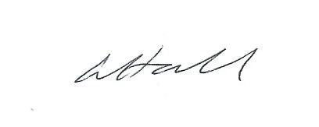

Headteacher
Laura Hall

