Dear Parents and Carers
Year 6 Transition 19th June 2026
We are delighted that you have chosen Blackwood Comprehensive School as your secondary school, and I look forward to getting to know you and your child during their time with us.
Our Head of Key Stage 3, Mrs Davies, Year 7 Progress Managers, Mrs Colley and Mr Williams, and Assistant Headteacher Inclusion & ALN, Mrs Rudman, have been working very closely with our primary schools all year, to ensure that your child’s move to us is as smooth and successful as possible.
We have already carried out some enhanced transition days, but our main Year 6 transition days are planned for the 8th and 9th July, one of which is an International Language Day. I hope these days help to alleviate any anxieties that you and your child may have about joining us in September. If you have any queries or questions, we will be holding a meeting in the hall for parents and carers at 3:00pm at the end of the transition day on 8th July, where you will have the opportunity to meet and speak to staff. Additionally, we have a transition folder on our website, under ‘About Us’, which contains lots of useful information about our school.
The link to the website is http://www.blackwood.caerphilly.sch.uk/
One of the biggest queries we have is around uniform and so it will be useful to ensure you know our policy, which consists of:
- Grey trousers, grey knee length pleated skirt or grey knee length tailored shorts.
- Compulsory black blazer with school badge on left hand side
- White blouse/shirt
- Optional V-neck black school jumper with school badge
- Plain black or navy coat
  - No denim, leather, or leather look jackets
  - No hoodies
- Flat black leather or leather look shoes
  - Leather or leather look Converse/Airforce style shoes are acceptable but not trainers or boots.
- Black, grey or white socks or black tights
- School clip on tie
- No bright or unnatural hair colours, tramlines or facial piercings. Pupils can wear one pair of stud earrings.
Items of uniform are available in store or online at Asda, Sainsbury’s, Next, Matalan or M&S amongst others. Ties can be purchased from reception.
Pupils will also need to have a PE kit and appropriate footwear for their PE lessons. This consists of:
- Plain black or school badged crew neck T-shirt
- Blackwood Comprehensive School reversible rugby shirt, for those who access boys’ PE
- Black shorts, leggings, joggers or skorts
- Black rugby/football style long socks, for those who access boys’ PE
- White socks
- Non-marking trainers, for use inside and out
- Plain black sweatshirt (recommended)
- Black sports type waterproof jacket (recommended)
- 4G boots with plastic moulded studs (see picture below)
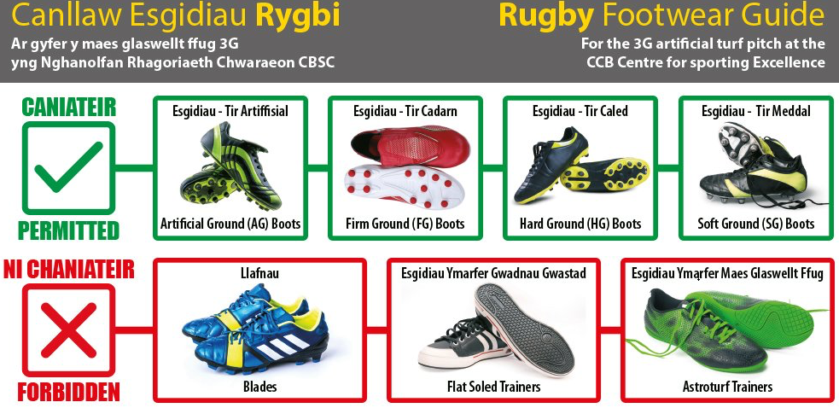

Again, if any families need support with purchasing any PE equipment, then please let us know.
We have two INSET days at the start of the autumn term, on Tuesday 1st and Wednesday 2nd September 2026, meaning that our new Year 7 pupils will join us on Thursday 3rd September. We are looking forward to welcoming them at 8:30am in the Hall.
Until then, I hope pupils have an enjoyable end of term in their primary schools as they prepare to leave.
Have a lovely summer break.
Kind regards
Jane Wilkie
Headteacher/Pennaeth

