Emergency Procedures Blackwood Comprehensive School

“Full Evacuation”
In addition to the need to evacuate the school in the event of fire etc. (which is addressed through the fire evacuation procedures and prompted by the sounding of the fire alarm), there may at times be the need for pupils and staff to fully evacuate the school grounds.
This is referred to as the “Full Evacuation” of the school. It may be necessary if a particular hazard has come to light or for any other reason when we need to evacuate the school as a matter of urgency.
The need for us to progress to “Full Evacuation” will be the sounding of the fire alarms. At this point, the normal “Fire Evacuation” procedures must be followed. Upon arrival at the tennis courts there will be a member of staff directing pupils and staff towards the front entrance of the school. This signifies “Full Evacuation” protocol should be followed
The decision to progress to a Full Evacuation situation can only be made by the most senior member of staff present in school.

Procedure
- Upon hearing the fire alarm, follow the agreed fire evacuation procedure.
- Staff & Pupils should make their way to the tennis courts.
- A staff member will be based at the entrance to the tennis courts and will instruct all pupils & staff to head towards the front school gates.
- Year groups 7, 8 & 9 should keep to the left when walking down the drive and enter the playing field through the bottom gates.
- Year 10, 11 & staff should keep to the right when walking down the drive and will enter the playing field through the gate at the top of Ty-Isha terrace
- Members of the SLT will be based at strategic locations along the evacuation route to assist with staff & pupil flow
- Once inside the field you should make your way to your designated year group area and line up in your form class. You should remain silent during this
- The ‘all clear’ will be signalled by the Head teacher or Business Manager

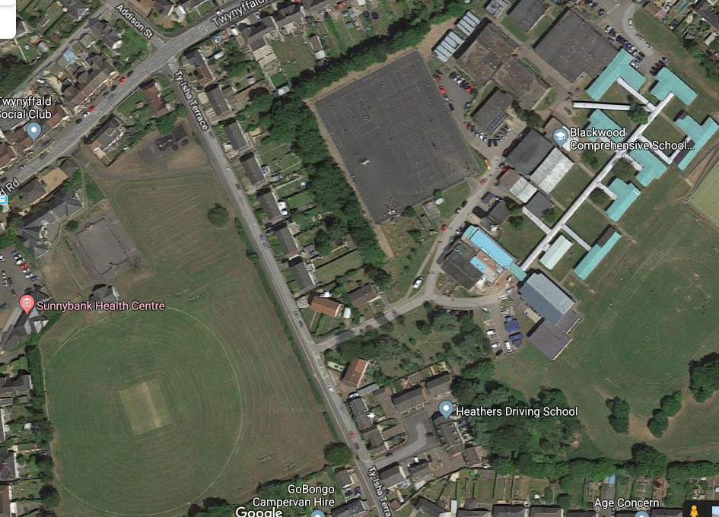
- All pupils & staff are to evacuate the building/area currently in and make your way towards the tennis courts as normal. In the event a full site evacuation is required there will be a member of staff positioned to direct pupils towards the front gate
- At the top of the drive, year 7, 8 & 9 pupils should keep to the LEFT of the drive and follow the RED arrow. Enter the field through the bottom gates
- Year 10 & 11 should keep to the RIGHT and follow the YELLOW arrow and enter the field through the top gates
- Make your way to your designated area on the field.
- Pupils are to assemble in single file in their form groups
- Members of staff will be at the locations to assist with pupil management
Year 7
Year 9
Year 11
Year 10
Year 8
Staff Assembly Point – Past the gate on Ty-Isha Terrace. This will ensure staff are back on site before pupils upon re-entry

Staff Members at Key Locations

Tennis Court – Andrew Winn
Top of Drive – Hilary Brown & Ceri Rudman
Gate entrance to the filed – Phil Villa (this includes taking the key for the gate and opening for pupil entry)
Bottom of the drive directing pupils – Natalie Griffiths
Bottom of Ty-Isha Terrace – Tracy Davies (stop all vehicles entering Ty-Isha terrace whilst we have pupils moving across the road
Top of Ty-Isha Terrace – Neil Hawkins
Based in the field – Sue Fowles, Jenna Jones & Kim Cole

Ms J Wilkie is free to communicate with the staff & pupils via the megaphone
Nathan will remain free to complete a site sweep & liaise with Emergency services

