Maths Homework
Due Thursday 25th May 2017

Please continue practising telling the time at home.

Draw the hands on the clock for the times shown underneath. Remember the hour hand is shorter than the minute hand.
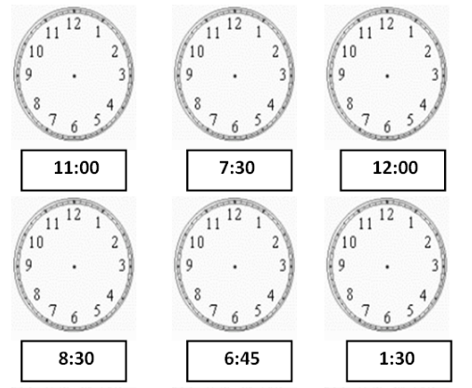

Write the time underneath the clocks. Look at the Roman Numerals and link them to the numbers they represent.
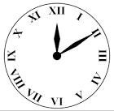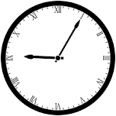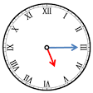

Challenge:
- How many minutes are in 2 hours?
- ½ minute = _____seconds
- ¼ of an hour = _____ minutes
- What time is noon?
- How many minutes are there in 1 ½ hours?

Months of the year: Which months have 30 days?

