Maths Homework
Due Thursday 18th May 2017

Keep practising telling the time at home.

Quick fire questions

- How many days in 72 hours?
- How many seconds in 1 ¼ minute?
- How many weeks in 56 days?
- How many hours in ⅛ of a day?
- How many minutes in 720 hours?

Time investigation - Use your growth mindset!

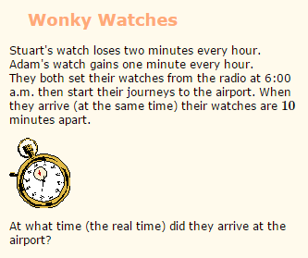
Use the table below to help you:

Hours | Stuart’s watch’s time (loses 2 minutes each hour) | Adam’s watch’s time (gains 1 minute each hour)
06:00 | 06:00 | 06:00

