Literacy Homework
Due Thursday 25th May 2017
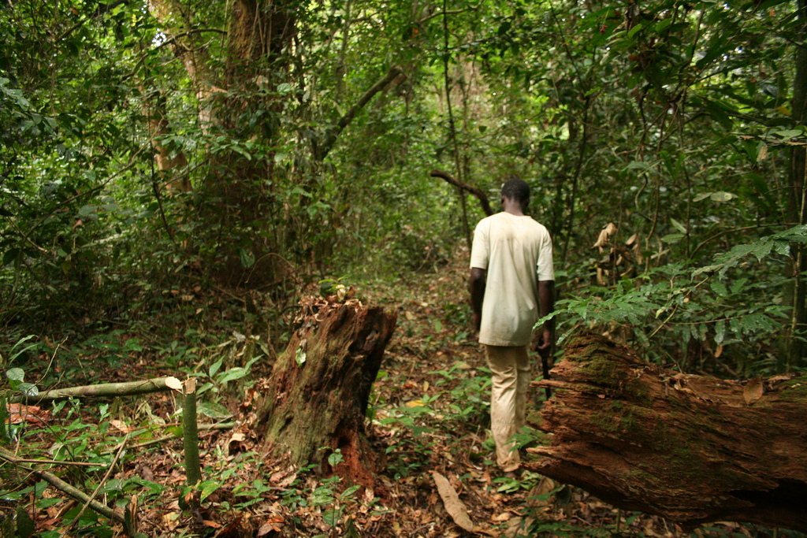
Our new literacy learning is looking at adventure stories. For your homework, we would like you pick two pictures and create a conversation between the animals.
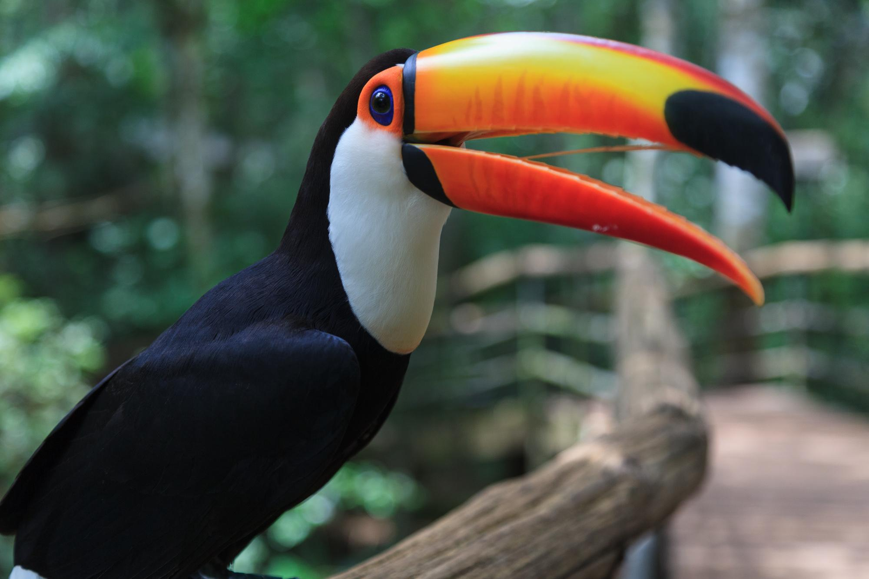
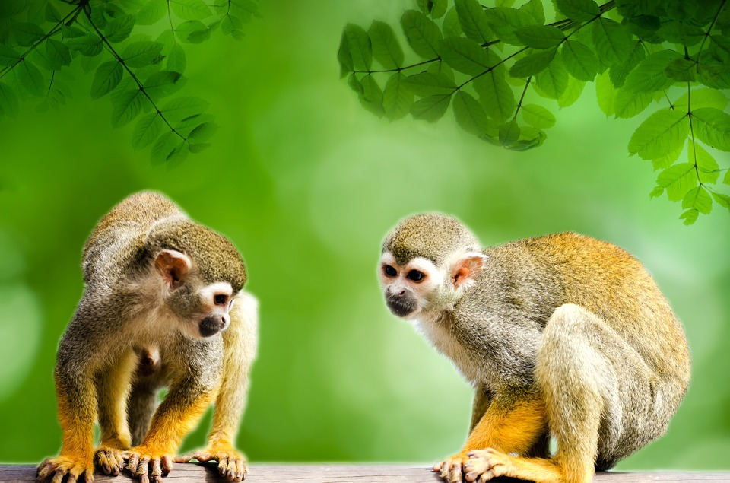
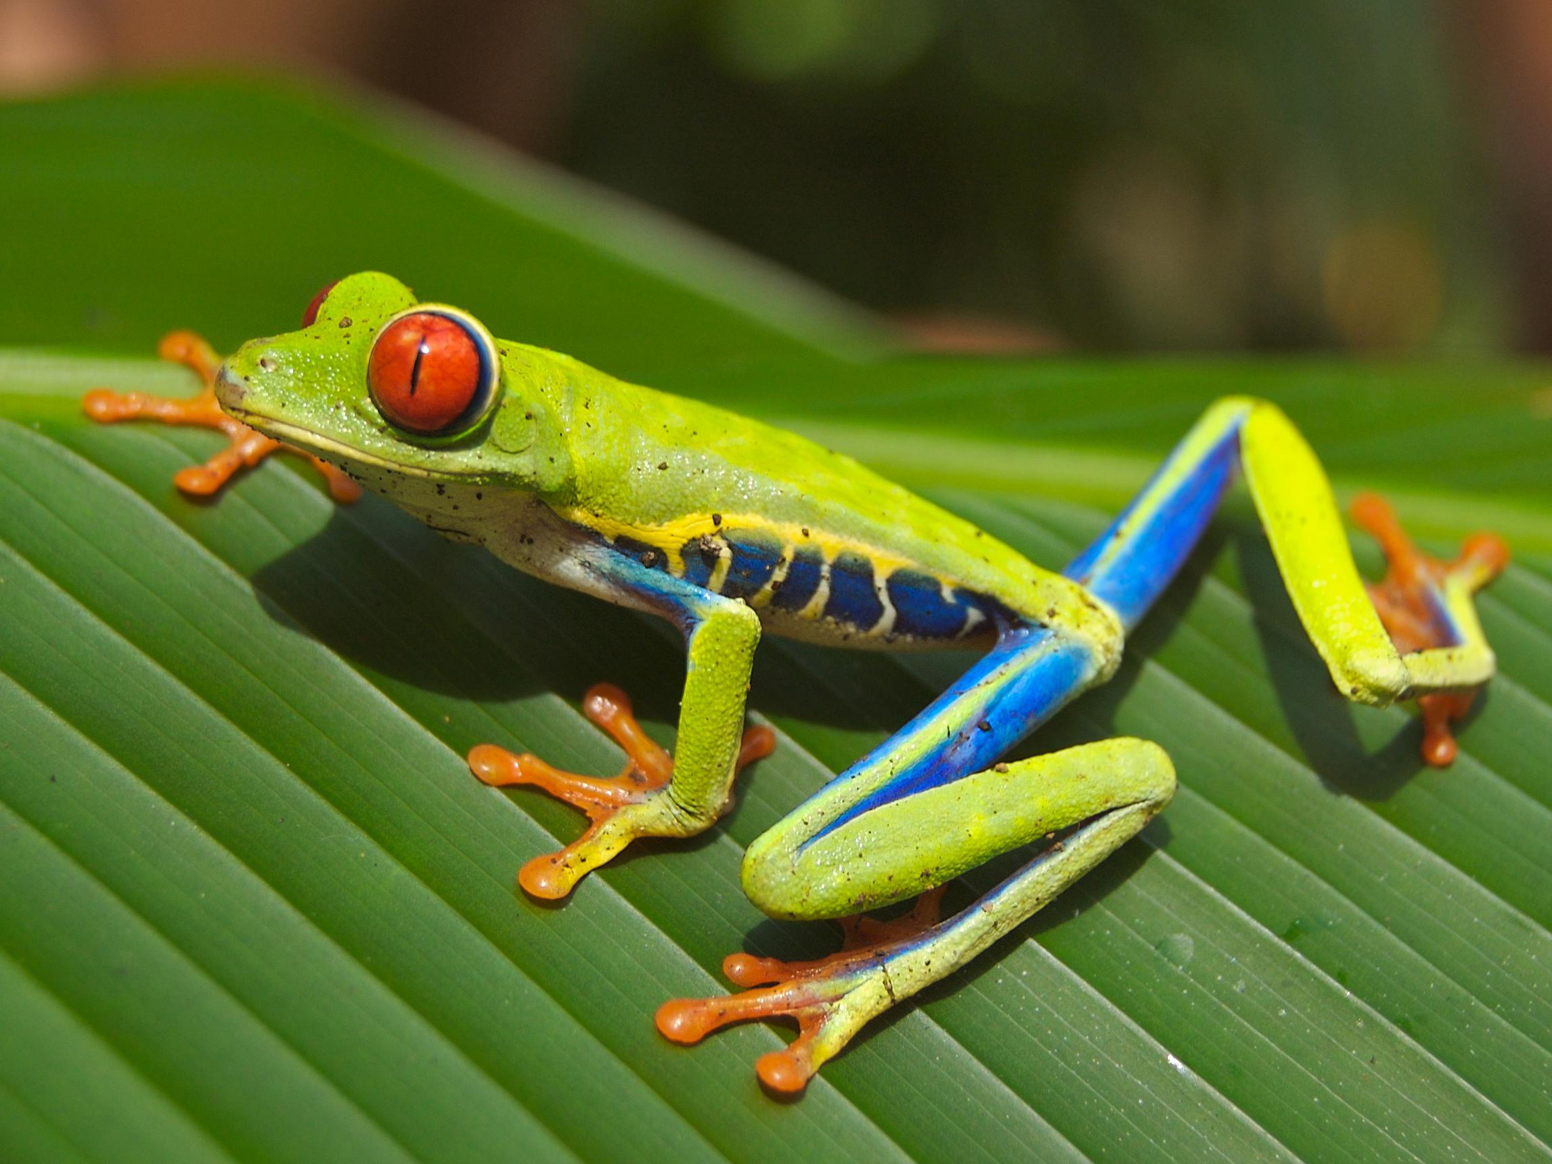

Success Criteria:
- Speech and punctuation - , . ! ? “”
- Speech verbs - shouted, growled, hissed, squawked
- Description - how do they look?
- Emotion - Lazily, happily, angrily
- Show not tell - The leaves swayed gently in the breeze while the monkeys clambered across the strong, steady branches.
- Past tense verbs - swayed, clambered, soared
- Adverbs - Gently, excitedly, quietly

Example:
“It is very hot in the rainforest today!” the toucan squawked excitedly.
“How about we go for a dip in the river to cool off?” the monkey replied quickly.
“That sounds like a great idea monkey,” he squealed happily. The leaves swayed gently in the breeze while the monkeys clambered across the strong, steady branches.

Literacy Homework
Due Thursday 25th May 2017

Our new literacy learning is looking at adventure stories. For your homework we would like you pick two pictures and create a conversation between the animals.
Success Criteria:
- Speech Verbs
shouted, growled, hissed, squawked
- Adverbs
Gently, excitedly, quietly
- Punctuation
! , . ? “”

Example:
“It is very hot in the rainforest today!” the toucan squawked excitedly.
“How about we go for a dip in the river to cool off?” the monkey replied quickly.
“That sounds like a great idea monkey,” he squealed happily.

