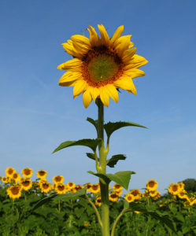
Project Homework
Due Thursday 27th April 2017

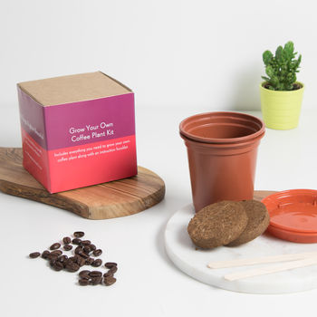
To start our new project learning on rainforests, we are going to be looking at plants and how they grow.

We would like to start with a competition!
Using the seeds provided we would like you to grow the seed to be a healthy plant.

You will need to think about:
- Where you will plant your seed
- What you will plant it in
- Where you will leave it to grow
- What you will add to it to help it grow

Keep a diary of your plants growth over the project - you could record this in writing or pictures. This could simply be notes or a few pictures; nothing very detailed is necessary!

Top Tips:
- Put the seed into a little pot to start with then you can grow it elsewhere.
- If you don’t have a garden, could you find somewhere to let your sunflower grow?

