Spelling Homework
Due Thursday 23rd March 2017

Please practice your high frequency words using Look, Cover, Write, check.
Then complete the sentences by adding the correct word.
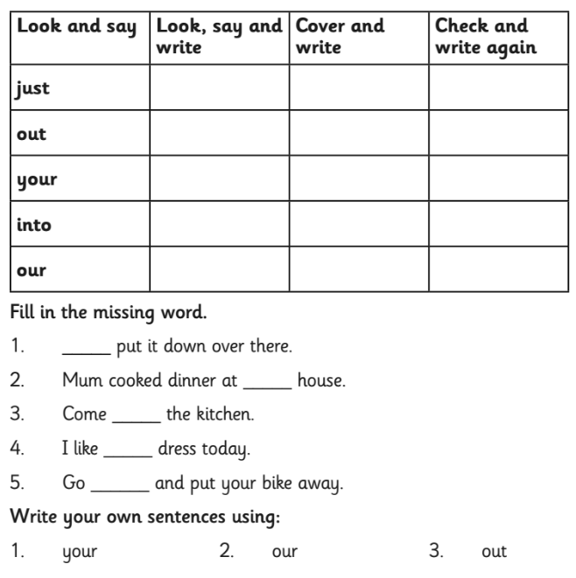
Finally write your own sentence using the words.

