Spelling
Due in Thursday 8th December 2016
This week we have been looking at homophones.
Homophones sound the same but have a different meaning and often spelling.
E.g. night / knight

Success Criteria:
- Read the word.
- Think about another meaning of the word.
- Write down the homophone with the different spelling.

Example:
Sea (the ocean) = see (to see things)

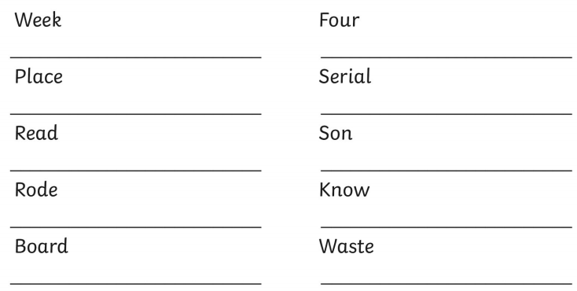

Challenge:
Can you find 3 more homophones not on the sheet?

___________________

___________________

___________________

