Year 3 Spelling Homework:
Due: Thursday 3rd November 2016

Over the half term, please practice these year 3 spelling words using each of the different techniques.

build
decide
exercise
complete
remember
natural

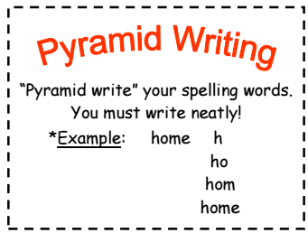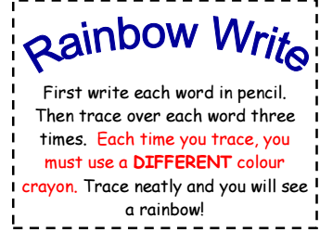
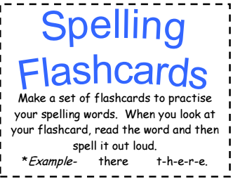

Year 3 Spelling Homework:
Due: Thursday 3rd November 2016

Over the half term, please practice these year 3 spelling words using each of the different techniques.

with
went
again
playing
said
like

