Whole school homework - due on your Curriculum Tea day!
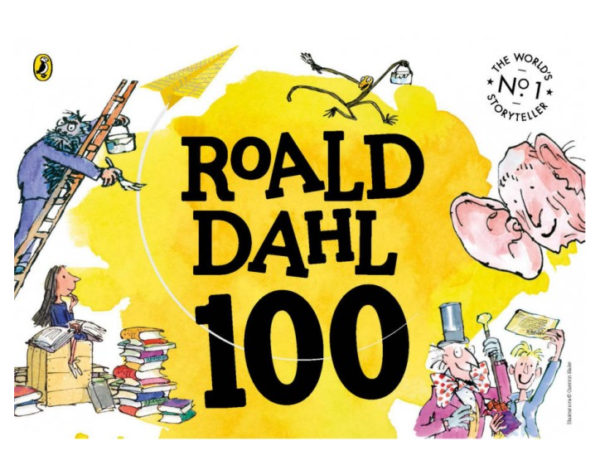
On Tuesday 13th September, it was Roald Dahl’s 100th birthday celebrations. As a hugely inspirational author, we encourage you to start reading a Roald Dahl book with your family this weekend. It could be that you read it yourself, or you may like to ask other members in your family to read it to you - it’s up to you!

Roald Dahl wrote many fantastic stories, including ‘Charlie and the Chocolate Factory’, ‘The BFG’ and ‘Matilda’ and some great poems, including his ‘Revolting rhymes’ collection. He has even written a hilarious cookbook - ‘Revolting Recipes’!
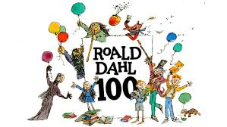
Curriculum Teas are always a great opportunity for our community to get together, learn about the new academic year and share food together. For your homework this week, we would like you to be inspired by Roald Dahl’s inventive stories and either make/bring something tasty for your Curriculum Tea that relates to one of his characters or books or design a Roald Dahl inspired recipe of your own. There will be a prize for the most inspired baking in each small school!

Here are some ideas -
- A Bruce Bogtrotter chocolate fudge cake (from Matilda)
- A frobscottle fizzy drink (from The BFG) or ‘George’s Marvellous Medicine’ drink
- ‘Worm’ spaghetti from The Twits (please don’t actually use real worms - worm shaped sweets could be a good alternative!)
- Anything made with chocolate (from ‘Charlie and the Chocolate Factory’)
- You could even make your own ‘revolting recipe’ to bring in, giving it a Roald Dahl style name like ‘whipple scrumptious fudgemallow delight’! (please make it edible though!!!)
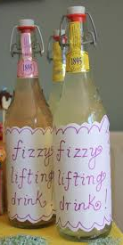
- Or you could try making some of the revolting recipes from Roald Dahl himself - http://www.roalddahl.com/create-and-learn/make/revolting-recipes
- https://www.brainpickings.org/2014/09/25/roald-dahl-revolting-recipes/

We would also love to see some inventive recipe writing for your creations or some pictures of your creative new food ideas!

Please don’t feel pressured to make your own food - you can write a recipe and draw what your Roald Dahl inspired food could look like to bring in and share with your class instead (a chocolate digestive could always come from Willy Wonka’s factory!)
Could we also ask that you do not add nuts to your recipes due to risk of allergies.
