TONER AVENUE PRIMARY SCHOOL

Composition of the Governing Board

- 2 Parent Governors
- 1 Head Teacher
- 1 Staff Governor
- 1 Local Authority Governor
- 7 Co-opted Governors

Committees of the Governing Board

- Resources
- Standards and Evaluation
- Ethics

Ethics - 3 non staff governors drawn from the governing board on an alphabetical rotational basis.

Chair of Governors
Mr George Bone MBE
Vice Chair of Governors
Mrs Wendy Stead

Name | Category | Appointing Body | Terms of Office | Committees (if associate member has voting rights) | Official responsibility
G M J Bone MBE | Co-opted | Governing Board | 27/05/2020 – 26/05/2024  27/05/2024 - 26-05-2028 | Resources Committee  Standards & Evaluation Committee | Chair of Governors
David Ewart | Co-opted | Governing Board | 22/1/2019 – 21/1/2023  31/1/2023 – 30/1/2027 | Resources Committee  Standards & Evaluation Committee
Jacqueline Glass | Co-opted | Governing Board | 31/1/2023 – 30/01/2027
Gray Haley | Co-opted | Governing Board | 10/06/2025 – 09-06/2029
H.E. McAtominey | Co-opted | Governing Board | 27/05/2020 – 26/05/2024 | Resources Committee
Wendy Stead | Co-opted | Governing Board | 22/1/2019 – 21/1/2023  31/1/2023 – 30/1/2027 | Resources Committee  Standards & Evaluation Committee | Vice Chair of Governors
Alex Whelan | Co-opted | Governing Board | 31-01-2024 – 30-01-2028
Nichola Fullard | Head Teacher | By Virtue of appointment | 25/04/2022 | Resources Committee  Standards & Evaluation Committee
Cllr Joan Keegan | LEA | Local Authority | 5/7/2023 – 4/7/2027
Graham Kelly | Parent | Parents | 21/01/2022 – 20/01/2026 | Resources Committee
Liam Prickett | Parent | Parents | 7/11/2022 – 6/11/2026
Lucy Almond | Staff | School Staff | 22/6/2022 – 21/6/2026
Coralie Morton | Associate Member  Co-opted | Governing Board  Governing Board | 14/10/2021 – 28/9/2022  29/9/2022 – 28/9/2026 | Standards | RESIGNED 20-11-2024

REGISTER OF GOVERNOR INTERESTS

TONER PRIMARY SCHOOL

Name | Position | Nature of Interest | Date Interest Registered | Date Interest Ceased | Notes
George Bone MBE | Co-opted | None | 10/06/2025
David Ewart | Co-opted | None | 10/06/2025
Jacqueline Glass | Co-opted | None | 10/06/2025
Gray Hayley | Co-opted
H.E. McAtominey | Co-opted
Wendy Stead | Co-opted
Alex Whelan | Co-opted
Nicola Fullard | Head Teacher | Director – Vision Learning Trust | 10/06/2025 |  | Governor – Hebburn Comprehensive
Cllr Joan Keegan | LEA
Graham Kelly | Parent
Liam Prickett | Parent | None | 10/06/2025
Lucy Almond | Staff | None | 10/06/2025

NO BI FORMS RECEIVED

Date of Review: 11/07/2025

Committee Chart

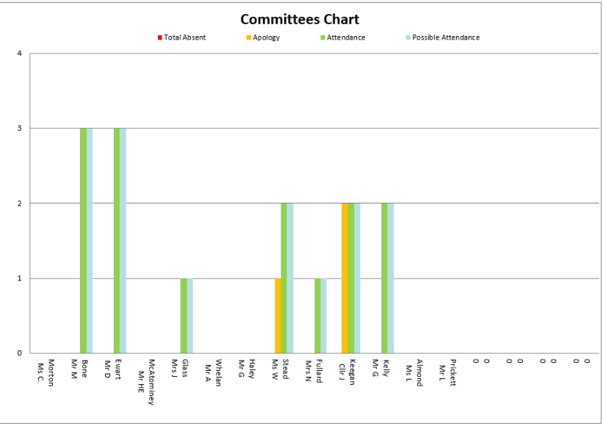

Full Governing Board Chart

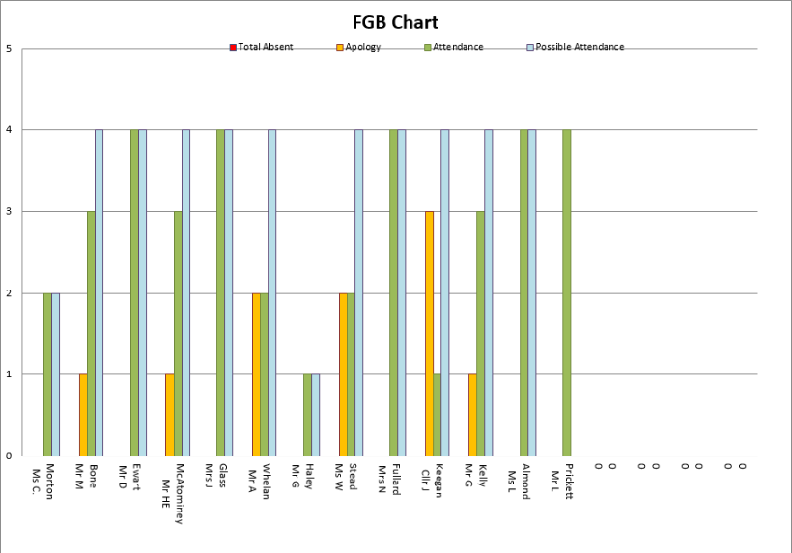
Total Governing Board

