**As a Reception Artist…….**

I can hold and use the equipment correctly and can produce a range of marks that describe different patterns and textures.

I am able to work directly from observation and from my imagination and have experienced a variety of 2D and 3D media.

I have worked in different ways on differently sized, differently coloured and differently shaped papers and cards, over different time scales by myself and in collaboration with others.

I can name the colours and equipment I have used.

I have a sketchbook in which I keep my experiments with different media and my skill work for reference.

I have worked on and into different surfaces, I have modelled and assembled end-pieces.

I work on a computer and have used art-based programmes.

I look at work produced by different artists, craftspeople and designers and can express my views and feelings about them.

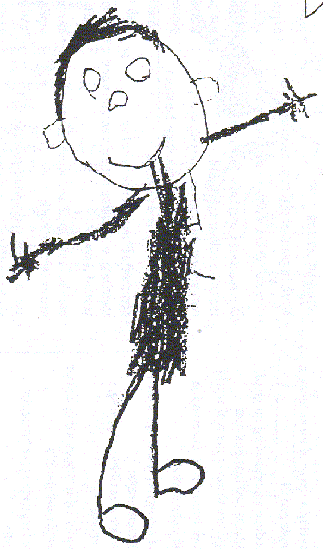

# As a Year One Artist……

Drawing

I can make marks using different media and know how to change the marks that I make to show texture.

I can use different textured media to create a new surface.

Painting

I can apply paint using different brush strokes and understand the techniques of mixing colours.

Printmaking

I can use primary colours to produce direct prints.

I have experienced different printmaking techniques including stencils, clay slab relief blocks and collographs.

Collage

I have experimented with using found materials to create different effects and can talk about their textures.

I understand the idea of hot and cold colours.

Textiles

I have developed simple weaving skills and understand the resist process.

3D

I have developed understanding of line, shape, colour and pattern.

I have learnt techniques to manipulate clay and have developed an understanding of relief surfaces.

I am starting to talk about my own work and that of other artists, crafts people and designers, describing what I can see and what I feel about their work.

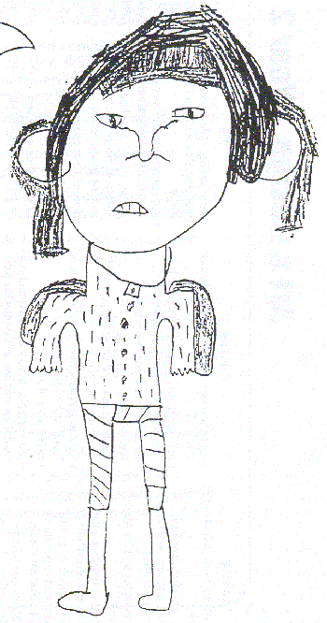

**As a Year Two Artist……**

Drawing

I understand that different mark makers produce different effects and can make marks in response to descriptive language.

I can show texture through my marks.

Painting

I have investigated line, colour and space in paintings.

I have developed my brush control and techniques of colour mixing, producing colour tints by adding white.

Printmaking

I have developed the techniques of making stencils and slab relief blocks, and can produce unique state prints.

Collage

I show an understanding of primary and complimentary colours.

I have explored line as a contour and have developed my cutting skills.

Textiles

I have experimented with dip dye processes and applied my knowledge of relief printing to produce an individual piece of textile work.

3D

I have learnt the process of rolling and inlaying clay into a slab and can use different techniques to change the shape of clay.

I am using language appropriate to the skills and techniques. I am able to talk about my own work and how it was produced as well as talking about the work of artists, craftspeople and designers.

I review my work, identify changes I might make and how I might develop the work in the future.

I can express my thoughts and feelings, applying my knowledge and understanding, about my own and others work.

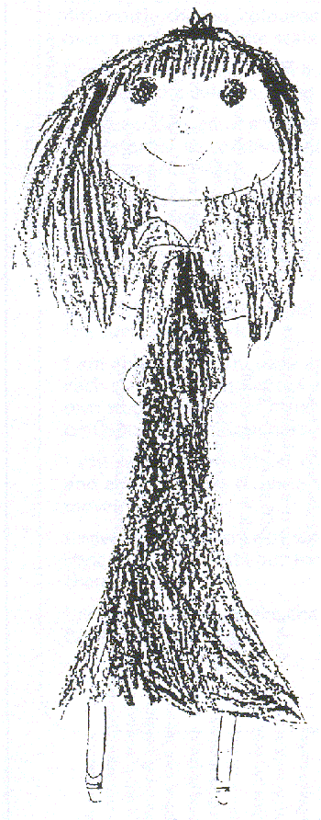

**As a Year Three Artist….**

Drawing

I have investigated different marks that can be made with a pencil and explored shading techniques investigating light, medium and dark tones.

Painting

I can mix primary colours to make secondary colours and can make tints and tones of colours.

I have experimented with the techniques of tonking and sgraffito to develop my work.

Printmaking

I can use a roller to ink up a slab and to experiment with mark making.

I have experimented with the monoprinting process.

Collage

I have developed positive and negative images and can transpose ideas from painting to collage.

Textiles

I can use my sketchbook to collect visual information and explore patterning from different cultures.

I can use my knowledge of dip dye to produce a background for printing and develop collographs and block printing techniques to use in my textile work.

3D

I can transpose 2D designs onto a 3D surface, and can roll and form clay slabs, inlaying different coloured clay.

I am able to use language appropriate to each area, can discuss and evaluate my own work and that of other artists, craftspeople and designers.

I review my work, make changes and can see further developments.

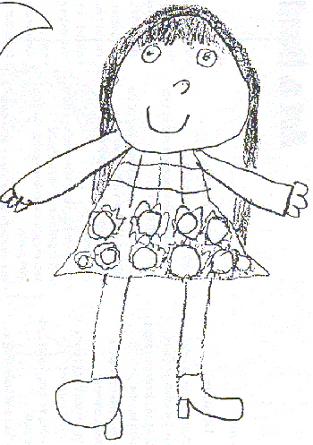

**As a Year Four Artist….**

Drawing

I can apply my experience of drawing materials and processes.

I can use a viewfinder and record linear patterning in natural objects, showing fine control with a pencil to make a detailed, analytical observational drawing.

Painting

I can select and assemble materials to make a multi-shaped and textured surface to work on.

I can mix colours and select and use appropriately sized brushes to produce careful, fine marks.

Printmaking

I have investigated designs from another culture and developed these design in my sketchbook.

I have developed the technique of monoprinting and transposed monoprint designs into Press Print.

Collage

I have described body positions of figures in motion using torn paper.

I have investigated and combined visual qualities of materials and explored the translucent nature of tissue paper.

Textiles

I have developed dip dye and resist techniques and have responded to the work of a textile artist, developing knotting, threading and binding techniques.

3D

I can use research and my sketchbook to explore designs and can cast 3D forms.

I can apply my experiences of materials and processes to develop my work and can adapt, modify and refine my work in process.

In all skill areas I am able to organise and take responsibility for the things I use.

I have an increasing knowledge of the breadth of art, can use appropriate language, and am able to discuss and evaluate aspects of my own work and that of my peers.

I am developing my knowledge of artists and I am able to recognise different art forms in the world around me.

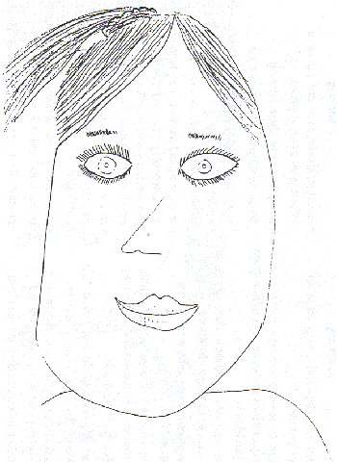

**As a Year 5 Artist…..**

Drawing

I can produce observational drawings and select and use a range of media.

I can use natural forms as starting points and select and enlarge drawings.

I have experimented with rubbers to work and draw in the negative.

Painting

I can question and make observations about using the work of other artists as a starting point and select ideas to use in my work.

I have applied my experience of materials and processes and developed my control of tools and techniques for painting.

I have made a multi-layered piece using a variety of media and understand the use of contrasting, adjacent colours.

Printmaking

I have learnt the process of reduction block printing using Press Print and primary colours.

I have developed my ideas and adapted and modified my work where necessary.

Collage

I can record from direct observation and can apply my experiences of materials and processes to develop my control of tools and techniques.

I have investigated and combined visual and tactile materials and processes to collage techniques.

Textiles

I have developed an understanding of wax resist and applied my knowledge of the Batik process to develop control of tools and techniques.

3D

I have developed an understanding of Modroc as a sculptural material and have recorded my ideas and processes that I used

I have reviewed my own sculpture and can say what I think and feel about it.

I am able to use Art vocabulary to talk about what I have done to express ideas, to discuss and evaluate my work, the work of my peers and the work of other artists, craftspeople and designers.

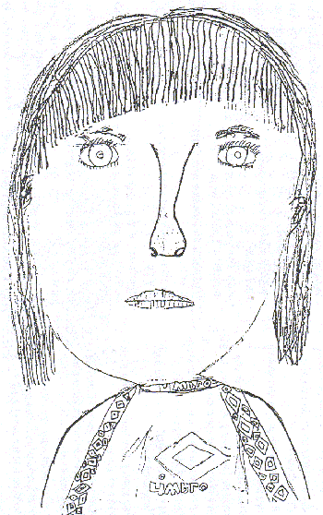

**As a Year Six Artist……**

Drawing

I understand the visual elements of tone.

I can respond to portraits from different times and styles and have investigated a variety of methods and different media used by artists for portrait work.

Painting

I can develop my ideas in my sketchbook.

I understand the visual elements of colour, shape and space and how these can be combined to produce abstract images.

I can concentrate on the outlines of images to produce simple linear shapes.

Printmaking

I can transfer my work and ideas into another medium and combine learned processes.

I have developed unique state prints using Press Print reduction blocks.

I have adapted and modified my work if necessary as it has progressed.

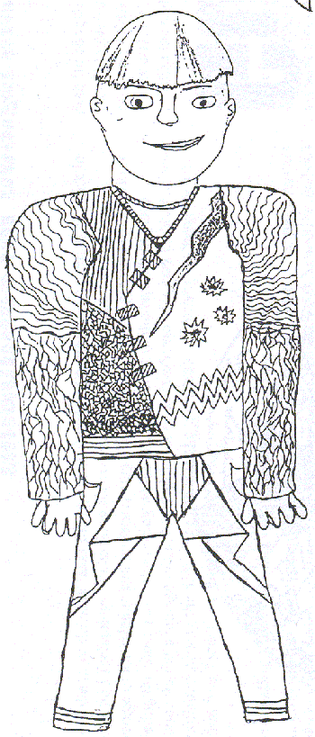

Collage

I have developed the use of simple geometric shapes and patterning in response to the work of an artist.

I have used my sketchbook to select, record and develop images.

I can combine visual and tactile qualities of materials and match these to the purpose of their work.

I can apply my experience of materials and processes and develop control of tools and techniques.

Textiles

I can collect and select visual information and develop ideas.

I can develop linear designs.

I can transpose linear designs into relief Press Print blocks.

3D

I have developed my research and design skills.

I can use the work of craftspeople and designers working in different times and cultures as a starting point for my work.

I can develop a small scale series of work.

I recognise art forms in the world around me and I am able to discuss them and the way they are produced, using appropriate terminology.

I can evaluate my own work and that of others, I can compare ideas and methods and am able to express my own opinion.

I am able to modify and improve my own work to realise my intentions.